NJACTS REDCap Workshop: Basic User Session

Introduction
Objective: Introduction to REDCap and basic data management practices
1 Getting Started
Objective: Access REDCap, get familiar with interface, project structure overview
2 Building Your First Instrument
Objective: Create an instrument, learn how to add different field types and field components
3 Data Collection and Project Changes
Objective: Project management, how to make changes and maintain data integrity
4 Reminders and Recap
User Rights, Reports, Data Quality, Longitudinal Module, Repeating Module

Introduction
About REDCap
REDCap is a secure web application for building and managing online surveys and databases. While REDCap can be used to collect virtually any type of data in any environment (including compliance with 21 CFR Part 11, FISMA, HIPAA), it is specifically geared to support online and offline data capture for research studies and operations. The REDCap Consortium, a vast support network of collaborators, is composed of thousands of active institutional partners in over one hundred countries who utilize and support their own individual REDCap systems.

In a nutshell: The REDCap Consortium has 4,641 active partners in 139 countries.
REDCap software has generated over 1,044,000 projects from over 1,504,000 users.
11,786 journal articles cite REDCap.
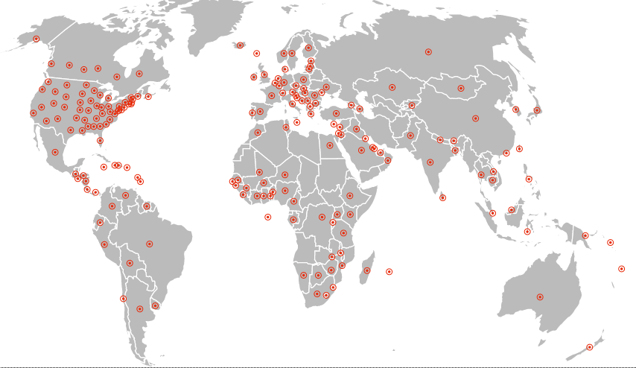
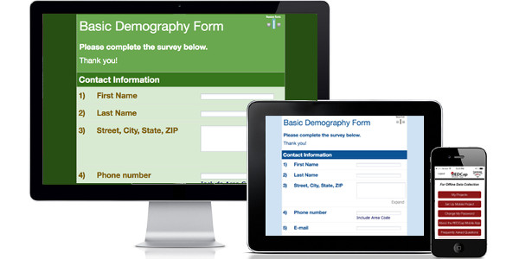
Cross platform, Mobile friendly

Features
- Build online surveys and databases quickly and securely in your browser - Create and design your project using a secure login from any device. No extra software required. Access from anywhere, at any time.
- Fast and flexible - Go from project creation to starting data collection in less than one day. Customizations and changes are possible any time, even after data collection has begun.
- Advanced instrument design features - Auto-validation, calculated fields, file uploading, branching/skip logic, and survey stop actions.
- e-Consent - Perform informed consent electronically for participants via survey.
- Diverse and flexible survey distribution options - Use a list of email addresses or phone numbers for your survey respondents and automatically contact them with personalized messages, and track who has responded. Or create a simple link for an anonymous survey for mass email mailings, to post on a website, or print on a flyer.
- REDCap Mobile App - Collect data offline using an app on a mobile device when there is no WiFi or cellular connection, and then later sync data back to the server.
- Data quality - Use field validation, branching/skip logic, and Missing Data Codes to improve and protect data quality during data entry. Open data queries to automatically identify and resolve discrepancies and other issues real-time.
- Custom reporting - Create custom searches for generating reports to view aggregate data. Identify trends with built-in basic statistics and charts.
- Export data to common analysis packages - Export your data as a PDF or as CSV data for easy analysis in SAS, Stata, R, SPSS, or Microsoft Excel.
- Secure file storage and sharing - Upload and share any type of file with anyone in the world through the File Repository feature or Send-It tool. Also works with exports and other built-in file uploading features.
- Data-based triggers and alerts - Send real-time alerts and notifications to your team or other stakeholders via email, text, or phone based on certain data being entered or specific questions having a particular answer.
- Connect to other resources - Use built-in features (API) to move data to/from your project. Build your own custom software development features to connect your project to other systems.

- Getting Started
Objective: Access REDCap, get familiar with interface, project structure overview
Activity: Create new project, navigate REDCap home and setup page

Log into REDCap–

RWJMS: https://redcap.rwjms.rutgers.edu/

CINJ: https://redc.cinj.rutgers.edu/redcap/

Other: https://research.njms.rutgers.edu/redcap
    - Rutgers NetID login credentials
    - Non Rutgers local account
Get account through Redcap admin, follow email to activate account
Demo user: njacts_demo, NJacts2020

Get familiar with the user interface: Home, My Projects, +New Project, Help&FAQ, Training Videos, Messenger

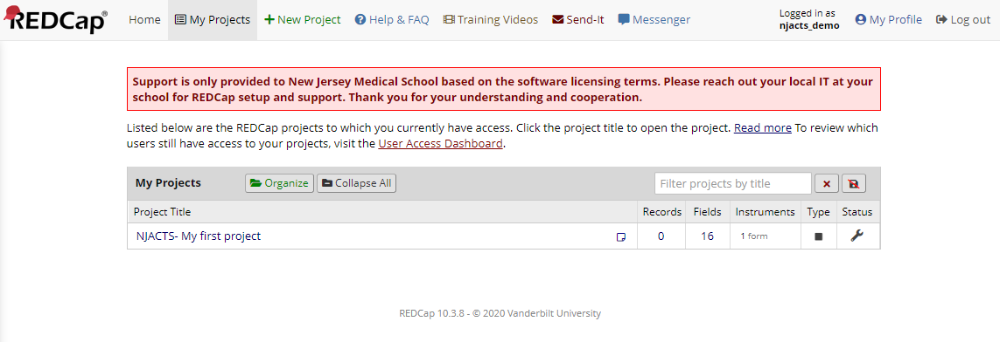

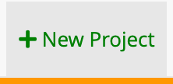
Click & select Use a template from the list

    - Templates:
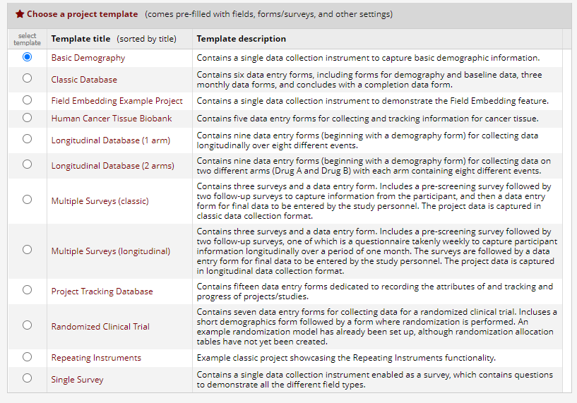
    - Project Home Page and Project Setup page
      - Top menu bar, project steps, applications menu
    - Definition: Development vs. production
- Development: build your project in this mode, create and edit forms, add users from your research team, test the project with test data
- Production: protects the collected data from being deleted or corrupted. The system warns the user if any changes to the project structure will affect the data, and will let them know exactly what changes will affect the data.

Build your project (two ways)
    - Types of projects

Classic
        - When would you use a classic project? For single time-point data collection (when you use a form once)
* Focus for today’s lesson

Longitudinal
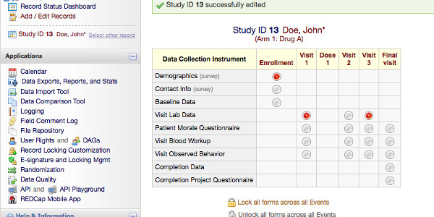
        - When would you use a longitudinal project? For many time-points data collection (when you use a form multiple times, namely forms in a longitudinal project can be completed repeatedly for a single record)

    - Type of data collection

Data entry
        - When would you use data entry? When the research team is entering data into REDCap, not participants of the research project

Surveys
        - When would you use surveys? When participants answer questionnaires or surveys about something.
        - More on this in “Building Data Collection Instrument for REDCap Survey”

Building an Instrument (Data Entry and Surveys)
Objective: Create a data collection instrument, learn how to add different field types and field components
Activity: add different field types, code answer choices

        - More on this in “Building Data Collection Instrument for REDCap Survey”

Overview of instrument creation and import options
- Online Designer – create forms online through REDCap platform
- Data Dictionary – import via Excel
- REDCap Shared Library – pre-created forms (e.g., PROMIS, etc), REDCap Shared Library is a global repository of data collection instruments that can be downloaded and used in your REDCap projects.
- Zip file – copy a form from one project to another

Instruments
    - Template instrument: Baseline Data
      - Record ID/Participant ID – located on first instrument, must be unique, links data to participant
      - Review field types: Different field type examples here (date, email, number, notes with placeholder text, checkbox with different alignment, new section, slider, image, signature)
      - Demo on screen

Create & name new instrument
    - Adding a new instrument
      - Example: ‘Test Instrument'
      - Drag instrument above Baseline Data
*notice that the record ID has moved to this form
    - Add field: short text box
      - Field label vs. variable name
      - ONE question per field
      - Naming variables (unique, easy to understand, less than 25 characters)
        - Cannot be changed once in production
      - Example: ‘Patient name’ [name]
      - Review:
        - Field annotation/action tags
        - Required
        - Identifier
        - Custom alignment – change to left horizontal
        - Field note
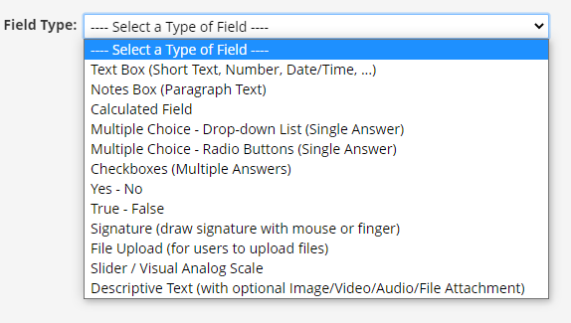
    - Field validation
      - Review validation types: Dates, Ontology (ICD-10 codes), Numbers
- Add field: ‘Visit Date’ [visit_date]
  - Add validation ‘DMY’ to Visit Date
- Add demo on screen
    - Add field: multiple choice radio buttons
      - Example: ‘Reason patient withdrew from study’ [reason_withdrew]
- Answer choices: non-compliance, could not tolerate, hospitalization, other

a. Coding answer choices – auto code
- Each answer choice must be attached to a coded number so the system can read it
- Manually code “Other” as ‘99’
**Anytime you can use categorical field types, you should.
    - Add field: checkbox
      - Review the difference between single and multiple choice options
i. Checkboxes export differently than the other field types. Each checkbox option becomes a column, and data is stored as either a "1" (checked) or as a "0" (unchecked).
      - Example: ‘What treatment has your child received so far for their condition? [treatment]
i. Answer choices: no treatment, medications, one surgery, two surgeries, don’t know (88), other (99)
    - Add a matrix
      - Can have radio buttons or checkbox options
      - Matrix group name – how REDCap knows to group all the matrix questions together
      - "Ranking" questions makes it so participants can only choose one answer per column
      - Example: Matrix Header – Concerning the past week, how do you feel about the ease of the following?
        - Matrix group name [past_week]
        - Field labels: Booking your appointment [appt]; Wait time [wait_time]; Staff friendliness [friendly_staff].
i. Answer choices: Dissatisfied, Somewhat Dissatisfied, Neutral, Satisfied, Very Satisfied
    - Add a Yes / No question
      - Auto-coded
      - Consistent coding
      - Example: ‘Has the patient been referred to this clinic?’ [clinic_referral]

Branching logic
    - Add branching logic
      - Example: create Notes box under [reason_withdrew]: “If other, please specify” [other_reason]
      - Add branching logic to this ‘dependent’ field
        - AND / OR logic – drag & drop builder
        - [reason_withdrew]=”88”
      - Use Drag & Drop builder for ease, or can type in logic with the Advanced Logic Syntax Builder

Action tags and Embedding Field

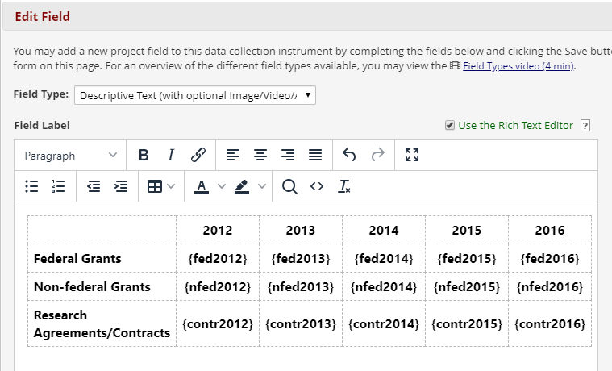

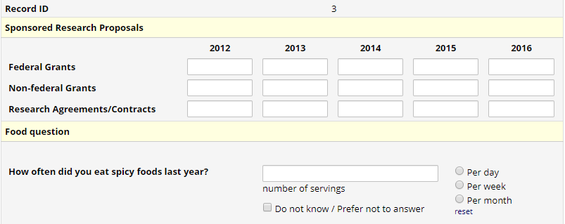

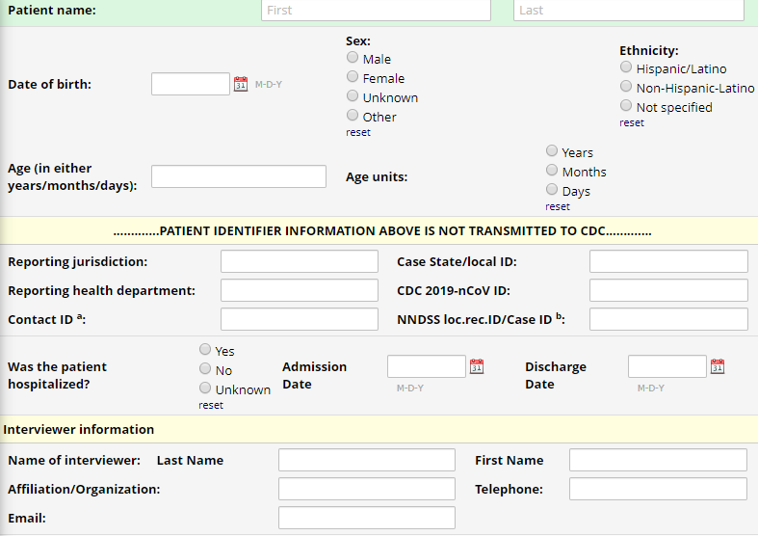

Piping
- Review applications and limitations
- Example: add short textbox field – ‘Please list medications that [name] is taking” [medication]

Calculated fields – see template instrument
- Review applications and limitations
- Example: BMI
- “How do I format the equation” resource

Review Codebook
- Variables, field labels, field attributes
- Edit field & branching logic directly from codebook

Data Collection and Project Changes
Objective: Project management, how to make changes and maintain data integrity
Activity: move to production! Collect real data.

Moving to production
    - Review development vs production
    - checklist
    - Have project move to production: from Project Setup page
      - Mention in ‘real’ REDCap, DM team moves the project and completes a checklist
      - Must delete data prior to moving to Production (or export, delete, import)
      - Only test data should be collected in Development

Collecting data
    - Auto-numbering vs custom record ID’s
    - Create records: Add / Edit Records
- Data Entry examples – review template field types, piping, branching
- Enter 3+ records into new form we created
- Form save options, history icon, comments box (and field comment log) PDF instruments
- Record 3, save and go back to change a value, show history icon

- Go over record status dashboard
- Review Action menu (rename records)
- Legend for status icons

Data Exports, Reports & Stats
    - Raw vs. labels in Export
- Download raw data, download labels
    - Export options to various statistics packages
    - Create a simple Report “Reason for withdrawal”
- Include: [visit_date], [reason_withdrew] (multiple choice), [treatment] (checkbox)
- View & run reports at any time by clicking the report name
    - User rights & exporting data

  - Making changes after data collection has started
    - Draft mode: make changes while in production without interrupting your live data entry. This is done by entering "draft mode," making the changes, and then submitting these changes.
      - Enter draft mode
- Change a field type
- Change answer choice coding
- Change a field label
      - Restrictions: in general, you can always add to a project in production. So adding a new field, a new form, or a new event causes no issues. Changing aspects of your project can cause data loss or modification. Deleting aspects of your project will lead to data loss.
    - Snapshot of data dictionary – data dictionary, version control, project revision history

End of Workshop

This is the end of the Instructional part of the workshop. The optional next half an hour will be time to explore, ask questions, and learn about more features if there is interest.

Reminders and Recap

Applications – brief overview
    - Applications workplace is mainly for Project Management tasks
    - User Rights
    - Logging
    - File Repository

Data Quality, Longitudinal Module, Repeating Module

Recap
- “Start from the end” - what is your objective and do you have the right questions to get there? Has the workflow been planned, how to register participants, how to consent them, collect email addresses to send them surveys, etc.?

