TEACHERS’ EXPERIENCES IN A CRITICAL FRIENDS GROUP:
A FOCUS ON STUDENT WRITING
By
Erin Comollo
A dissertation submitted to the
Graduate School of Education
Rutgers, The State University of New Jersey
in partial fulfillment of the requirements
for the degree of
Doctor of Education
Graduate Program in Teacher Leadership
written under the direction of
________________________
Alisa Belzer, Dissertation Chair
________________________
Melinda Mangin, Committee
________________________
Tali Axelrod, Committee
New Brunswick, New Jersey
May 2019

Abstract
A growing body of literature on teacher learning highlights that teachers are not likely to change their practices as a result of participating in traditional one-shot conference and workshop professional development activities, and suggests that a more effective approach is a teacher-driven, situated, collaborative, and sustained one (Ball & Cohen, 1999; Brown et al., 1995; Bruce, 2010; Burke, 2013; Cochran Smith & Lytle, 1999; Little, 2002; Nelson, Slavit, Perkins, & Hathorn, 2008; Putnam & Borko, 2000; Newmann, Smith, Allensworth, & Bryk, 2001; Smith, Hofer, Gillespie, Solomon, & Rowe, 2008; Wood, 2007). Research shows that Critical Friends Groups (CFG) can be an effective way to enact this type of professional development (Bambino, 2002; Baskerville & Goldblatt, 2009; Curry, 2008; Dunne et al., 2000; Kember et al., 1997; Swaffield, 2004, 2005).
As a first grade teacher, I was aware that my colleagues and I had few meaningful opportunities to learn with and from each other. Therefore, I sought to introduce Critical Friends Groups in order to understand how elementary teachers in an independent school experienced research-based professional development focused on writing instruction. The three products in this paper reflect the outcomes and challenges relating to the implementation of a CFG in a school that previously had not used this form of professional development. First, in an article written for publication in a practitioner journal, I detail the CFG processes that supported changes to teachers’ practices and community and collegial benefits that occurred as a result of participating in a CFG focused on student writing. Next, I present teacher training sessions to describe how the CFG implementation process and the factors that influenced the implementation in order to help teachers consider how to drive their own change efforts forward within their school contexts. Finally, a facilitator’s handbook describes the roles, responsibilities, challenges, and possible solutions that are required in order to be an effective CFG facilitator.

Dedication
I dedicate this dissertation to my mother, Kathleen “Casey” Santye. Your life taught me how to live with integrity, faith, resilience, and most of all, love. I hope I have made you proud.

Acknowledgements
First, I would like to acknowledge and thank my incredible chair, Dr. Alisa Belzer for sticking with me all these years. I am so grateful for your patience and wisdom throughout this process. I am a better teacher, leader, writer, and researcher because of you. Dr. Melinda Mangin, thank you for your warmth and guidance throughout the program. Our office hour conversations during my independent study helped me find my voice as a writer and as a leader. Dr. Tali Axelrod, I appreciate the time you gave towards reading and reviewing my work and for agreeing to join my committee during the home stretch.
To the incredible community at my participating school, your enthusiasm for my work made my research easy and rewarding. I have never met such passionate, dedicated, and caring educators. Your willingness to go above and beyond for your students is unparalleled. The world is a better place because of your influence on its children. I feel lucky to know you and to have worked with you.
To my family and husband, Drew, thank you for always supporting all of my endeavors – big and small. Whether it was lending a listening ear, putting life on hold, or simply encouraging me to keep moving forward, I could not have accomplished this without you.

Table of Contents
Abstract i
Dedication iii
Acknowledgements iv
Chapter 1: Introduction to the Study 7
Problem of Practice 13
Research Questions 16
Dissertation Description 17
Chapter 2: Practitioner Article: Care, Community, and Change: Teachers’ Experiences in a Critical Friends Group Focused on Student Writing 24
Abstract 25
Introduction 27
Research Design 28
Findings 34
Discussion and Implications 50
Conclusion 56
References 52
Chapter 3: Critical Friends Group Implementation Presentation and Materials 65
Presentation Slides and Notes 68
Participant Handbook 123
References 139
Chapter 4: Critical Friends Facilitator Handbook and Materials 144
Appendix 201
References 211
Chapter 5: Conclusion 218

Chapter 1: Introduction
Since the adoption of policies such as No Child Left Behind and more recently, the Common Core State Standards (CCSS) for ELA and Mathematics (Common Core State Standards: Development Process, 2015), approaches to teaching and learning have shifted to meet the high standards demanded by federal and state governments. In response, researched and identified best practices in teacher professional development have been put in the spotlight to ensure teachers have in-depth content knowledge, are equipped to deliver high quality instruction, and can utilize the results of student and teacher data to inform, improve, and implement new approaches to instruction and assessment.
Unfortunately, most teachers’ professional learning experiences are generally poor, comprised of “a patchwork of opportunities – formal and informal, mandatory and voluntary, serendipitous and planned – stitched together into a fragmented and incoherent ‘curriculum’” (Ball & Cohen, 1999 as cited by Wilson & Berne, p. 173). Often, teachers’ learning comes in the form of “one and done” workshops, where teachers are expected to learn from a “sage on a stage” often in a session of brief duration, not long enough to make an impact on practices (Bruce, Esmonde, Ross, Dookie, & Beatty, 2010; Garet, Porter, Desimone, Birman, & Yoon, 2001; Wilson & Berne, 1999). This approach to instruction typically focuses on teacher-centered instruction, is concept-centered, and is de-contextualized from the school culture, colleagues, and students each teacher is working with, despite research that advocates for learner-centered environments that “build upon strengths, interests, and needs of the learners” (Bransford, 2000, p. 192; Bruce et al., 2010; Wilson & Berne, 1999). These typical professional development conditions make it challenging for teachers to successfully use what, if anything, they have learned, especially when they lack sustained guidance and feedback if they try out new practices (Bransford, 2000; Garet et al., 2001).
Much of the literature on teacher learning does confirm that teachers are not learning much through the traditional one-shot conference and workshop approach to professional development, and suggests that a more effective approach is a teacher-driven, situated, collaborative, and sustained one (Ball & Cohen, 1999; Brown et al., 1995; Bruce, 2010; Burke, 2013; Cochran Smith & Lytle, 1999; Little, 2002; Nelson, Slavit, Perkins, & Hathorn, 2008; Putnam & Borko, 2000; Newmann, Smith, Allensworth, & Bryk, 2001; Smith, Hofer, Gillespie, Solomon, & Rowe, 2008; Wood, 2007). This research demonstrates that situating learning within teachers’ schools and classrooms provides teachers with the opportunity to collaboratively problem solve authentic problems of practice, ensures the learning is sustained over time, and distributes the learning across an organization (Cochran-Smith & Lytle, 1999; Garet et al., 2001; Wilson & Berne, 1999; Wood, 2007). For teachers, when learning is situated within their own schools and with their own colleagues, their work can be contextualized, job-embedded, relevant, and aligned coherently with their current work and that of their colleagues (Ball & Cohen, 1999; Putnam & Borko, 2000). Teachers, alongside their colleagues, are able to problem solve as practitioners working on authentic teacher activities, the ordinary practices of their school culture, in order to develop strategies and solutions to their actual problems of practice (Brown et al., 1995).
When teachers have time and supportive structures to talk to each other in meaningful ways about substantive issues of practice, they can learn from one another’s experiences and expertise, construct new knowledge that can transform practice, and potentially, shift a school learning culture from a content-centered approach to one that encourages a deeper understanding of problems of practice (Burke, 2013; Cochran-Smith & Lytle, 1999; Putnam & Borko, 2000). This approach to learning is undergirded by an inquiry-based conception of professional development where teachers “engage in joint construction of knowledge through conversation and other forms of collaborative analysis and interpretation” (Cochran-Smith & Lytle, 1999, p. 294). Cochran-Smith and Lytle (1999) conceptualize this generative form of knowledge as “knowledge-of-practice,” where all teachers, novice and veteran alike, are assumed to have the capacity to contribute towards building new knowledge relevant to addressing their problems of practice. Teachers begin to see themselves as part of a community of learners as they collaboratively deprivatize their practice, improve the substance and quality of collegial dialogue, building their collective capacity to improve and change practice as (Franke et al., 2005; Little, 2012).
Teachers’ ability to learn, communicate, and problem solve are enhanced by the use of artifacts and tools that help generate and distribute their knowledge and learning within the school community (Nelson et al., 2008; Putnam & Borko, 2000). Examples of artifacts include student and teacher work. Student work that can be used to highlight a particular problem or dilemma includes writing samples, assessments, student portfolios, and observation notes of their interactions in the classroom. Rather than relying on self-reported descriptions of student learning, teachers use artifacts to serve as evidence of what children “do, say, and produce in the course of everyday instruction” (Little, 2012, p. 9). When they do so, they provide teachers with the opportunity to look deeply at authentic examples of students’ actual learning and thinking. Additionally, teacher work such as lesson plans, assessments, and observed or videotaped lessons can also be used for practice-related inquiry, making visible what is often invisible in day-to-day practice. Similar to the way in which student work creates a common learning focus, the use of tools such as conversation protocols help foster a collaborative, shared learning experience (Little, 2012; Nelson, et al., 2008; Wood, 2007).
While the collaborative, situated approach to teacher learning clearly has advantages for learning, the factor predicting whether learning will actually be retained and acted upon is sustainability. When learning experiences are longer in duration, and a series of those experiences are held with intensity and regularity over time, teacher learning is positively impacted (Garet et al., 2001; Little, 2012; Newmann et al., 2001; Smith et al., 2008). Sustained learning experiences provide multiple opportunities for teachers to engage in collegial dialogue that promotes alignment and coherence between their goals and experiences, content areas, and standards (Little, 2012). The more time devoted to teacher learning, the more chances there are for teachers to participate in demonstrations, observations, classroom implementation, reflection, collaborative problem solving, and knowledge generation--the kinds of professional development that can lead to long term change and improvement (Bruce et al., 2010). While it takes time to grow and develop a professional community that can support collaborative, meaningful learning, the value of professional development that has scope and depth should not be underestimated in its impact on teacher learning (Feinman-Nemser, 2001).
While there is still a need for more research that looks at the causal relationship (versus correlational) between teacher learning and improved student achievement, it seems likely that by improving teachers’ learning experiences, positive changes can be anticipated in instruction and teacher practice. With the growing understanding that effective professional development can positively affect teacher quality, more research is surfacing on different enactments of effective professional development, including different approaches to teacher learning communities. There are varying conceptions and definitions of teacher learning communities that have evolved through the years. For the purposes of this study, I will focus specifically on Critical Friends Groups as one example because it is the approach I used for this study.
A growing number of studies are finding that Critical Friends Groups (CFGs) can be an effective approach to support teacher learning because they are situated, sustained, and collaborative (Bambino, 2002; Baskerville & Goldblatt, 2009; Curry, 2008; Dunne et al., 2000; Kember et al., 1997; Swaffield, 2004, 2005). According to the National School Reform Faculty (NSRF), founded by the Annenberg Institute for School Reform in 1995 to support the development of and training for CFG facilitators, CFGs are defined as “5-12 members who commit to improving their practice through collaborative learning and structured interactions (protocols), and meet at least once a month for about two hours” (NSRF, n.d.) and can include coaches, administrators, and teachers who individually and collaboratively reflect on student work, as well as their own work, as a way to improve practice and reach student learning goals. Since NSRF developed the CFG training program, more than 1,000 CFG coaches who work in 700 schools have been trained (Dunne et al., 2000).
In CFGs, participants are trained to be more than simply congenial friends or colleagues; they become “critical friends.” There are many definitions of this term; however, the most cited and referred to definition comes from Costa and Kallick (1993) who explained that “a critical friend is a trusted person who asks provocative questions, provides data to be examined through another lens, and offers critique of a person’s work as a friend. A critical friend takes the time to fully understand the context of the work presented and the outcomes that the person or group is working toward. The friend is an advocate for the success of that work” (p. 50). CFGs ask teachers “to construct their own learning through a repeating cycle of inquiry, reflection, and action” (Curry, 2008, p. 736) with the goal of increasing and improving student learning through evolving teacher practices. CFG facilitators use conversation protocols to guide discussions and provide a common, collegial language and work format for participants to do problem solving, peer observations, goal creation and setting, and analyses of teacher and student work with a constant focus on improving student learning.
While the body of research focused specifically on CFGs is fairly limited and largely descriptive, researchers have found that participation in professional development reflecting characteristics similar to CFGs increased new knowledge through the process of critical discussion and questioning developed shared understandings of teaching and learning, students, content, and contexts; increased collaboration and improved collegial relationships; increased knowledge about new best practices; and increased participants’ willingness to change their practices (Burke, et al., 2001; Curry, 2008; Dunne et al., 2000; Nelson, 2005; Nelson, 2009; Williams, 2012). Teachers reported the factors that contributed towards these outcomes were the continual, sustained work aimed at improving practice, and the systematic and collaborative collegial interaction that are typical of CFGs (Dunne et al., 2000).
Developing trust between critical friends is key to the success of the group, and yet it is one of the greatest challenges of implementing successful CFGs (Bambino, 2002; Dunne, 2000; Kember, 1997; Kersey, 2014; Kuh, 2015; Swaffield, 2004). CFG procedures that focus on description and understanding as a means to develop implications for practices rather than evaluation are designed to build a trustworthy learning environment (Selkrig, 2015). Trust is also established through team-building activities, a sense of shared responsibility towards student learning, as well as time given for critical friends to gain an understanding of each other’s contexts, purposes, and use of data shared during the meetings (Bambino, 2002; Dunne, 2000; Kember, 1997; Swaffield, 2004). Once trust is established, teachers are more likely to collaborate openly and honestly with one another, one of the most important aspects of CFGs and a cornerstone of all teacher learning communities. Trust is a necessary component for people to be able to give and receive meaningful, substantive feedback, to be willing to share their challenges, and deprivatize their classrooms. Without trust, none of the potential benefits are possible (Bambino, 2002; Dunne et al., 2000; Storey & Richard, 2015; Swaffield, 2004).
Problem of Practice
Far Brook School, the site for this study, is an independent school with a professional development budget the size of which most public schools would be envious. However, teacher learning opportunities adhere to the traditional “one and done” workshop approach. Typically, teachers are sent out to learn about a topic from an expert and are then expected to come back to implement and share their learning; however, meaningful sharing and follow-through are rare. Instead, meeting time for faculty is typically spent on announcements, personal or emotional reflections, or unproductive discussions about challenging students; there is little structure or conclusive, actionable information for teacher practice disseminated or generated. Despite the co-teaching model practiced in the school, which could facilitate collaborative professional learning, co-teachers’ and their associates’ communication generally consists of quick, informal, and spontaneous interactions. Time during the day when teachers could speak collegially with each other about teaching and learning is limited because they attend lunch with their students and prep periods are consumed by communicating with parents or student support services such as occupational therapists, tutors, reading specialists, etc. With only one class per grade level, teachers lack the support of additional grade level team colleagues, and there is no across grade common planning time. As a result, there are no structures and very limited time to encourage or help teachers reflect on, raise questions about, or generate thoughtful solutions to challenges in their classroom practices. Additionally, in the absence of a consistent teacher evaluation system, there is a lack of peer or supervisory feedback. Even communication with instructional support staff, such as the reading and learning specialists, is rare. These circumstances are likely to contribute to feelings of isolation, and teachers are left without the guidance or skills to communicate and work together collegially.
Consequently, teaching is done “the way it’s always been done,” without supports directing teachers’ attention to raise meaningful questions about problems of practice, individual student learning needs, or collaborative problem solving, despite the fact that Far Brook prides itself on its progressive, child-centered curriculum. In the absence of any structures or staff such as team leaders, teacher leaders, or instructional coaches to provide relevant teacher learning, feedback, and reflection, teachers find themselves lacking confidence in their ability to deliver quality and individualized learning programs to their students (Tschannen-Moran & McMaster, 2009). As a result, there is strong need for teachers to learn how to learn with and from one another. Based on the literature, and on my own CFG experience, I saw CFGs as a promising practice that could address this need if implemented at Far Brook.
Despite the fact that Far Brook is an independent school and, as such, is not required to adhere to the CCSS or meet other specific testing benchmarks, it is not immune to the intended and unintended outcomes of educational reform, such as changes in curriculum and demanding expectations, which are expressed via accreditation processes for independent schools. Far Brook is committed to staying current on best practices, as well as ensuring that its curriculum is competitive with its peer schools. One example of this is its adoption of the widely acclaimed, research-based Teachers College Reading and Writing curriculum. Founded by Lucy Calkins, The Robinson Professor of Children’s Literature at Teachers College, The Teachers College Reading and Writing Project (TCRWP) was developed to support a literacy curriculum that is “student-centered, responsive, assessment-based instruction [with a] moral imperative to accelerate students’ development as readers and writers, and to help schools maintain a laser-like focus on improving teaching and learning” (“History: Teachers College Columbia University,” n.d.). Over 170,000 teachers have attended their weeklong literacy conferences to learn how to implement its approach to teaching literacy effectively in a data-based school culture (“History: Teachers College Columbia University,” n.d.).
While many teachers from Far Brook have attended these weeklong institutes and workshops, the Teachers College writing instruction and assessment approaches were loosely enacted, if at all, and the quality was inconsistent across the school. Not only do teachers at Far Brook lack a strong understanding of the writing curriculum and an idea of its progression, they do not have the time to examine or communicate about their students’ work to see if progress is actually occurring. As a first grade teacher there, I was aware that my colleagues and I have many learning needs, such as how to effectively implement new and changing curricula, but have few meaningful opportunities to deepen our understanding of the writing curriculum after attending the TC workshops and no opportunities to learn with and from each other. With this understanding, as well as a suggestion from the administration, writing instruction was chosen as the primary topic for the Critical Friends Group.
The purpose of this case study was to understand how a Critical Friends Group (CFG) consisting of elementary teachers in an independent school experienced professional learning conversations focused on writing instruction. The study also examined how participation in the CFG influenced teachers’ practices and their interactions with one another, and how their participation in the CFG impacted their feelings about teaching. Experiences were interpreted based on analysis of video recording transcripts and field notes of the meetings, anonymous teacher reflection documents written at the end of every meeting, transcripts of semi-structured interview conducted at the end of the school year, and field notes from “one-legged” interviews (Hall & Hord, 2001) with participants during and after the CFG implementation.
Research Questions
The research question guiding this study were:
How do Far Brook School elementary teachers experience participation in a CFG which focuses on improving writing instruction? The following subquestions helped deepen and focus understanding of answers to this question:
a. In what ways does participation in the CFG influences teachers’ practices in the classroom?
b. How does teachers’ participation in the CFG influence the ways in which they interact with each other within the CFG?
c. In what ways does teachers’ participation in the CFG impact their feelings about teaching?
By examining what teachers’ experiences are when participating in CFGs, and consequently, how their practices, interactions with one another, and feelings about teaching are influenced by their participation, I intended to use what I learned, assuming the outcomes were positive, to help me make a case with the school administration to support school-wide, ongoing, high quality professional development as operationalized through CFGs. A limited quantity of research has been conducted on CFGs specifically (Burke, et al., 2001; Curry, 2008; Dunne et al., 2000; Williams, 2012), and this study can also contribute to the growing body of research describing what CFGs look like in action, what impact they can have on participants, and understanding ways to effectively initiate and sustain them.
Description of Dissertation
Together, the three products that were produced as a result of this study-- a practitioner journal article, a presentation intended for professional development for teacher leaders and administrators, and a CFG facilitator handbook-- fully encompass the traditional standards and requirements of a dissertation by providing reviews of relevant literature, as well as descriptions of data collection and data analysis methods in both practical and professional ways. Linking the findings, recommendations and implications from my study served as a practical way to communicate my results, and hopefully, foster positive change in teacher professional development. Each product was different in its format and content: the practitioner article focused on a teacher audience, describing the outcomes of using CFGs as an approach to improve writing instruction; the presentation series, aimed towards teacher leaders and administrators, outlined and described the elements of the organizational change process when implementing a research-based approach to professional development in a school that previously lacked one; finally, the handbook focused on providing potential CFG facilitators with the understandings, skills, and tools needed to facilitate an effective CFG in their school.
Practitioner Article. The first piece in my dissertation is an article aimed at a practitioner audience to be submitted for publication in a journal such as Teaching and Teacher Education. This article described the outcomes of teachers participating in a Critical Friends Group (CFG) that focused on improving writing instruction. Teaching and Teacher Education was selected as a potential outlet for this work for two reasons: 1) it reaches an audience of classroom teachers and teacher leaders who would potentially be interested in using this approach to professional development in general or to improve writing instruction specifically and 2) because of its aim to “enhance theory, research, and practice in teaching and teacher education through the publication of primary research and review papers” (Teaching and Teacher Education, 2017). The literature included in the article briefly describes best practices in supporting teacher learning, the characteristics of CFGs, and the benefits of using them as an approach to teacher professional development. The majority of the article provides the context of the study to give readers an understanding of what the teachers learned and most importantly, how they learned it. This includes how the research was conducted, descriptions of the sessions’ contents, and findings that focus on what structures supported successful teacher learning and what the teacher learning and community outcomes were. Finally, it includes implications that would be informative to other school and teacher leaders wanting to implement CFGs with the goal of improving teacher practice.
Critical Friends Group Implementation Presentation and Materials. The second piece of my dissertation is a five-part presentation series focused on the process of implementing CFGs. Situating characteristics of change through the context of my study, participants are asked to reflect, investigate, and problem solve their own CFG implementation process in their own school context using conversation and thinking protocols. The first part of the presentation provides an introduction and overview of CFGs and their theoretical frameworks. The next session provides an overview of the factors that support successful change implementation. The remaining sessions of the presentation draw upon the literature regarding Fullan’s (2006) stages of change contextualized through my CFG. These underpinnings are instrumental in supporting the audience’s understanding of how to implement a process of improving professional development in their own environments. This product differs from the article in that it will address the question: when you plant the seed of high quality teacher learning, what happens next?
A Critical Friends Group Facilitator Handbook. The final piece of my dissertation is a “Critical Friends Group Facilitator Handbook” which outlines the goals and role of a CFG facilitator, whether in a formal or informal role. This product differs from the first two in that the purpose of the handbook is to give facilitators an understanding of their role in CFGs, CFGs’ purpose and benefits, and consequently, the skills and tools needed to help support consistent, thoughtful, and effective teacher learning opportunities to their colleagues. I use the methods, experience, and results of my own study to guide facilitators in how to conduct CFGs that lead to successful teacher learning. The handbook begins with a brief introduction to the relevant research literature, a short description of my study’s conclusions, and the purpose for the handbook. Next, it takes facilitators through the strategies, resources, potential challenges (“Bends in the Road”), and possible solutions that should be considered when planning, facilitating, and sustaining successful CFG sessions. Sample conversation protocols are included in the handbook as well as a list of suggested items that can be used as data during conversations to highlight how their use led to intended and unintended outcomes in our school. These outcomes include changes in teacher practice, improved feelings of productivity, efficacy, morale, and respect among colleagues.
It is my hope that these three products will go beyond the scope of my school and colleagues, and will contribute to the broader education community in re-thinking the what and the how of effective opportunities for teacher learning and professional development.

References
Ball, D., & Cohen, D. (1999). Developing practice, developing practitioners: Toward a practice-based theory of professional education. Teaching as the Learning Profession. San Francisco: Jossey-Bass.
Bambino, D. (2002). Critical friends. Educational leadership, 59(6), 25-27.
Baskerville, D., Goldblatt, H., & Ccje, F. (2009). Learning to be a critical friend: from professional indifference through challenge to unguarded conversations. Cambridge Journal of Education, 39(2), 205–221.
Bransford, J. D., Brown, A. L., & Cocking, R. R. (2000). How people learn: Brain, mind, experience, and school. Washington DC: National Academies Press.
Brown, J. S., Collins, A., & Duguid, P. (1995). Situated cognition and the culture of learning. Educational Researcher, 18(1), 32-42.
Bruce, C., Esmonde, I., Ross, J., Dookie, L., & Beatty, R. (2010). The effects of sustained classroom-embedded teacher professional learning on teacher efficacy and related student achievement. Teaching and Teacher Education, 26(8), 1598–1608. doi:10.1016/j.tate.2010.06.011
Burke, B. (2013). Experiential professional development: A model for meaningful and long-lasting change in classrooms. Journal of Experiential Education, 36(3), 247–263. Retrieved from https://sakai.rutgers.edu/access/content/group/03bdb334-44c6-42a4-8687-8e3ecbd9333d/Week 8/Burke.pdf
Burke, W., Marx, G. E., & Berry, J. E. (2011). Maintaining, reframing, and disrupting traditional expectations and outcomes for professional development with critical friends groups. Teacher Educator, 46(1), 32–52.
Cochran-Smith, M., & Lytle, S. L. (1999). Relationships of knowledge and practice: Teacher learning in communities. Review of Research in Education, 24(1), 249–305. doi:10.3102/0091732X024001249
Common Core State Standards: Development Process. (2015). Retrieved June 30, 2015, from http://www.corestandards.org/about-the-standards/development-process/
Costa, A. L., & Kallick, B. (1993). Through the lens of a critical friend. Educational Leadership, 51(2), 49. doi:10.1007/s00115-010-3170-x
Curry, M. (2008). Critical friends groups: The possibilities and limitations embedded in teacher professional communities aimed at instructional improvement and school reform. The Teachers College Record, 110(4), 733-774.
Dunne, F., Nave, B., & Lewis, A. (2000). Critical friends groups: Teachers helping teachers to improve student learning. Phi Delta Kappan, 28(4), 31-37.
Feiman-Nemser, S. (2001). From preparation to practice: Designing a continuum to strengthen and sustain teaching. Teachers College Record, 103(6), 1013–1055. doi:10.1111/0161-4681.00141
Garet, M. S., Porter, a. C., Desimone, L., Birman, B. F., & Yoon, K. S. (2001). What makes professional development effective? Results from a national sample of teachers. American Educational Research Journal, 38(4), 915–945. doi:10.3102/00028312038004915
Hall, G.E., Hord, S.M. (2011, 3rd Ed.) Implementing change: Patterns, principles, and potholes. Boston: Allyn & Bacon. ISBN-13: 978-0137010271.
History: Teachers College Columbia University. (n.d.). Retrieved from https://www.tc.columbia.edu/tisch/about-us/history/
Kember, D., Ha, T. S., Lam, B. H., Lee, A., NG, S., Yan, L., & Yum, J. C. (1997). The diverse role of the critical friend in supporting educational action research projects. Educational Action Research, 5(3), 463-481.
Kersey, Shannon. Building community in schools: Narratives of possibilities and limitations in critical friends groups. (Doctoral dissertation), Georgia State University, 2014.
Kuh, L. P. (2015). Teachers talking about teaching and school: Collaboration and reflective practice via critical friends groups. Teachers and Teaching, 0602(March), 1–22.
Little, J. W. (2012). Professional community and professional development in the learning-centered school. In Teacher learning that matters (pp. 42-64). London: Routledge.
Nelson, T. (2009). Teachers’ collaborative inquiry and professional growth: Should we be optimistic? Science Education, 93, 548–580. doi:10.1002/sce.20302
Nelson, T., Slavit, D., Perkins, M., & Hathorn, T. (2008). A culture of collaborative inquiry: Learning to develop and support professional learning communities. Teachers College Record, 110(6), 1269–1303. Retrieved from http://www.tcrecord.org/Content.asp?ContentID=14745
Newmann, F. M., Smith, B., Allensworth, E., & Bryk, A. S. (2001). Instructional program coherence: What it is and why it should guide school improvement policy. Educational Evaluation and Policy Analysis, 23(4), 297–321. doi:10.3102/01623737023004297
Putnam, R. T., & Borko, H. (2000). What do new views of knowledge and thinking have to say about research on teacher learning? Educational Researcher, 29(1), 4–15. doi:10.3102/0013189X029001004
Selkrig, M., & Keamy, K. (2015). Promoting a willingness to wonder: Moving from congenial to collegial conversations that encourage deep and critical reflection for teacher educators. Teachers and Teaching, 21(4), 421-436.
Teachers College Reading and Writing Project. (2014). Our History. Retrieved 2018, from https://readingandwritingproject.org/about/history
Tschannen-Moran, M., & McMaster, P. (2009). Sources of self-efficacy: Four professional development formats and their relationship to self-efficacy and implementation of a new teaching strategy. The Elementary School Journal, 110(2), 228–245.
Williams, T. (2009). Critical friends groups: Building teacher capacity through collaboration in a professional learning community. (Doctoral dissertation), Trevecca Nazerene University, 2012.
Wilson, S. M., & Berne, J. (1999). Chapter 6: Teacher learning and the acquisition of professional knowledge: An examination of research on contemporary professional development. Review of Research in Education, 24(1), 173–209. doi:10.3102/0091732X024001173
Wood, D. R. (2007). Professional learning communities: Teachers, knowledge, and knowing. Theory into Practice, 46(4), 281-290.

Chapter Two: Practitioner Article for Teachers College Record

CARE, COMMUNITY, AND CHANGE:

TEACHERS’ EXPERIENCES IN A CRITICAL FRIENDS GROUP FOCUSED ON STUDENT WRITING
Erin Comollo
Rutgers University
2018

Abstract
This case study examined how participants in a Critical Friends Group (CFG) consisting of elementary teachers in an independent school experienced professional learning conversations focused on writing instruction. The conversations were characterized by Earl and Timperley’s (2008) components of evidence-informed conversations--having an inquiry habit of mind, using relevant data, and cultivating relationships based on respect and challenge--to encourage productive professional conversations about writing instruction. Using structured conversation protocols and a writing assessment rubric to analyze and examine student writing across grade levels, teachers reflected on and revised their approaches and beliefs about writing instruction over multiple sessions. Analysis of field notes and observations of CFG meetings and individual, open-ended interviews with participants indicate that conversation protocols created norms, routines, and prompts to guide and structure purposeful collaboration, and the writing assessment text provided a lens through which teachers were guided in their analysis of student work. This resulted in changes to teacher practice and community and collegial benefits such as shared and distributed learning, emotional validation, and positive regard for a new way to approach professional learning. These findings are significant, because while there is growing research on CFGs, this particular study provides a narrative description of a variant to a CFG in its use of a shared professional text to support teachers’ inquiry. The findings point to ways in which CFGs can be used to enhance teacher learning, encourage changes in practice, and influence school culture.
Keywords
Teacher professional development
Professional learning communities
Critical friends groups
Writing instruction
Assessment rubrics
Teacher leadership
Protocols

Introduction
An approach to teacher learning that has been found to be effective is the teacher learning community (TLC) model. Teacher learning communities are a collaborative, situated approach to professional development in which teachers work together to problem solve, create new practices, and consult each other on problems of practice that are situated in their daily work as educators. The goal is to improve student achievement by identifying and articulating strategies for improvement, assessing the impact of those strategies, and continuously focusing on, designing, and evaluating improvement efforts (Bolam et al., 2005; Day, 1999; Levine, 2011; Little, 2012; Wood, 2007). When doing so with an inquiry-based approach to learning, teachers construct new knowledge through the process of critical discussion and questioning, developing shared understandings of teaching and learning, students, content, and contexts (Nelson, 2005; Nelson, 2009). Collaborative reflection and critique of teaching practices and student learning are part of the inquiry process, as teachers use their combined experiences and knowledge to examine and question problems of practice (Putnam & Borko, 2000).
Teacher learning communities are enacted in various ways, going by different names such as professional learning communities (PLCs), teacher research groups, teacher study groups, and critical friends groups (CFG). Despite the differences across each of these, they all approach professional development through teacher-driven, collaborative, ongoing, data-driven learning activities focusing on improving teacher practice and, as a result, student achievement.
The study described here focused on one type of teacher learning community: a critical friends group (CFG). First popularized in education in 1990s by the National School Reform Faculty (NSRF), CFGs ask teachers “to construct their own learning through a cycle of inquiry, reflection, and action” (Curry, 2008, p. 736). As a practitioner-driven professional learning experience, CFGs rely on participating teachers to share, generate, and co-construct their knowledge, experience, and expertise with the goal of increasing and improving student learning through evolving teacher practices. This approach to professional development was used for this study because it is aligned with best practices in teacher learning as well as with the community-centered culture of Far Brook School, the site where it was conducted. It was also chosen because of its contrast with the school culture. At the time, professional development at Far Brook consisted of the following practices: sending teachers out for workshops, bringing in an expert to conduct one-shot professional development sessions, and multiple faculty meetings a week. The meeting culture was very loose; meetings lacked agendas, structure, focus, and action driven, learning-centered conversations centered on the challenges teachers faced in their day-to-day work. Rarely was a topic sustained over time, and there was little or no follow up to any discussions that took place. Through CFGs, I sought to introduce an alternative: an on-going, teacher-driven, inquiry-based approach to the school that was grounded in PD best practices.
The purpose of this case study was to understand how participants in a Critical Friends Group (CFG), consisting of elementary teachers in an independent school who had had no school-based experiences with this PD approach, experienced professional learning conversations focused on writing instruction. The research questions guiding this study were: How do Far Brook School elementary teachers experience participation in a CFG which focuses on improving writing instruction? In what ways does participation in the CFG influence teachers’ practices in the classroom?

Research Design
A qualitative case study approach was used to understand the experiences of teachers who participated in a newly initiated CFG focused on improving writing instruction at Far Brook School. A case study was the most appropriate design because I was interested in understanding a particular phenomenon over time within a specific context (Creswell, 2007; Patton, 1990). In this case, I sought to understand the experiences of a specific group of teachers within their school context as they participated in the CFG approach to professional development, which they had not experienced previously. Specifically, I was interested in examining what teachers reported about how their participation in the CFG influenced their practices as learners and teachers. In order to get a holistic understanding of this bounded system, I used multiple sources of evidence such as interviews, observations, and transcripts meeting videos to develop an in-depth description of the CFG meetings (Creswell, 2007). My case study enabled me to explore emerging topics, issues, and themes relating to the participating teachers’ experiences.
Research Site
Far Brook School is a Pre-K through eighth grade progressive, independent school serving approximately 233 students, 40% of whom are students of color (“Far Brook at a Glance,” n.d.). The student population of the school consists primarily of children from upper-middle class families; most parents have white-collar jobs. Far Brook is located in Short Hills, New Jersey, which was recently named by Time.com as the richest town in America. The school was founded in 1948 and prides itself on its long standing traditions and its commitment to the arts. It is led by a Head of School and two divisional heads. There are approximately 37 full and part-time faculty members including classroom teachers, associate teachers, and special area teachers.
Participants
The purposive sample of participating faculty was identified through specific selection criteria because I wanted to collect data in a specific setting (Merriam, 2009) with first through third grade co-teachers and their associate teachers. This group was chosen because they were not consistently using curriculum or assessment tools to assess and plan their writing instruction. Additionally, Nursery, Kindergarten, and Specials area teachers were invited to participate or observe voluntarily. Each meeting was attended by an average of seven (out of eight) participants, most regularly by first and second grade teachers. Attendance was spottier for others due to a teacher who went on maternity leave in third grade, and competing priorities for others.
Table 1
Participant Information
Name | Role | Years of Experience | # Meetings Attended
Gabriella | Kindergarten Associate Teacher | < 3 years teaching | 1
Jennifer | First Grade Teacher | 11 years teaching, 6 years in education policy | 6
Margaret | First Grade Associate Teacher | < 1 year teaching | 6
Morgan | Second Grade Teacher | 16 years teaching | 5
Joy | Second Grade Teacher | 29 years teaching | 5
Julie | Second Grade Associate Teacher, Graduate Student at Teachers College, Columbia University | 10 years teaching | 1
Marissa | Third Grade Teacher, returned mid-year from maternity leave | 16 years teaching | 4
Maria | Third Grade Teacher |  | 6
*Kathy | Fourth Grade Teacher | 3 years teaching | 1
*Leah | Fifth Grade Teacher | 5 years teaching | 1
*Alan | Fifth Grade Associate Teacher | 1 year teaching | 1
Elizabeth | Resource Room Teacher | 30 years teaching | 5
Pamela | Lower School Director | 43 years combined teaching and in administration | 4
*Natalie | Lower School Art Teacher | 30 years teaching | 1
*Catherine | Lower School French Teacher | 10 years teaching | 1
Janet | Lower School Science Teacher | 22 years teaching | 3
*David | Woodshop Teacher | 7 years teaching | 1
*Erika | Lower School Music Teacher | 10 years teaching | 1
*Maeve | Literacy Specialist (Grades 4-8) | 11 years teaching, 1 year literacy specialist | 1
*Participated as a result of the CFG being offered as a professional development day option from a menu of choices
Description of CFG Meetings
From December 2015 through May 2016, CFG meetings were held approximately every three weeks on Fridays for about 50 minutes during a required meeting time for a total of eight sessions. Teachers were expected by administration to attend. During the initial meeting, time was given to collaboratively set goals and establish norms. Six of the eight meetings followed a very similar format where a conversation protocol was used to guide participants through a presenter’s description of a problem of practice, its characteristics and context, participant feedback, and then finally solutions, strategies, and suggestions. The National School Reform Faculty (2014) library of protocols states, “A protocol consists of agreed upon guidelines for a conversation. This type of structure permits very focused conversations to occur. [They are used] for looking at student and adult work, giving and receiving feedback, solving problems or dilemmas, observing classrooms or peers, to push thinking on a given issue and to structure a discussion around a text.” (NSRF, 2014). Additionally, protocols provide “norms,” or “guidelines” that are designed to foster a safe, respectful environment in which to give and receive feedback. While researchers have found that some participants may find protocols constraining or anxiety-inducing, most identify these features as contributing to the success of CFGs and can be mitigated by skilled facilitation (Curry, 2008; Wachob, 2011).
I modified the traditional NSRF described CFG approach that relies solely on conversation protocols and data (student work, teacher work, assessment data), to include the use of a professional text during all eight sessions. We used the book, Writing Pathways: Performance Assessments and Learning Progressions, Grades K-5 (Calkins, 2013) as a resource for describing student work and writing assessment rubrics. This resource was recommended by Julie, a second grade teacher who was interning at TCRWP at the time, because of its alignment with the school’s writing curriculum. Most frequently the use of professional texts is limited to disseminating knowledge and is a departure from typical CFGs. However, Cochran-Smith and Lytle (1999) argue that teacher knowledge of practice can be constructed through the use of “a wide range of texts” (p. 295) as long as they are treated as sources to be interrogated, critiqued, problematized, and use in the task of generating new knowledge.
While most of the meetings followed the format described above, two of the meetings did not. One meeting asked participants to engage in a critical discussion after reading a chapter from Writing Pathways (2013). This session was developed after one of the regularly scheduled meetings was re-scheduled for a professional development day and was offered as an option to all faculty or staff at the school. With the addition of new and potentially one-time-only participants who hadn’t attended previous meetings (i.e., specials area teachers, upper grade level teachers, support staff), I decided to switch the content of the meeting from a student work analysis to a text analysis in order to increase the applicability of the learnings to a more diverse group of participants.
During another one of the meetings, Julie, the presenting teacher, shared teacher work rather than student work for feedback. She presented and demonstrated how to use a record keeping tool she created to help support her data collection during student conferences based on the writing rubrics. She explained how she used the data she collected using the tool as documentation of each student’s writing progress and how it could be used to inform future individualized teaching points. Using a protocol to study, question, and critique the tool, the participating teachers revised the tool to make it more feasible and applicable to their work.
The participants relied on the conversation protocols to structure their conversations, help generate deeper understanding, and encourage problem solving, while the professional text provided common definitions, terminology, and grade-level benchmarks for student work analysis. The protocols and rubrics were used simultaneously to enhance both of their functions as tools to guide inquiry, construct meaning, and generate conversation and knowledge. Each meeting ended with a request that participants to fill out an anonymous teacher reflection slip to focus on its content, its implications, and the process itself.
Data Collection Procedures and Analysis
The data sources for this study were CFG meeting video recording transcripts, field notes written during the meetings, anonymous teacher reflection documents, semi-structured interview transcripts, and one-legged interview field notes. Individual “one-legged” interviews (Hall & Hord, 2011, p. 79) were conducted periodically throughout the study to gather informal feedback. Formal interviews using a semi-structured protocol were conducted mid-way through the year (primarily in February) and then in May at the conclusion of our CFG to gain information on changes in teachers’ practices. The data was coded, and sorted by codes that emerged inductively, while others were created deductively, based on the literature associated with CFGs and teachers’ practices as teachers and learners.
Researcher Role
My role in the CFG was as a participant-observer and as someone who was interested in implementing CFGs to improve practice. I also acted as facilitator because others had not yet experienced or had training in CFG facilitation. My experience facilitating professional development included doctoral course work that required guided practice and participation in the facilitation of CFGs, as well as during a pilot study when I initially introduced the concept of CFGs to the school. I had been co-teaching first grade at Far Brook for five years at the time of the study. Although I had an interest in the success of the CFG as both a researcher and facilitator, I participated in the conversations as a practitioner, like the others, interested in improving my instructional practice. According to Merriam (2009), due to the nature of qualitative research, “subjectivity and interaction are assumed” (p. 127). That being said, I had a responsibility as participant-observer to identify the effects of my role and account for them when analyzing and interpreting the data.
To understand the advantages and disadvantages of being a participant-researcher in a professional development activity that I facilitated with my colleagues, it is important to clarify my role at Far Brook School as a first grade teacher. My familiarity with the participants, the school culture, and the curriculum, enabled me to better understand group dynamics, teacher personalities, and what occurred during the CFG meetings. However, it could have reduced my ability to look at the data as objectively as possible, and participants might not have been comfortable expressing critique of the process for fear of hurting my feelings or it having a negative impact on my study or the process. My own bias and experience seeing CFGs as an effective approach towards professional development could have made it difficult for me to see the challenges or negative outcomes of CFGs. To increase the trustworthiness of the data I collected and the interpretation I brought to them, I engaged in triangulation, member-checking, peer review/examination, and clarification of researcher bias (Creswell, 2009; Merriam, 2009).

Findings
The data indicated that specific processes and tools used during the CFG supported teachers’ learning and changes in practice. Partipcants reported that these processes fostered safe and productive conversations about teaching and learning, facilitated the development of shared and distributed learning, and provided a sense of emotional validation. As a result, participants reported benefits in both community and classroom practices. While the findings described in this section may be unique to the specific setting where the research was conducted, the benefits described may be attainable for most teachers who participate in a CFG as a way to improve their teaching, better meet the needs of their students, and feel more satisfied with their work (Skaalvik & Skaalvik, 2011).
CFG Processes and Protocols
The CFG utilized two processes that were instrumental in supporting teacher learning and changes in practice. These were the use of conversation protocols and the professional text, Writing Pathways: Performance Assessments and Learning Progressions, Grades K-5 (Calkins, 2013). Conversation protocols were used to structure the meetings the interactions that occurred within it, while the contents were driven by whichever grade level teacher was presenting student writing during that session, and the corresponding book section from Writing Pathways (Calkins, 2013). Each meeting began with the facilitator (myself) reviewing the agenda for the meeting, which included pointing out the conversation protocol selection as well as reviewing which teacher was presenting student work and their problem of practice, or dilemma. Next, the presenting teacher would share the student work and the dilemma associated with it. Using a protocol, participants responded to various prompts that led them through rounds of conversation. In order to build coherence around curricular terminology and grade level benchmarks, teachers used descriptions of writing expectations and assessment rubrics from Writing Pathways to analyze the student work.
Conversation Protocols. The school’s usual approach to professional conversations was very informal and loose, resulting in faculty conversations going off topic, covering too many topics on their surface, and/or ending without closure or action steps. This changed in the CFG. What set the CFG approach apart, according to participants, was the use of conversation protocols. As Morgan described it, “protocol usage is an efficient and valuable tool in shaping a conversation to be action/outcome driven.” The specific prompts provided by the protocols encouraged teachers to question, observe, generate curiosities, and ultimately make recommendations or provide feedback based on a relatively deep understanding of the presenting teacher’s problem of practice which emerged from the preceding rounds of the protocol. The rounds and prompts provided a language and structure, that helped teachers “learn how to analyze and better give feedback...as well as how to discuss a growing writer's piece” (anonymous reflection form). By listening to each other’s responses, teachers were able to build on colleagues’ feedback and generate new ideas and learning.
Teachers felt that the protocols were helpful in focusing conversations on a single topic which allowed them to work on the selected topic in depth instead of skipping around on the surface of many topics. This allowed for participants to arrive at tangible conclusions in an efficient manner. As a result, Marissa, felt that
the conversations were much more productive [than the usual ones]. I think they were more productive because the group was very focused and had one objective to accomplish. The CFG stayed on topic and did not go in ten different directions…The difference between other meetings and [the] CFG was that we had a focused question and had to stay on topic. With the format of going in a circle and having everyone respond in order, it forced us to stay on topic and not get pulled in a different direction.
The traditional norm at school meetings or learning experiences is to encourage teachers to speak at will. Often, this results in one or two voices monopolizing the conversation, tangential comments that could take the conversation off track, and the over-representation of some opinions while others remained unheard. The conversation protocols offered communication norms and routines such as taking turns speaking and encouraging an equal level of participation. Marissa felt that the structure and norm of “having everyone respond in order” helped eliminate interruptions and prevented the problem of “only 1 or 2 people talking the entire time.” She also felt that getting to “hear from people who may not normally talk or share during meetings” was beneficial in providing a perspective she often didn’t have a chance to hear.
Following a protocol teaches “habits that we wish we already had: to take the time to listen and notice, to take the time to think about what we want to say, to speak up less (or speak up more), to give and receive graciously both forthright praise and forthright critique…[and] force the raising of questions, the suspension of judgement, and the withholding of response” (McDonald, Mohr, Dichter, & McDonald, 2013, p.7). Jennifer pointed out that giving each person a designated opportunity to participate helped create a safe, unintimidating structure because “you can’t interrupt, you can listen and reflect.” During an interview, Morgan emphasized how important those small, quiet moments of reflection were when she said, “CFG participation…made me realize that the quiet time to think on my own - even having sixty seconds before my next class to be intentional about my work, my goal for the class - is so different than the way I teach now…I think I always knew the value of reflection, but our CFG brought it home for me.” The use of conversation protocols slowed teachers down and encouraged them to describe and deepen understanding rather than rush to evaluate and tell others what to do, to listen to and reflect upon a fully unpacked dilemma, and enabled them to give more thoughtful and meaningful feedback.
Professional Text. The use of the professional text, Writing Pathways: Performance Assessments and Learning Progressions, Grades K-5 (Calkins, 2013) in conjunction with the conversation protocols added even greater focus and productivity of conversations. The use of an external source is a deviation from the traditional CFG process. However, the data demonstrated that using the professional text deepened the group’s collective understanding of the curriculum and grade level expectations, thus increasing the application and understanding of text and, as a result, curricular cohesion and implementation fidelity. The book provided a series of grade level writing rubrics that guided teachers in their evaluation of student writing development, elaboration, and conventions. Formalized analysis of student work was new for the participants, so anchoring their inquiry using a common assessment rubric helped form objective, rather than subjective, claims regarding the student or the work.
Because the rubrics follow a developmental progression, they gave teachers consistent, clear standards to assess where students fell on a continuum across writing domains. These standards were helpful in giving teachers context while analyzing student work using a protocol. For example, the “Describing Student Work: A Slice of Writing” (NSRF, n.d.) protocol is a popularized protocol for teachers to use when looking at student writing samples. This protocol asks participants to respond in rounds based on their general impressions, as well as the literal/physical characteristics, style, tone, and audience, themes, and missing elements of the writing. In order to frame the conversation within the context, progression, and expectations of the writing curriculum teachers were using, I adapted the protocol so that the rounds reflected specific elements of writing development, elaboration, and conventions from Writing Pathways (Calkins, 2013). Additionally, as a result of using a professional text and a system of rubrics that were both developed by the writing curriculum’s author Lucy Calkins, teachers’ understanding of the curriculum’s overall approach to teaching writing was reinforced.
In addition to using Writing Pathways’ (Calkins, 2013) assessment rubrics, one of the sessions asked participants to engage in a critical discussion regarding the chapter, “Using Early Results to Plan and Adapt Your Writing Curriculum” (Calkins, 2013) using the “The Four A’s” (NSRF, 2015) protocol. This protocol guides teachers through conversation rounds to unpack assumptions, agreements, arguments, and aspirations relating to the content of the text. Anonymous teacher reflection forms indicated teachers learned new strategies when planning for, carrying out, and assessing instruction as a result of sharing their opinions, suggestions, and solutions in an “efficient and well-organized discussion” around a professional text. The use of a professional text in conjunction with a conversation protocol fostered the integration of outside expertise with the groups’ existing professional wisdom to generate new knowledge.
Community and Collegial Benefits
Using the protocols and professional text, teachers formed new habits and ways of interacting with one another, resulting in benefits as a community and as colleagues. The new approach for structuring their talk during designated professional learning time supported collaborative discussions that generated and distributed knowledge and provided opportunities to hear new and unique perspectives. By hearing a variety of perspectives, teachers felt an enormous sense of emotional validation and affirmation as well as a heightened level of respect for their colleagues.
Meaningful Collegial Conversations. Having spent many hours in unproductive meetings and professional development experiences where participants could speak at will, or not at all, many teachers expressed appreciation for the ways in which the CFG differed from previous professional development experiences at the school. They valued the ways in which the CFG organized and structured their time together, gave equal opportunity for participants to speak, and encouraged goal-oriented conversations. When comparing the CFG to other learning experiences, Jennifer stated, “I realized how poor the professional development at our school is. This [realization] was frustrating.” Marissa confirmed the positive difference stating, “having the time to meet with colleagues to analyze and discuss student work was rewarding.”
Teachers also reported that the CFG provided a meaningful space, time, and focus for reflection on their practice, something that Brookfield (1990) says is often neglected in exchange for the “thick and fast” (p. 50) dissemination and assessment of new ideas and knowledge. For example, during one of the CFG sessions, Pamela observed that participating in the CFG was “really great because we can take the time to really be thoughtful about what's going on in that moment for [a student].” She added, “I think it's a great process ... and probably one that, for me personally, forces me to sit down, really look at this…We're [usually] multitasking in so many different ways.”
Teachers saw CFG conversations as an unusual opportunity to reflect upon teaching dilemmas, as well as to develop actionable strategies, skills, and tools that could be used to improve instruction, and/or in planning. Morgan noted having concrete outcomes of the collegial conversations engendered by the work of the CFG was in contrast to her prior experiences. She explained that “many faculty meeting and professional development experiences generate amazing conversation, but things never go any further. With our CFG, I didn't feel that our work stopped when the conversation ended or when our time ran out; I could take ideas with me to really work on in productive, useful, interesting, informative ways.” Unlike previous PD experiences, participants observed that the CFG provided space and time for teachers to actively listen, reflect, and build on their colleagues’ contributions, elevating the quality of conversation and resulting in feelings of accomplishment.
Widening the Teaching Lens. Previously, teachers’ insight into their teaching was limited to their own isolated, privatized practices, with little to no opportunities for feedback. By discussing problems of practice in the CFG, teachers widened their scope to include their colleagues’ observations, suggestions, and solutions regarding their students’ progress, and how it can be used to inform their practice. Having opportunities to get input from their colleagues helped teachers look and think differently about their teaching, their students’ strengths and challenges, and themselves as learners. By participating in generative conversations about practice, teachers expanded their view to include new ways of learning and communicating, simultaneously learning from one another in the process.
Even participants who were not specifically tasked with teaching writing found the CFG helpful because it increased their understanding of the skills, language, and approaches to instruction and assessment their colleagues were using. As a result, they felt encouraged to reflect on their own practices and integrate the concepts introduced by their colleagues to create more consistency and coherence across content areas. For example, the Lower School Art teacher, Natalie, reflected, “It’s hard for me to make it relate to what I’m doing…It’s sort of like putting somewhat of a square peg in a round hole, but I know that those skills do apply to the project I am working on with first grade. It gives me a little bit more of a background.”
In addition to the synergy possible because different grade level and content area teachers participated in the CFG, as Natalie described, the CFGs also fostered interaction and learning between new and veteran teachers. First year associate teacher Margaret felt that she benefitted from the veteran teachers in the group, gaining “...meaningful suggestions and verbiage shared by seasoned teachers in regards to differentiating instruction for learners.” Meanwhile, Pamela, the lower school director, who has over thirty years of working at the school reflected that Jennifer helped her understand “how the writing lessons were set up… in supporting [the student] to be able to do [a skill] independently.”
The benefit of meeting and talking about teaching and learning across grade levels was not limited to simply addressing teacher’s interests and curiosities, but also provided important information and insight as to, as an anonymous teacher stated in a reflection form, “how the skills learned across the grades progress.” Maria felt that having an understanding of what other grade levels were doing was important so she could “refer to it in her own class.” Morgan, who had participated in a CFG in the school where she had worked previously, agreed that “it's interesting to hear different points of view. I think especially in a small school, it's so nice to hear from a third grade teacher and first grade teacher; it's so easy to get the where did [my kids] come from and where are they going in half an hour. That's really magical.”
The work in the CFG also illuminated the “grade level problems from year to year,” such as the understanding that students were not retaining sight word spelling from second to third grade. This understanding led participants to consider ways to address this issue that they only became aware of as a result of working across grade levels in the CFG. These learning experiences and conversations led teachers to ask questions about the scope and sequence of the whole school writing curriculum, and Morgan wondered “how can we continue these important conversations between [lower school and upper school] divisions” to better ensure a cohesive, integrated school-wide curriculum? Because the CFG encouraged dialogue, learning, and problem solving across different grade levels and at times, content areas, it set potential groundwork for greater instructional coherence at the school.
Strengthened Support Systems. Far Brook’s community prides itself on close social-emotional relationships between all its members. Brookfield (1990) asserts that these relationships are crucial for teachers “surviving education” (p.55). However, while warm, friendly, and polite congenial relationships between teachers foster supportive workplaces, they do little to improve and change actual practice (Selkrig & Keamy, 2014). Collegial relationships on the other hand, support teacher improvement and growth through reciprocal sharing and responding regarding problems of practice. However, teaching is often perceived as an isolating profession, without many opportunities for professional affirmation, input, feedback, or collegial interactions. Participants reported that the CFG helped undo this isolation, de-privatize their practice, and provide a lens into each other’s classrooms which helped them increase collegiality. Teachers believed that working together to solve problems and improve their practice gave them a sense of camaraderie, that they were “in this together,” and “not out there alone.” Morgan expressed “huge emotional validation” upon hearing her colleagues’ shared struggles, frustrations, and dilemmas:
As a new teacher in the school, CFG participation was so reaffirming and reassuring that I wasn't the only one feeling overwhelmed, confused, unsure…. It helped me to really see how hard everyone is working, how much everyone cares, and how we all are really feeling the same things... [the CFGs] normalized my feelings and experiences.
In addition to having their work and emotions supported and validated by their colleagues, teachers gained appreciation for each other’s professionalism and contributions to their teaching and learning. Some teachers admired their colleagues’ openness to discussion and helping one another, while others observed how thoughtful everyone is about their practice. Morgan explained that
It helped me to really see how hard everyone is working, how much everyone cares, and how we all are really feeling the same things. I definitely think that our interactions furthered our professional and personal relationships. CFGs to me automatically require trust, honesty, and bravery in being open to what others have to say about your practices. So rarely do we have time to interact as professionals or simply as people at school! The formality of protocol usage created a sense of order and safety in sharing and receiving feedback, and then engaging in the experience together created a sense of trust, unity, openness and community. Even the regularity of time to talk together about our teaching, to share success and frustration, brought us closer together - in a weird way, reminding us that we are all doing and feeling the same things!
Not only did the CFG experience bolster morale, it also supported teachers’ sense of professionalism and self-efficacy. In other words, through the experience, teachers grew in their “beliefs in their own ability to plan, organize, and carry out activities that are required to attain given educational goals” (Skaalvik & Skaalvik, 2007, p. 613). Participating in a CFG encouraged teachers to contribute as both learner and expert to the work of the group, and placed teacher and student work at the front and center of each conversation. Jennifer felt that the experience “[helped] you feel like your work is meaningful and important.”
Classroom Practice Benefits
In addition to the community benefits teachers experienced, they also described changes to their assessment, lesson planning, and instructional practices as a result of their participation in the CFG. Although the impact of these changes is beyond the scope of this paper, it seems likely that improved practices would contribute to increased student learning
Improved assessment. During the initial sessions, teachers from different grade levels brought in samples of student writing which the group analyzed using a conversation protocol. The group used grade-specific descriptive indicators from Writing Pathways: Performance Assessments and Learning Progressions, Grades K-5 (Calkins, 2013) to reference as they contributed conversation round responses. Most teachers typically had not implemented formal assessment and were used to using broad, subjective judgments to categorize or evaluate student writing. As such, assessment data was never recorded or used to inform planning or instructional practices. Teacher opinion was the primary source of data when communicating with families about student performance. In contrast, the rubrics give teachers to formatively assess their students’ use of structure, development, and language conventions and determine where students fall on the developmental continuum across one or multiple grade levels. Participants reported that using a conversation protocol to more closely investigate the rubric’s standardized, different areas of writing (development, elaboration, and conventions) more accurately revealed students’ strengths and areas of needed growth. For example, during one of the meetings, Kindergarten associate teacher, Gabriella, described how on a first glance she made the assumption that a student’s writing was on or above grade level, but when she referred to the rubric she noticed, “he’s not using the second grade words like ‘when,’ and ‘after,’ just ‘and,’ ‘then’’ and ‘so.’ He’s probably still [only] developing [that skill].” Maria also found that using the rubric “made [her] notice more little things” that helped her look more carefully at different elements of a writing piece, as opposed to subjective judgments of the piece as a whole. As a result, she was better able to evaluate her students’ writing. Multiple anonymous reflection forms indicated that others agreed that the rubric helped them more accurately evaluate student writing.
Teachers were able to look beyond each individual students’ writing strengths and needs, to “see what skills groups of students were needing to work on” (Morgan M, Third Grade Teacher, Interview) during one session where teachers analyzed and sorted their entire class’s writing according to the rubrics. Using a conversation protocol to guide their process, teachers noticed patterns and themes emerging across class and grade levels. For example, teachers found that often, students who appeared to be weak writers because of poor mechanics actually had strong structure and elaboration skills. Or, students were masking organization deficiencies with strong writing mechanics.
Second grade teacher Morgan reported that by analyzing student work from other grade levels, she gained a better understanding of what other grade levels’ skills were expected. This helped her know what to expect of students at the beginning of the year, as well as were they should be at the end of the year in order to be prepared for the next grade. As a result of the CFG, for the first time, all teachers in first through third grades were using a standardized, common instrument to formally assess their students’ writing, as well as a system for meaningful, generative discussions to inform their planning and teaching practices. Gaining clarity on a coherent progression of teaching objectives, conceptual connections, and learning goals year to year for both teachers and students was significant in its implication for improved instruction.
Finally, Joy commented that in addition to using the rubrics to assess the students’ writing skills, they could also be used to assess the effectiveness of her instruction: “Not only do you have a record of what they're actually doing, but you have a record did they listen to the lesson and try out whatever you were talking about. So that was doubly good” (video transcript).
Improved planning and instruction. The rubric helped teachers deepen their understanding of their students’ strengths and needed areas of improvement, and the progressive rounds of a conversation protocol increased teachers’ ability to make informed planning and instructional and then “look at [student] work and group [it] according to skills needed,” for future lessons and conferences. In their anonymous reflection forms, many teachers aspired to “use the rubrics to plan units of study” and “use the rubrics for writing more frequently when planning lessons, and when conferring with students.” Having a more concrete way to understand their students’ writing development and challenges enabled them to prepare more targeted and effective lessons, materials, and methods of differentiation. This approach, combined with using conversation protocols that require teachers to consider implications for practice, teachers felt inspired to change their practices. These changes included how they collected assessment data, planned for and implemented writing conferences, and selected and utilized instructional strategies. Overall, teachers developed a stronger conceptual understanding of what constitutes effective writing instruction.
Using the rubric to assess student learning and the conversation protocol to generate implications, teachers were able to revise their approaches, strategies, and tools for planning and carrying out writing instruction. The rubrics helped Lower School Director Pamela ask herself, “So what is the next teaching problem for that child? What is it that you want to bring them to? What should be the focus?” Thinking about these questions was helpful to Marissa, because they “made it very easy to see where I needed to go with my teaching and what each group needed” and Jennifer felt she could “use the writing rubrics while planning and implementing a unit.” Other examples of implications that arose during the protocol included the first grade teachers reflecting on how they should break down and sequence lessons more intentionally, and third grade teachers realizing they needed to extend the length of their writing units after recognizing how much time it takes to engage in intentional and responsive planning, teaching, and assessment. Another example of changes in practice reported in anonymous reflection forms was the expressed desire to use more small group work to better differentiate their instruction.
Student writing conferences are central to providing individualized writing instruction. Yet many teachers admitted during CFG meetings that they did not feel they implemented them effectively. Issues that emerged were that when they conferenced with students, they often improvised, addressed too many areas of needed improvement which overwhelmed students, or lacked a goal or a focus. By using a protocol that encouraged implications based on the analysis of student writing (in this case, according to a rubric), teachers developed a clearer understanding of what to expect from their students, and therefore could be clearer with students when meeting with them in individual writing conferences. For example, during a CFG meeting, Jennifer observed that “when you conference with that kid, having this rubric nailed in your head or with you on a clipboard is so important because you have to make momentary decisions… if you have that rubric as your guideline it's like you’re golden. It's so helpful.” Anonymous reflection forms also indicated that the rubric could help teachers be more intentional and productive during their student writing conferences by setting specific goals and giving more explicit feedback to their students.
The CFG also helped teachers learn how to be more data collectors during writing conferences. Teacher notetaking during writing conferences can be a valuable tool for writing instruction, as it provides a record of what teaching points, writing strengths, and areas of opportunity are observed and discussed. However, teachers admitted that they did this inconsistently, with little follow up, or not at all. During a session when Julie (a second grade teacher and graduate student at Teachers College) shared a notetaking tool she developed as a result of working with the rubrics for feedback, Morgan was inspired to modify tools so she could collect and organize data more efficiently: “I really, really loved the different charts we explored for student data collection. I am still experimenting with them, but I regularly use [on a daily basis] several of the forms we shared during our group work to track data and then use it to inform my instruction.”
In addition to supporting teachers in their planning before a student conference, the tool was also helpful for teachers while conferencing with students. Maria reported that “using the T-chart helped with setting goals during my writing conferences. So helpful, quick and convenient!” The tool was versatile enough that even Catherine, the Lower School French teacher, was able to imagine using it in her work: “I'm already thinking, ‘How can I apply that not just with writing and reading but orally. Just putting in one strength and one weakness, just so I can really focus on each child, and not just the group. Maybe one strength, one weakness, and think about each kid individually, ‘What is it that they need from me? Then, what is it that they have acquired?’”
By participating in the CFG, teachers learned the skills, habits of mind, and resources that are helpful when using student work and formal assessments to insightfully and intentionally plan, carry out instruction, and record their students’ learning in effective, efficient, and informative ways. This is a significant departure from the school’s culture which promotes an informal, organic approach to teaching and does not consider assessment or record keeping as necessary to effective instructional practices. Using the rubrics to examine student writing samples provided a scope and sequence of benchmarks and gave teachers more confidence in their ability to plan, assess, and provide writing instruction. The use of protocols and the professional text helped teachers have productive and positive interactions with one another while enriching their understanding of writing development and instruction, resulting in collective improved practice.

Discussion and Implications
The data suggest that the use of protocols and a professional text in a CFG positively influenced participants’ instructional practices as well as their sense of community and collegiality, as well as. Overall, the CFG described in this study fully emulate Michael Fullan’s (2007) definition of a professional learning community because it promoted “reflective dialogue, deprivatization of practice, collective focus on student learning, collaboration, and shared norms and values” (p. 148-149). As Jennifer put it,
We felt validated because we were treated as if our work had meaning and importance - that academics are important. I think we felt like we had a chance to grow professionally, to be considered relevant. Our voices were taken seriously, and we were able to actually take action in our classrooms with what we'd learned. It is also really gratifying to actually talk to teachers in other classrooms and realize that you are all a part of the shared goal of educating the student body. It has a feeling of "we are in this together" which I think is pretty gratifying.
As teachers learned new ways to interact with one another as colleagues, they created a sense of camaraderie and collegiality while generating new knowledge and improving their practice. These findings contribute to the growing body of literature which finds that CFGs deepen relationships and build strong social networks (Baskerville, et al., 2009; Curry, 2008; Kuh, 2015; Moore & Carter-Hicks, 2014; Williams, 2012). The teachers’ experiences in the CFG reflected change expert Fullan’s (2007) theory that empathetic and respectful interactions between colleagues builds on the agency and urgency of accomplishing an important task. In this way, teachers are building a culture of sharing and increasing their feelings of self-efficacy, or the “I can do this!” attitude (Fullan, 2007). This study’s findings support Brookfield’s (1990) claim that learning and emotions are connected. It particularly resonates with his assertion that when learners deviate from traditional ways of learning and thinking, overcome a challenging task, or understand a complicated idea, it can be exhilarating and exciting. Supporting positive attitudes towards teaching, as well as teachers’ sense of self-efficacy is an important factor in preventing emotional exhaustion and teacher burn-out (Brouwers & Tomic, 2000; Skaalvik & Skaalvik, 2007).
Implications for Administrators
While there were many positive outcomes to this study, it was not without bends in the road and important lessons learned. In order for CFGs to be successful and effective communities of practice that are sites for teacher learning, it is imperative to have administrative support to provide the structures and time needed to sustain them. While the lower school director attended most meetings, Jennifer expressed that she wished there was more participation by [additional] administrators so they could see the value in this work, and, in turn, reflect its importance in the schedule. That being said, it is recommended to invite and encourage all administrators to at least sit in on, if not participate, in a CFG meeting to demonstrate the benefits of teacher-directed, inquiry-based, data-driven approach to professional development. Having administrative support and buy-in towards CFGs increases the likelihood that time during the school day will be allotted for them. For example, I used positive outcomes from a pilot study to advocate for the need to have the CFGs during teachers’ school day schedule versus before or after school. As a result of securing time during the day, the CFG had consistent attendance and engaged teachers who may not have been able attend outside of the school day.
The heterogeneous nature of the group was important to the CFG’s success in its ability to provide insights from a variety of content areas and grade levels. Due to the small size of the school, the group was automatically composed of teachers from across grade levels because there is only one class per grade level (each classroom has two co-teachers and an associate). Administration supported the participation of other teachers such the resource room teacher, literacy specialist, specials area teachers, and upper grade level teachers when their schedules allowed. The diverse composition of the group provided a wider range of opinions, perspectives, and suggestions. The variety of participants in the group enhanced the learning taking place in the CFG, and therefore, another recommendation is to ensure that a variety of faculty members are represented in the CFG groups.
The primary challenges related to sustaining the CFG included working around teacher schedules and participant absences. Even though the meetings were scheduled to occur during faculty meeting times, occasionally they would be bumped due to last minute administrative needs, lack of participants due to other responsibilities, snow days, or illness. This made consistent attendance a challenge. Yet, consistent participation is key to building a collegial, trusting, and safe community. One recommendation to encourage consistent participation and scheduling that emerged from this experience is to schedule CFGs during a bi-weekly prep period designated specifically for teacher learning so that teachers do not have to find extra time to participate. Scheduling the meetings bi-weekly will also ensure that not too much time between meetings occurs, even if one has to be cancelled due to unforeseen circumstances.
Implications for Facilitators
The faculty participating in the study were a notably enthusiastic, dedicated, and passionate group of teachers who were open to new ways of learning and teaching. It seems likely that this also helped the group succeed, so an implication for practice would be to start with willing, voluntary participants whose successes can be shared and can, in turn, plant a seed for wider school community enthusiasm and interest in voluntarily participating in CFGs.
As a new practice, having teachers collect, prepare, and present data that reflected a problem of practice was cognitively taxing and an additional responsibility on top of an already burdensome workload. In order to reduce this burden on teachers, I sent out reminder emails to presenting teachers and participants, as well as helped to make copies of agendas, protocols, and student work samples. Therefore, it is recommended that facilitators consider these tasks as part of their responsibility in this role.
Finally, while teachers felt that their participation was a good investment of their time, felt energized by the work of the group due to their learning, and made changes in their practice, the new approach contributed to their sense of what Fullan (2007) describes as “innovation overload” (p. 68), or as Reeves (2009) puts it, “initiative fatigue” (p. 14). With so many other initiatives taking place in schools, the expectation for participation in a teacher learning community such as a CFG focused on a topic chosen by administrators could have led teachers to view it as just another irrelevant initiative which could lead to resistance and resentment. In contrast to previous learning experiences, however, teachers felt that the experience of having supportive, productive, learning-filled conversations were worth their time and embraced this initiative. One strategy in preparing meaningful learning experiences that participates feel are worthwhile is to implement best practices of adult learning, or andragogy. This includes ensuring the learning experience has purpose and draws upon the teachers’ experiences, and is self-directed, experiential, applicable, and is internally motivating (Merriam & Bierema, 2014). Additionally, engaging participants in the planning and improvement of sessions, and acknowledging and celebrating positive outcomes in order to overcome any feelings of resistance that inevitably occur during any innovation or change are helpful approaches in sustaining motivation and buy-in (Brookfield, 1990).

Conclusion
The CFG approach to professional development introduced new protocols and processes that were integral in supporting teachers’ interaction and learning as they reflected, assessed, planned, and made changes to their instruction. Using conversation protocols taught teachers a new approach to discussion that supported more thoughtful listening and responding to one another’s problems of practice. The professional text we used to add on to the traditional CFG format provided content knowledge and writing assessment rubrics that helped teachers gain an understanding of the scope and sequence of conventions, structure, and elaboration through developmental writing stages. The participating teachers expressed enthusiasm for receiving collegial support in addressing instructional challenges and improving their practices, but acknowledged how little time was devoted towards it. The use of tools in the CFG approach to teacher learning can play a powerful role in making the most of teacher productivity, efficiency, and efficacy. As a result of participating in this new collaborative process of analyzing student writing, teachers felt inspired to change their planning, instructional, and assessment practices.
The interactions between this diverse group of teachers during the shared experience of participating in a CFG reflected the respect teachers had for each other’s perspectives, expertise, and knowledge, their desire to create a more cohesive and coherent curriculum across grade levels and disciplines, and a deeper understanding and respect for what others were doing in their particular classrooms. Teachers felt emotionally validated regarding their struggles and challenges in the classroom by hearing from each other. They also acknowledged that they all had something to learn from one another. As a result, stronger collegial and trusting relationships were formed.
Teachers must have ways to continue learning in order to improve and teach in ways that support the growing needs of their students. CFGs have the power to increase teachers’ knowledge, generate learning, and change teacher practices, interactions, and emotions towards each other and themselves as teachers and learners. By providing teachers with the opportunity to deprivatize their practice and engage in deep, meaningful conversations around problems of practice, CFGs can begin to unpack the complex nature of teaching and learning.

References
Ball, D., & Cohen, D. (1999). Developing practice, developing practitioners: Toward a practice-based theory of professional education. Teaching as the Learning Profession. San Francisco: Jossey-Bass.
Baskerville, D., Goldblatt, H., & Ccje, F. (2009). Learning to be a critical friend: from professional indifference through challenge to unguarded conversations. Cambridge Journal of Education, 39(2), 205–221.
Bolam, R., McMahon, A., Stoll, L., Thomas, S., Wallace, M., Greenwood, A., Hawkey, K., & Smith, M. (2005). Creating and sustaining effective professional learning communities. London: Department for Education and Skills.
Bransford, J. D., Brown, A. L., & Cocking, R. R. (2000). How people learn: Brain, mind, experience, and school. Washington DC: National Academies Press.
Brown, J. S., Collins, A., & Duguid, P. (1989). Situated cognition and the culture of learning. Educational Researcher, 18(1), 32-42.
Brouwers, A., & Tomic, W. (2000). A longitudinal study of teacher burnout and perceived self-efficacy in classroom management. Teaching and Teacher Education, 16, 239-253.
Bruce, C., Esmonde, I., Ross, J., Dookie, L., & Beatty, R. (2010). The effects of sustained classroom-embedded teacher professional learning on teacher efficacy and related student achievement. Teaching and Teacher Education, 26(8), 1598–1608. doi:10.1016/j.tate.2010.06.011
Burke, B. (2013). Experiential professional development: A model for meaningful and long-lasting change in classrooms. Journal of Experiential Education, 36(3), 247–263. Retrieved from https://sakai.rutgers.edu/access/content/group/03bdb334-44c6-42a4-8687-8e3ecbd9333d/Week 8/Burke.pdf
Burke, W., Marx, G. E., & Berry, J. E. (2011). Maintaining, reframing, and disrupting traditional expectations and outcomes for professional development with critical friends groups. Teacher Educator, 46(1), 32–52.
Cantrell, S. C., & Hughes, H. (2008). Teacher efficacy and content literacy implementation: An exploration of the effects of extended professional development with coaching. Journal of Literacy Research, 40(1), 95–127. doi:10.1080/10862960802070442
Cobb, P., McClain, K., de Silva Lamberg, T., & Dean, C. (2003). Situating teachers’ instructional practices in the institutional setting of the school and district. Educational Researcher, 32(6), 13-24.
Coburn, C. E., & Stein, M. K. (2006). Communities of practice theory and the role of teacher professional community in policy implementation. New directions in education policy implementation: Confronting complexity, 25-46.
Cochran-Smith, M., & Lytle, S. L. (1999). Relationships of knowledge and practice: Teacher learning in communities. Review of Research in Education, 24(1), 249–305. doi:10.3102/0091732X024001249
Common Core State Standards: Development Process. (2015). Retrieved June 30, 2015, from http://www.corestandards.org/about-the-standards/development-process/
Common Core State Standards: Frequently Asked Questions. (2015). Retrieved June 30, 2015, from http://www.corestandards.org/about-the-standards/development-process/
Costa, A. L., & Kallick, B. (1993). Through the lens of a critical friend. Educational Leadership, 51(2), 49. doi:10.1007/s00115-010-3170-x
Creswell, J. W. (2007). Qualitative inquiry and research design: Choosing among five approaches, Second edition. Thousand Oaks, CA: Sage Publications, Inc.
Creswell, J. W. & Plano-Clark, V. L. (2007) Designing and conducting mixed methods research. Thousand Oaks, CA: Sage Publications, Inc.
Creswell, J.W. (2009). Research design: qualitative, quantitative and mixed methods approaches 3rd ed. Thousand Oaks, CA: Sage Publications, Inc.
Curry, M. (2008). Critical friends groups: The possibilities and limitations embedded in teacher professional communities aimed at instructional improvement and school reform. The Teachers College Record, 110(4), 733-774.
Day, C. (2006). Developing teachers: The challenges of lifelong learning. London: Routledge.
Darling-Hammond, L. (2004). Standards, accountability, and school reform. Teachers College Record, 106(6), 1047–1085.
Desimone, L. M., Porter, A. C., Garet, M. S., Yoon, K. S., & Birman, B. F. (2002). Effects of professional development on teachers’ instruction: Results from a three-year longitudinal study. Educational Evaluation and Policy Analysis, 24(2), 81-112.
Dufour, R. (2004). What is a professional learning community? Educational Leadership (May), 1–6.
Dunne, F., Nave, B., & Lewis, A. (2000). Critical friends groups: Teachers helping teachers to improve student learning. Phi Delta Kappan, 28(4), 31-37.
﻿Earl, L. M., & Timperley, H. (2008). Understanding how evidence and learning conversations work. In L. M. Earl & H. Timperley (Eds.), Professional learning conversations: Challenges in using evidence for improvement (pp. 1–12). London: Springer.
Fairman, J., & Mackenzie, S. (2012). Spheres of teacher leadership action for learning. Professional Development in Education. 38(2), 229–246. Retrieved from http://www.tandfonline.com/doi/abs/10.1080/19415257.2012.657865
Far Brook at a Glance. (n.d.). Retrieved from https://www.farbrook.org/page.cfm?p=510
Feiman-Nemser, S. (2001). From preparation to practice: Designing a continuum to strengthen and sustain teaching. Teachers College Record, 103(6), 1013–1055. doi:10.1111/0161-4681.00141
Franke, M. L., & Kazemi, E. (2001). Learning to Teach Mathematics: Focus on Student Thinking. Theory Into Practice, 40(2), 102-109. doi:10.1207/s15430421tip4002_4
Franke, M. L., Kazemi, E., Shih, J., Biagetti, S., & Battey, D. (2005). Changing teachers’ professional work in mathematics: One school’s journey. Understanding mathematics and science matters, 209-230. London: Routledge.
Franzak, J. K. (2002). Developing a teacher identity: The impact of critical friends practice on the student teacher. English Education, 34(4), 258–280.
Fullan, M. (2001) Leading in a Culture of Change. San Francisco: Jossey-Bass
Fullan, M. (2007). The New Meaning of Educational Change. 4th Ed. Teachers College Press: New York, NY. ISBN: 978-0-8077- 4765-0
Garet, M. S., Porter, a. C., Desimone, L., Birman, B. F., & Yoon, K. S. (2001). What makes professional development effective? Results from a national sample of teachers. American Educational Research Journal, 38(4), 915–945. doi:10.3102/00028312038004915
Graham, P. (2007). Improving teacher effectiveness through structured collaboration: A case study of a professional learning community. Research on Middle Level Education Online, 31(1), 1–17.
Guskey, T. R. (2002). Professional development and teacher change. Teachers and teaching, 8(3), 381-391. Retrieved from http://www.tandfonline.com/doi/abs/10.1080/135406002100000512
Hall, G.E., Hord, S.M. (2011, 3rd Ed.) Implementing change: Patterns, principles, and potholes. Boston: Allyn & Bacon. ISBN-13: 978-0137010271.
Horn, I. S., & Little, J. (2014). Attending to problems of practice: Routines and resources for professional learning in teachers’ workplace interactions. American Educational Research Journal, 47(1), 181–217.
Kazemi, E., & Stipek, D. (2001). Promoting conceptual thinking in four upper-elementary mathematics classrooms. The Elementary School Journal, 102(1), 59. doi:10.1086/499693
Kelley, Michaelann. Critical friends groups: Building teacher knowledge through collaboration and reflection. (Unpublished doctoral dissertation), University of Houston, May 2012.
Kersey, Shannon. Building community in schools: Narratives of possibilities and limitations in critical friends groups. (Doctoral dissertation), Georgia State University, 2014.
Kruse, S. D., & Louis, K. S. (1993). An Emerging Framework for Analyzing School-Based Professional Community. Washington, D.C.: Distributed by ERIC Clearinghouse.
Kuh, L. P. (2015). Teachers talking about teaching and school: Collaboration and reflective practice via critical friends groups. Teachers and Teaching, 0602(March), 1–22.
Lave, J., & Wenger, E. (2016). Situated learning: Legitimate peripheral participation. Cambridge, United Kingdom: Cambridge University Press.
Lencioni, P. (2002). The five dysfunctions of a team (Vol. 2022). San Francisco: Jossey-Bass.
Levine, T. H. (2011). Experienced teachers and school reform: Exploring how two different professional communities facilitated and complicated change. Improving Schools, 14(1), 30–47. doi:10.1177/1365480211398233
Little, J. W. (2012). Professional community and professional development in the learning-centered school. In Teacher learning that matters (pp. 42-64). London: Routledge.
Louis, K. S., & Marks, H. M. (1998). Does professional community affect the classroom? Teachers' work and student experiences in restructuring schools. American Journal of Education, 106(4), 532-575.
McDonald, J. P., Mohr, N., Dichter, A., & McDonald, E. C. (2013). The power of protocols: An educators guide to better practice. Moorabbin, Vic.: Hawker Brownlow Education.
Merriam, S. (2009). Qualitative research: A guide to design & implementation. San Francisco: Jossey-Bass.
Moore, J. A. & Carter-Hicks, J. (2014). Let’s talk! Facilitating a faculty learning community using a critical friends group approach. International Journal for the Scholarship of Teaching & Learning, 8(2), 1–17.
National School Reform Faculty. "Describing Student Work: A Slice of Writing." National School Reform Faculty. N.p., n.d.
National School Reform Faculty. "NSRF Protocols and Activities." National School Reform Faculty. N.p., n.d.
National School Reform Faculty. "The Four A’s." National School Reform Faculty. N.p., n.d.
Nelson, T. (2009). Teachers’ collaborative inquiry and professional growth: Should we be optimistic? Science Education, 93, 548–580. doi:10.1002/sce.20302
Nelson, T., Slavit, D., Perkins, M., & Hathorn, T. (2008). A culture of collaborative inquiry: Learning to develop and support professional learning communities. Teachers College Record, 110(6), 1269–1303. Retrieved from http://www.tcrecord.org/Content.asp?ContentID=14745
Newmann, F. M., Smith, B., Allensworth, E., & Bryk, A. S. (2001). Instructional program coherence: What it is and why it should guide school improvement policy. Educational Evaluation and Policy Analysis, 23(4), 297–321. doi:10.3102/01623737023004297
"Our History." The Reading & Writing Project. Columbia University Teachers College, 2014. Web. 28 Aug. 2015.
Patton, M. Q. (1990) Qualitative Interviewing. Qualitative evaluation and research methods. Thousand Oaks, CA: Sage Publications.
Putnam, R. T., & Borko, H. (2000). What do new views of knowledge and thinking have to say about research on teacher learning? Educational Researcher, 29(1), 4–15. doi:10.3102/0013189X029001004
Rowe, K. J. (1989). The impact of professional development on teachers’ self perceptions. Teaching and Teacher Education, 5(2), 129–141. Retrieved from http://www.sciencedirect.com/science/article/pii/0742051X89900115
Selkrig, M., & Keamy, K. (2015). Promoting a willingness to wonder: Moving from congenial to collegial conversations that encourage deep and critical reflection for teacher educators. Teachers and Teaching, 21(4), 421-436.
Skaalvik, E.M., & Skaalvik, S. (2007). Dimensions of teacher self-efficacy and relations with strain factors, perceived collective teacher efficacy, and teacher burnout. Journal of Educational Psychology, 99(3), 611-625. doi: 10.1037/0022-0663.99.3.611
Snow-Gerono, J. L. (2005). Professional development in a culture of inquiry: PDS teachers identify the benefits of professional learning communities. Teaching and Teacher Education, 21, 241–256. doi:10.1016/j.tate.2004.06.008
Storey, V. A., & Richard, B. (2015). The role of critical friends in supporting institutional change: Developing a collaborative environment. Journal of Applied Research in Higher Education, 7(2), 412–428. http://doi.org/10.1108/JARHE-10-2013-0043
Swaffield, S. (2004). Critical friends: supporting leadership, improving learning. Improving Schools, 7(3), 267–278. http://doi.org/10.1177/1365480204049340
Teachers College Reading and Writing Project. (2014). Our History. Retrieved 2018, from https://readingandwritingproject.org/about/history
Teaching and Teacher Education. (n.d.). Retrieved from https://www.journals.elsevier.com/teaching-and-teacher-education
Tschannen-Moran, M., & McMaster, P. (2009). Sources of self-efficacy: Four professional development formats and their relationship to self-efficacy and implementation of a new teaching strategy. The Elementary School Journal, 110(2), 228–245.
Tyack, D. & Cuban, L. (1995). Tinkering toward utopia: A century of public school reform. Cambridge, MA: Harvard University Press.
Wachob, P. (2011). Critical friendship circles: The cultural challenge of cool feedback. Professional Development in Education, 37(3), 353–372.
Wallender, J. (2014). The common core state standards in American public education: Historical underpinnings and justifications. Delta Kappa Gamma Bulletin, 80(4), 7.
Wenger, E. (1999). Communities of practice: Learning, meaning, and identity. Cambridge: Cambridge University Press.
Williams, T. (2009). Critical friends groups: Building teacher capacity through collaboration in a professional learning community. (Doctoral dissertation), Trevecca Nazerene University, 2012.
Wilson, S. M., & Berne, J. (1999). Chapter 6: Teacher learning and the acquisition of professional knowledge: An examination of research on contemporary professional development. Review of Research in Education, 24(1), 173–209. doi:10.3102/0091732X024001173
Wood, D. R. (2007). Professional learning communities: Teachers, knowledge, and knowing. Theory into Practice, 46(4), 281-290.

Chapter Three: Critical Friends Group Implementation Presentation and Materials

CRITICAL CHANGES THROUGH CRITICAL FRIENDS

Target Audience: Teacher Leaders and K-12 Administrators
Logistics: Approximately Five 1-Hour training sessions; Approximately 20 participants
Trainer: Erin Comollo, Ed.M., Ed.D. candidate at Rutgers University

Learning Goals:
The goals of these training sessions are to:
- Increase knowledge and skills regarding Critical Friends Groups (Cognitive)
- Increase comfort level in implementing Critical Friends Groups (Affective)
- Identify the components and challenges of implementing change. (Cognitive)
Training Objectives:
- Participants will learn about the components and roles of participants in Critical Friends Groups
- Participants will learn about theoretical background and benefits of Critical Friends Groups
- Participants will learn about the stages of change and the factors that support successful change implementation
- Participants will analyze how the stages of change impact the implementation of Critical Friends Groups in their school settings
- Participants will identify contributing factors and challenges when implementing Critical Friends Groups in their school context
Needs Assessment Plan:
Participants will be informally polled upon the start of the training session to assess educational role and rationale for attendance. This will help me tailor my workshop and to anticipate obstacles I might encounter with the participants involved. Since this training is voluntary, it can be assumed most participants are already interested in learning about Critical Friends Groups.

Critical Changes through Critical Friends Instructional Outline
Session | Activities | Duration
1 | Introduction to Critical Friends Groups  - Opening Activity: Reflection on a Word  - Theoretical Frameworks  - What are CFGs?  - Fears and Hopes Activity | 55 minutes
2 | Thinking about Critical Friends Groups and Change  - Factors that Support Successful Change: Brain Friendly Presentation  - Closing Whip Around | 75 minutes
3 | Planning and Initiating CFGs  - Overview of the Stages of Change  - Study Examples  - Problem Solving Solution/Competencies  - What? So What? Now What? Conversation Rounds | 70 minutes
4 | Implementing CFGs  - Study Examples  - Problem Solving Solution/Competencies  - Action Planning Activity | 75 minutes
5a | Institutionalizing CFGs  - Study Examples  - Problem Solving Solution/Competencies  - Action Planning Activity | 70 minutes
5b | Conclusion  - Measuring Success  - Q&A  - Training Evaluations | 20 minutes

Session 1: Introduction to Critical Friends Groups
Objective: Identify components and roles of participants in Critical Friends Groups
Materials Needed: Writing/drawing materials; chart paper; Participant Workbook; PowerPoint; Projector
Time: 55 minutes

Welcome (5 minutes)
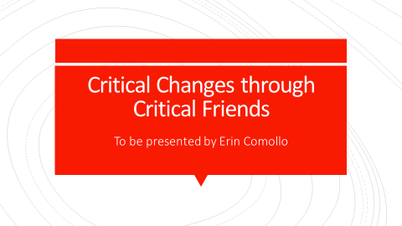
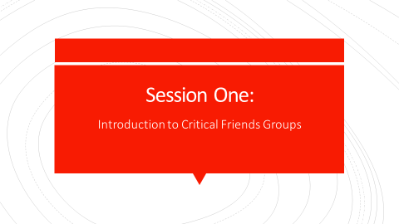
Teachers will be seated at tables and given participant workbooks. After it seems like most participants have arrived and settled in, they will be guided through a quick “Who’s in the Room” activity:
- Who’s in the Room: ask for a show of hands – how many are K-12 teachers, department heads/chairs, supervisors, administrators, university, anyone else?
- Quick assessment: Ask for a show of hands – What brings you here today – never heard of Critical Friends Groups, thinking of starting one/them, are currently involved in CFGs, other.
Give an introduction: My name is Erin Comollo, and I have taught for over eleven years in the elementary school setting. From my personal experience, which is supported by research, I know that most teachers experience professional development through workshops and conferences; however, much of the research literature on teacher learning points to the fact that teachers are not learning much through the traditional, one-shot conference and workshop approach to professional development, and suggests that a more effective approach is a teacher-driven, situated, collaborative, sustained, and focuses on improving student learning. This session is designed to model some of what I’m presenting about and despite its workshop approach, it is my hope that you are a bit more likely to learn and would be inspired to continue to learn and experiment with ideas and strategies being presented in this workshop than in a less-interactive presentation approach.

Overview (5 minutes)
Training Agenda
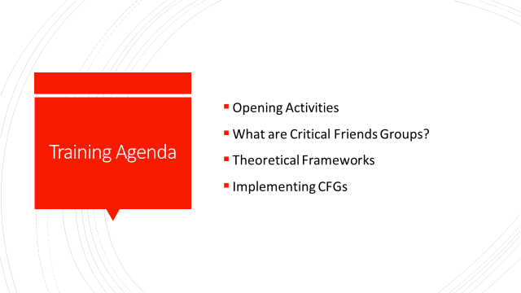
Go over training agenda: First, I am going describe the research literature to give you some context. Then, I’ll go describe the implementation of a Critical Friends Group in my own school setting. The second part of the presentation will be focused on how to actually go about implementing CFGs in your school, keeping best practices regarding change theory in mind. To get us started, I’m actually going to use an activity that I’ve used in CFGs and other teacher work groups.

Opening Activity: Reflection on a Word (10 minutes)
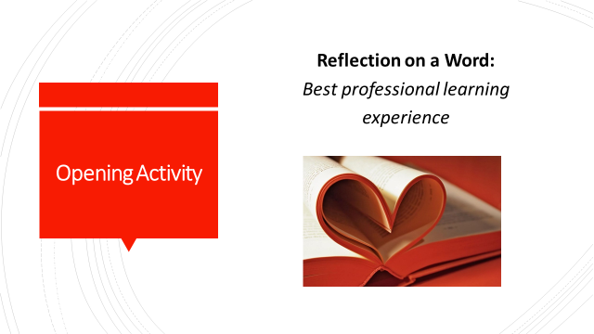
Individually, participants will reflect on their experiences and knowledge of learning experiences. (Script: To start, I’d like you to think and write down as much as you can about the phrase, “best professional learning experience” Write about it in your workbook, page 4.)
In small groups, they will share out their lists. (Share your list with 3-4 people nearby- make sure to introduce yourself. As a group, see if you can combine or choose one attribute that best represents what made everyone’s learning experience was successful).
Each group will share 1 attribute while I chart their responses. Agree that this can be a list that guides our learning time together, but also that most of the characteristics they’ve described as positive learning experiences align themselves with what the literature says are best practices in teacher learning. (What attributes contributed towards this being a successful learning experience?) If not mentioned, offer these characteristics as additional attributes:
- Teacher Directed
- Inquiry Based (problems of practice)
- Situated (contextualized, or in the place of practice with colleagues)
- Distributed (collaborative)
- Use of tools and artifacts (protocols, data)
- Sustained (longer in duration, as well as over time)
The characteristics we’ve described here are not only components of best practices in teacher learning, but are also the foundation of what CFGs are based upon.

What Are Critical Friends Groups? (15 minutes)

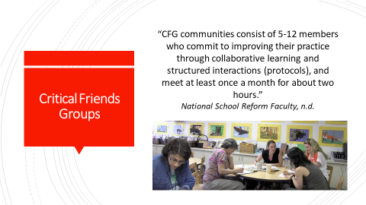
Introduce Critical Friends Groups: The National School Reform Faculty was founded in 1994 as a professional development initiative and is the official trademark owner of the specific professional learning approach called “Critical Friends Groups.” Their official definition of CFGs is “5-12 members who commit to improving their practice through collaborative learning and structured interactions (protocols), and meet at least once a month for about two hours.” (“NSRF,” n.d.).

Learning Theories
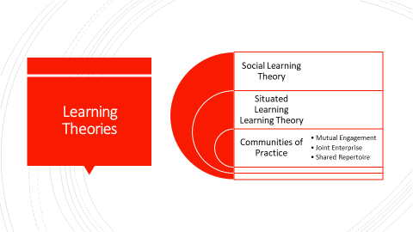
Introduce the learning theories that undergird CFGs: CFGs are a formalized model for enacting what has been identified as attributes of effective teacher learning which recognizes that teachers build individual and collective knowledge through their interactions with one another, their environment, and the social context. This premise is based on three interconnected theories:
  - Situated Learning
  - Social Learning
  - Communities of Practice
Situated and Social learning theories posit that teacher learning is more meaningful and impactful when it is based on actual problems of practice contextualized within teachers’ specific place of practice. Communities of practice assume that as people interact within a specific context (whether it be professional, personal, local, global, etc.), they develop shared practices (skills, strategies, and ways of interacting) and learn collectively.
What is a Critical Friend?
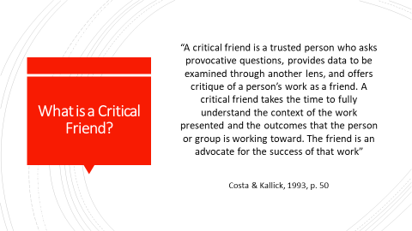
Introduce the role of a Critical Friend: CFGs are composed of critical friends. So, who is a CF and who can be a CF? Read definition: “A critical friend is a trusted person who asks provocative questions, provides data to be examined through another lens, and offers critique of a person’s work as a friend. A critical friend takes the time to fully understand the context of the work presented and the outcomes that the person or group is working toward. The friend is an advocate for the success of that work” (Costa & Kallick, 1993, p. 50). Characteristics of effective CFs include strong communication skills, content knowledge, and most of all, trustworthiness (Bambino, 2002; Dunne, 2000; Kember, 1997; Swaffield, 2004). CFs can be formalized coaches and advisors, administrators, research team members, colleagues/peers, and even students. (Baskerville & Goldblatt, 2009; Costa & Kallick, 1993; Curry, 2008; Dunne, 2000; Kember, 1997; Swaffield, 2004, 2005)

Critical Friends Groups in Action – (15 minutes)
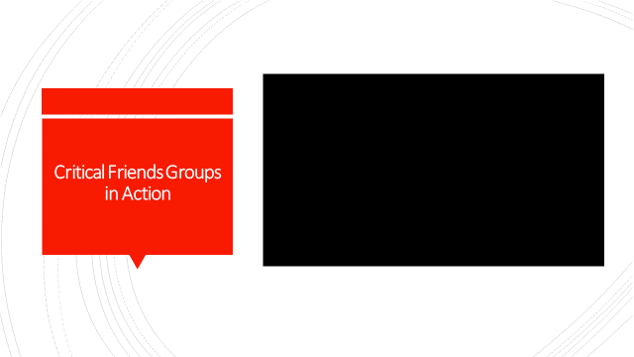
In order to give you a feel for what CFGs look and feel like in action, I’d like to share some video clips from one of my CFGs with you.
Show portions from the video to highlight various aspects of a CFG:
**3:38-6:20 Facilitation and Presentation of a Dilemma
9:30 -11:19 Clarifying Questions
**17:36-18:29 Description of Conversation Rounds
18:30-20:44 First Impressions
**24:03-24:53 Discussing Writing – “Leads”
**27:30 Sample of Facilitation Redirection
**40:30-44:00 Presenters Reflect and Synthesize Feedback from Colleagues
**44:45-49:33 Debrief of the Process

What do Participants Say?
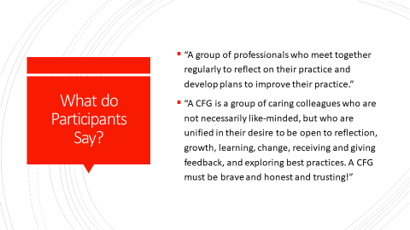
Bridge the connection from theory to practice: Like many concepts, how things are defined or assumed in theory to play out isn’t always what occurs. Most of my presentation will be drawing upon my experience as a CFG facilitator so that I can give you a realistic look at CFGs and how to implement them. That being said, this slide includes a couple of definitions of a CFG given by some of the participants in my CFG based on their experience participating in one.

Activity: Fears and Hopes (20 minutes)
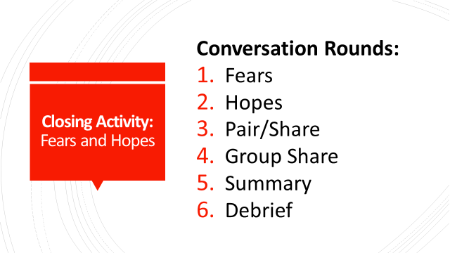
Give an overview of the protocol:
- Explain to participants that you will be guiding the groups through another protocol called Fears and Hopes, and direct them to page 4 in their workbook
- Questions:
  - Thinking about CFs and CFGs, take a moment to jot down your greatest fear for CFGs at your school: if CFGs went horribly wrong at your school, what will happen or not happen?
  - Now, write down your greatest hope for CFGs at your school: if CFGs turned out to be the best professional development your school offered, what could some of the outcomes be?
- Participants will pair/share
- Ask for volunteers to share fears/hopes and chart them on chart paper; If not mentioned, point out:
  - Potential barriers/challenges/fears: Time, discomfort with change and the idea of peer-to-peer feedback, lack of expertise, resistance from administration and/or teachers
  - Hopes and benefits: Focused, action based conversations, equal distribution of voices, data driven conversations, teacher-led inquiry, improved practices and learner outcomes
- Synthesize and summarize any big ideas, themes, or patterns
- Debrief: Did you notice anything surprising or otherwise interesting while doing this activity? What were some of the benefits of the activity? How do you envision using this exercise in your own school contexts?
- Closing: In the next few sessions, we’ll explore the stages of change and factors that influence the implementation of CFGs in your school in order to mitigate some of the issues that arose for you during this activity.

Session 2: Thinking about Critical Friends Groups and Change
Objectives:
- Participants will learn about the theoretical background and benefits of Critical Friends Groups
- Participants will learn about the five factors that influence successful change implementation
- Participants will identify factors that will impact the implementation of a change in their school context
Materials Needed: Writing/drawing materials; chart paper; Participant Workbook; PowerPoint; Projector
Time: 75 minutes

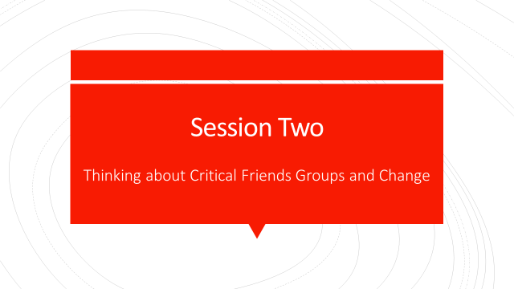
Brain-Friendly Presentation (65 minutes)
Factors that Support Change (3 minutes)

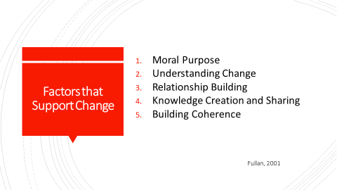
In the last session, we discussed some of the characteristics that made our learning experiences great, what some of the potential benefits of implementing CFGs into your schools were, and what some of your fears regarding the implementation would be. Today, we will explore some of the factors that support change in order to address and proactively plan some of the fears your expressed.
First, I am going to describe the genesis of my change effort, and then I will describe the change process through each one of the stages.

The Context of Change (5 minutes)
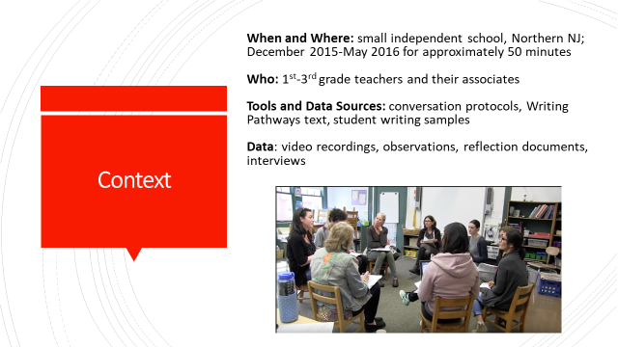
In order to help teachers at my school foster meaningful conversations about teaching and learning and to enact what the research tells us about high quality professional development, I introduced the Critical Friends Group approach to the faculty as part of a pilot study during the 2014-2015 academic school year. The was no one focus of this particular CFG, but served as an introduction to this teacher-directed inquiry approach as a form of professional development. Each week, a different teacher would present a piece of student work to analyze as a way to get help on dilemma she was facing. The participating teachers included Nursery-Third grade teachers, both classroom and specials areas. Based on positive teacher feedback regarding the process, changes in practices, increased collegiality and professional growth, as well as attendance rates, the school administrators supported my implementation of another CFG the following year.
This time, however, the group focused in on a particular area of concern that we all shared: student writing and writing instruction. At the same time, we were increasing knowledge and skills and improving practices in a curricular domain, we could also address our need to develop more collegiality. This group was the focus for my second study. I am going to share some of the findings from that study so you have a deeper understanding of what CFGs are, how they function, what they look like in action and what some of the outcomes of our group were as a way to encourage you to think about trying this out in your own school context. I documented the work of the group, collected feedback after each session, and interviewed the participants after the CFG concluded. I will use this data during each session to provide examples and illustrations of the content I am presenting.
When I started teaching at this school eight years ago, the administration and faculty had committed to adopting the widely acclaimed, research-based Teacher’s College Reading and Writing curriculum. Founded by Lucy Calkins, The Robinson Professor of Children’s Literature at Teachers College, The Teachers College Reading and Writing Project was developed to support a “student-centered, responsive, assessment-based” literacy curriculum (Our History, 2014). Several needs related to professional development on writing instruction surfaced as part of this curriculum adoption.
While many teachers from Far Brook had attended the weeklong institutes and numerous workshops that Teacher’s College offers to support implementation of the curriculum, the curriculum had been enacted loosely and inconsistently across grade levels with no accountability or follow-up. As a result, writing instruction and assessment is inconsistent throughout the school. As a first grade teacher at Far Brook, I was aware that I, along with my colleagues, had many learning needs and questions about teaching writing, such as how to effectively implement the new curricula’s lesson plans and instructional activities and how to assess students’ work to see if progress was actually occurring along that developmental trajectory.
Despite these needs, there were few meaningful opportunities to learn with and from each other regarding our efforts or our students’ progress and challenges. This was demonstrated fully in the inconsistent implementation of the writing curriculum. The CFG addressed this professional learning gap. The CFG utilized two processes that were instrumental in supporting teacher learning and changes in practice. These were the use of conversation protocols and the professional text, Writing Pathways: Performance Assessments and Learning Progressions, Grades K-5 (Calkins, 2013). During the study, teachers took turns bringing in writing samples illustrative of an instructional dilemma or looking for next steps for instruction, and we would use a conversation protocol to help guide our conversation while using a rubric to analyze students’ writing development. Conversation protocols were used to organize the structure and schedule of the meeting, while the contents were driven by whichever grade level teacher was presenting student writing during that session and the corresponding grade level writing assessment rubric from Writing Pathways. Each meeting began with the facilitator (myself) reviewing the agenda for the meeting, which included the conversation protocol selection as well as reviewing which teacher was presenting student work and their problem of practice or dilemma. Next, the presenting teacher would share the student work and the dilemma associated with it. Using a protocol, participants responded to various prompts that led them through rounds of conversation focusing on the dilemma, the student work, and its corresponding writing assessment rubric in order to make meaningful observations and develop substantive recommendations for practice.
As the change agent driving CFGs forward, it was important for me throughout this process, and for you to have an understanding of five leadership competencies for driving change in order to support a cultural shift. These include: moral purpose, understanding change, relationship building, knowledge creation and sharing, and building coherence.

Mini-Lecture: Moral Purpose (3 minutes)
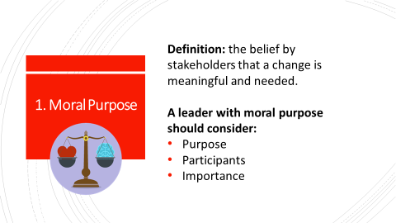
What is moral purpose? As a change agent, it is most important that your stakeholders believe a change is meaningful and necessary. This is what inspires motivation, buy-in, and commitment to the change. Leaders should consider the purpose of the change, who will be involved in the change, and why the change is important. In order leaders to successfully implement and sustain CFGs, teachers first need to feel that that CFGs can help them address useful and important problems of practice that they experience directly. That also goes for whatever topic or content area you decide to focus on. Maybe it’s a content area, but maybe it is lesson planning, or classroom management, or maybe your school is struggling with behavior problems – whatever the topic is, the stakeholders involved need to see the moral purpose and imperative behind it.

Participant Engagement/Turn and Talk: Moral Purpose (10 minutes)
Share examples from my study (3 minutes)
- What was the purpose of CFGs?
  - To improve writing instruction through consistent curriculum implementation across grades 1-3;
  - To enact best practices in teacher learning
  - To create consistency and coherence in writing instruction across grade levels
  - To encourage accountability and feedback to teachers on their instructional practices
- Who was involved? In my CFG: Teachers and the director of the school would be involved.
- Why was the CFG important?
  - Student writing performance was inconsistent and not what it should be, so we needed to improve instruction
  - Most of the teachers had attended the week long trainings on writing instruction that had been offered at the school. However, they had no in-school guidance or conversations on implementing the curriculum as follow-up to actually support implementation.

Ask participants to turn to a partner to discuss and write responses to the consideration questions with regards to a CFG (4 minutes)
Have a few partners share their ideas. (2 minutes)

Mini-Lecture: Understanding Change (5 minutes)
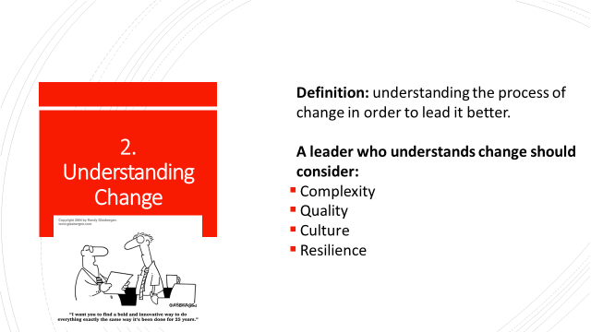

Understanding change requires the change agent to think through the process and nature of the change in order to lead it better.
Leaders who understand change prepare and plan for change by assessing its complexity: how complicated will the change be? Examining the nature of the change – its quality, requirements, and potential challenges are part of that assessment. When considering the quality of the change, it’s important to gauge its overall impact. What will its ripple effect be? And, is the change more quantitative or qualitative? After all, the most creative or greatest amount of innovations doesn’t necessarily equate to successful change or the most impact. Change often requires a complete re-culturing of structures, processes, and habits of mind to support the required for changes in practices, programs, and policies to take place. So, once the complexity and quality of the change are assessed and deemed to be worthwhile and impactful, change agents need to consider the structures, processes, and habits of mind need to be re-cultured in order for the change to take place. Finally, after thinking through these characteristics of the change, leaders must recognize and troubleshoot for any potential challenges and resistance that may occur.

Participant Engagement/Turn and Talk: Understanding Change (10 minutes)
Share examples from my study (5 minutes)
As the change agent driving CFGs forward, I knew shifting a school steeped in tradition and doing things the way they’ve always been done would be both complex and challenging. However, I also knew from both the research literature and my own experience how impactful a teacher driven inquiry approach to professional development was. So, I started small and low stakes. After meeting with administration, I began CFGs with voluntary participants outside of the school day, opening it up to any grade level or content area teachers who wanted to present a dilemma. Because it was outside of school, it had little effect on school structural changes, however, the CFG introduced new processes and habits of mind introduced vis a vis conversation protocols. The feedback and experiences were so positive that I was able to use that data to communicate the benefits to administration. A year later, with administrative support, CFGs were integrated into the lower school teachers’ faculty meeting schedule, with a specific focus: writing instruction.
It is crucial for those involved in implementing CFGs as a change vehicle to understand, anticipate, and plan for these aspects.
Ask participants to turn to a partner to discuss and write responses to the consideration questions with regards to a CFG and what to do as a result (4 minutes)
Have a few partners share their ideas. (2 minutes)

Mini-Lecture: Relationship Building (5 minutes)
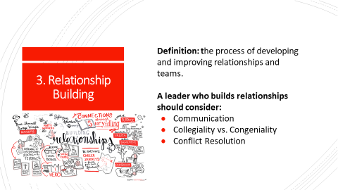
Relationship building refers to the process of developing and improving relationships and teams. Leaders who cultivate and improve relationships in order to move the change forward consider their communication, the types of relationships they are fostering, and have a plan for conflict resolution should it be needed. When considering communication, leaders must think about how and when communication will take place, and with who. They also need to think about whether or not the relationships they are developing extend beyond friendly, congenial interactions – how are professional relationships that provide honest sharing and feedback being encouraged? Finally, leaders must develop systems and processes to navigate professionally and effectively through conflicts so that healthy, functional relationships are maintained.
Participant Engagement/Turn and Talk: Relationship Building (10 minutes)
Share examples from my study (4 minutes)
When initiating CFGs at my school, I knew administrative buy-in and support would be a crucial aspect of moving them forward. I met with leaders to explain the CFG process, benefits, and my plan for implementation. I also knew that my participants, while enthusiastic and initially, voluntary, were busy teachers. With this in mind, I made sure my communication was done via email with clear instructions, agendas, roles, and assignments with ample time and follow up reminders to ensure I was not “using” up any additional time of theirs aside from the CFGs themselves. I anticipated and knew that developing collegial relationships versus congenial ones would be part of the re-culturing required for the change. In order to cultivate professional interactions, I built in the expectation that participating teachers would all have turns to present their work, thus distributing the responsibility and leadership amongst the group. The groups also utilized conversation norms and protocols, which structured the teachers’ language, habits of mind, and approach to feedback in a way that fostered professional interactions and built in conflict resolution.
Ask participants to turn to a partner to discuss and write responses to the consideration questions with regards to a CFG (4 minutes)
Have a few partners share their ideas. (2 minutes)

Mini-Lecture: Knowledge Creation and Sharing (5 minutes)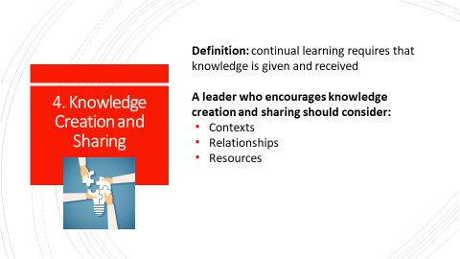

Knowledge creation and sharing refers to the idea that learning is more meaningful and is more likely to be sustained when knowledge is generated and exchanged. Leaders who support knowledge creation and sharing develop a context and culture that supports creativity, risk taking, mistake-making, and acknowledges emotion. They create the spaces and places for people to learn, reflect, share, get feedback, and generate new learnings. Building a culture of learning is crucial to “establishing and reinforcing habits of knowledge exchange among organizational members” (Fullan, 2001, p. 87) – learning opportunities such as peer networking and coaching are examples. As we learned in the last slide, relationship building is a crucial aspect of change, and in this case, in order to have the conversations and experiences that lead to shared knowledge creation and sharing, people must have relationships that are trusting and collaborative. Finally, leaders need to consider what resources are required to create and share knowledge – does it require funding? Materials such as curricula, professional texts? What human resources are required – i.e., will you need facilitators; who will they be and how will they be trained?
Participant Engagement/Turn and Talk: Knowledge Creation and Sharing (10 minutes)
Share examples from my study
Through a culture of working together to building new knowledge and deprivatizing their practices, teachers in my CFG were encouraged to share strategies, suggestions, and questions with one another in regard to writing instruction. In this way, teachers are building a culture of sharing and increasing their feelings of self-efficacy. They were also given opportunities to be both participants as well as presenters during CFGs so that they can both give and receive feedback and work together to generate new understandings and knowledge. As one participant put it, “The formality of protocol usage created a sense of order and safety in sharing and receiving feedback, and then engaging in the experience together created a sense of trust, unity, openness and community. Even the regularity of time to talk together about our teaching, to share success and frustration, brought us closer together - in a weird way, reminding us that we are all doing and feeling the same things!”Ask participants to turn to a partner to discuss and write responses to the consideration questions with regards to a CFG (4 minutes)
Have a few partners share their ideas. (2 minutes)

Mini-Lecture: Building Coherence (5 minutes)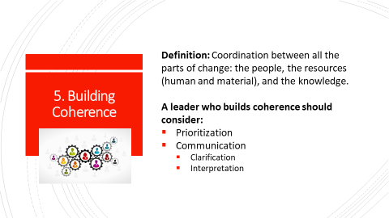

Building coherence refers to the coordination between all the elements of change is needed: the people, the resources (human and material), and the knowledge. In order to build coherence, change leaders must refer back to the moral purpose of the change. Coherence is directly built upon a shared moral purpose and clear communication; by ensuring the moral purpose is primary driving factor towards change, decisions can be made accordingly. Leaders must reflect on why the change is a priority, and how will it be made a priority to the organization. Once this is established, leaders must consider how the needs and expectations of the change are communicated with stakeholders in a way that clarifies and articulates the moral purpose behind the change and the need for it. The best communication will have already take how people will interpret the change, the need for it, and opposing opinions into consideration. Coherence is developed over time through a shared vision, knowledge creation and distribution, and clearly defined goals and outcomes.

Participant Engagement/Turn and Talk: Building Coherence (10 minutes)
Share examples from my study:
In my situation, there was a significant lack of coherence regarding the implementation of writing instruction. Teachers had attended training weeks by themselves, during different summer sessions, and had zero follow-up, coaching, or feedback on how or if they were implementing the curriculum. Because of the lack of clarity in what was expected, the lack of follow up and feedback, as well as the lack of tools to measure the change, the curriculum was met with inconsistent implementation, as each faculty member interpreted the need and expectations differently (Hall & Hord, 2011). The need for writing instruction improvements were clear in the students’ inconsistent writing abilities and their teachers’ frustrations regarding this. All participants understood the priority and need for this improvement. While some didn’t quite understand or feel comfortable with using conversation protocols initially, over time, after being encouraged to stick with them and try them out, they eventually reported seeing and valuing the process.
By engaging diverse stakeholders in CFG meetings using conversation protocols, different grade levels and occasionally even content area teachers had an opportunity to create coherence around language, practices, strategies. As a result, teachers began to change their practices as a and the group coherence also created group accountability and increased the likelihood of sustainability.
Ask participants to turn to a partner to discuss and write responses to the consideration questions with regards to a CFG (4 minutes)
Have a few partners share their ideas. (2 minutes)

Closing Activity: Whip (5 minutes)
(Allen & Blythe, 2015, p. 62)
Invite the participants to reflect on the following prompts (found in Workbook page 8):
- I have changed my views on…
- I have improved my skills in…
- I have learned new information and concepts regarding…
- I still have a question about…
Then, have participants go around in a circle to share their phrase or short sentence, with no responses from others. Participants can say “pass” or “repeat” if needed.
Session 3: Initiating and Planning Critical Friends Groups
Objectives:
- Participants will learn about theoretical background and benefits of Critical Friends Groups
- Participants will learn about the characteristics of the initiation/planning stage of change
- Participants will identify factors and potential challenges for initiating/planning CFGs in their school
- Participants will identify next steps for initiating/planning CFGs in their school
Materials Needed: Writing/drawing materials; chart paper; Participant Workbook; PowerPoint; Projector
Time: ~70 minutes

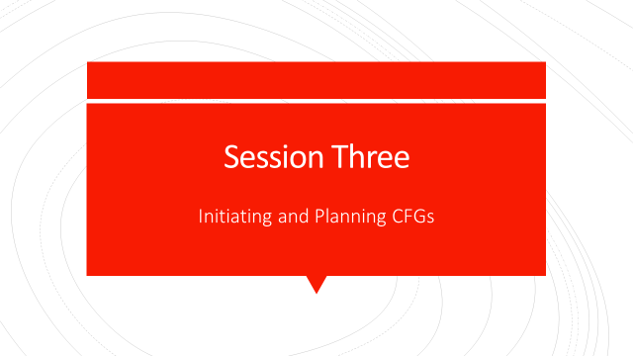
Participants will be seated at tables and given participant workbooks. After it seems like most participants have arrived and settled in, they will be guided through another quick “Who’s in the Room” activity. Explain that the purpose for this re-assessment is to group similar participants for the small group activities:
Who’s in the Room: ask for a show of hands – who came here today with other colleagues from the same school? (ask these participants to sit together; repeat this with the following descriptors of participants). Who here is coming from:
- Public schools?
  - Urban, suburban or rural?
  - Elementary?
  - Middle School?
  - High School?
  - Charter schools?
  - Urban, suburban or rural?
  - Elementary?
  - Middle School?
  - High School?
- Independent schools?
  - Urban, suburban or rural?
  - Elementary?
  - Middle School?
  - High School?
  - Other?

Stages of Change (3 minutes)
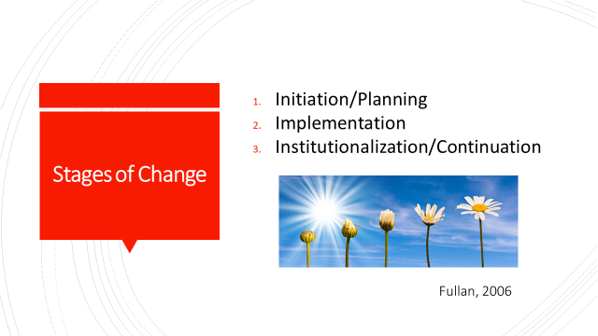
Now that we’ve examined the factors that contribute towards driving a change forward, we are going to look at how they unfold within the stages of implementing the change. The Three Stages of Change are:
1. Initiation/Planning
2. Implementation
3. Institutionalization/Continuation
It’s important to note that the stages can overlap (more common when you try to implement more than one change). Also, the stages can take a long time; may take 2-5 years to get through a cycle & organizations struggle to see changes through to the institutionalization stage unless sustainability plans are put into place from the start. To contextualize each of the stages, I will share how I used the stages to inform the study I conducted about teachers’ experiences in a CFG. Then, you’ll have the opportunity to troubleshoot and action plan how you might do the same in your school. In order for you to get the most out of your time and problem solving, please sit

Initiation and Planning (5 minutes) –
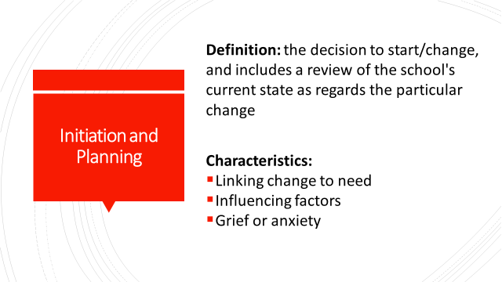
The initiation and planning stage of this process was undergirded by Michael Fullan’s definition and characteristics.
Once the decision to change has been made, initiation stage of change has begun. The first step includes a review of the school's current state as regards the particular change. Change must be linked to a need and have a clear approach to addressing the need/problem and an advocate. Factors that influence how this stage is carried out include leadership style and the potential for two-way communication, buy-in, resources, and the relationships between stakeholders.
Grief or anxiety related to the change must be anticipated as it is a natural response to change; participants need to grieve over loss of favorite and comfortable ways of acting and learning

Next Steps (3-5 minutes)
Briefly go over next steps and study examples for this stage of change:
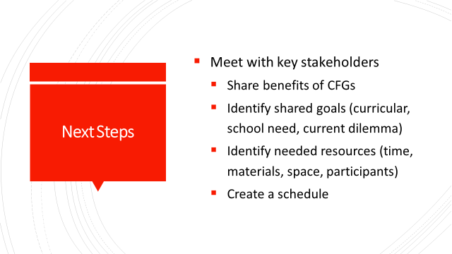

During the initiation stage of implementing CFGs, meet with key stakeholders to educate them on CFGs with regard to why they are beneficial and what will be needed to increase the potential for successful implementation and to select a focus for the meetings. It is also important to plan a schedule for the meetings. Fortunately for me, I had gone through this stage during my pilot study in 2014-2015, offering a voluntary learning opportunity to participate in CFGs for teachers. Using the outcomes from this study, I was able to meet with administrators to share the benefits of CFGs and push to have them scheduled into our faculty meeting and prep schedule, rather than try to do it outside of school hours. This was important for a number of reasons. First, it demonstrated to teachers that their learning was valued and prioritized. Second, using work hours made it possible to engage teachers who may not have volunteered outside time to participate in CFGs due to scheduling, resistance, or disinterest. Third, it sent a message that professional learning with colleagues is part of their job as professionals.

What? So What? Now What? (adapted from Thompson-Grove, 2012) – 40-45 minutes
Introduction (3 minutes)
Give an overall introduction to the protocol goals and steps: this protocol allows participants to reflect and connect to one another and one another’s work towards a change. You will work with a small group of 3-6 that best represents your school context.
Process – Conversation Rounds (25 minutes)
First, participants will address the “What?” conversation prompt. After a round of responses, they will move on to the “So What?” conversation prompt. Finally, they will respond to the “Now What?” conversation prompt. Groups should be prepared to summarize and share a general theme or idea from each round with the group.
Round 1 - What:
- What aspects of initiation and planning CFGs stood out to you in regards to your school?
- What factors do you think will affect initiation in your context?
- What are potential challenges and what plans can be made to overcome them?

Round 2 - So What:
- How might CFGs connect to the needs at your school?
- How will moral purpose, understanding change, relationship building, knowledge creation and sharing, and coherence building play a part in this stage?

Round 3 - Now what?
- Based on what you’ve heard so far what might your next steps be?

Sharing (5-7 minutes):
Volunteer representatives from each group will share a general theme or idea from each round with the group.
Debrief and Closing (5-7 minutes)
Lead participants in an open discussion regarding the What, So What, Now What activity:
- What worked about this process?
- What could be improved?
- Which question was most useful/lease useful?
- How might you use this in your work?

Session Four: Implementing CFGs
Objectives:
- Participants will learn about the implementation stage of change
- Participants will identify factors that influence change implementation within their schools regarding the nature of the change effort, the local context, and external factors
- Participants will identify potential challenges they may encounter while implementing CFGs into their schools
- Participants will develop a plan to address potential challenges they may encounter while implementing CFGs into their schools
Materials Needed: Writing/drawing materials; chart paper; Participant Workbook; PowerPoint; Projector; Video Clip
Time: 75 minutes

Introduction and Overview (3-5 minutes) 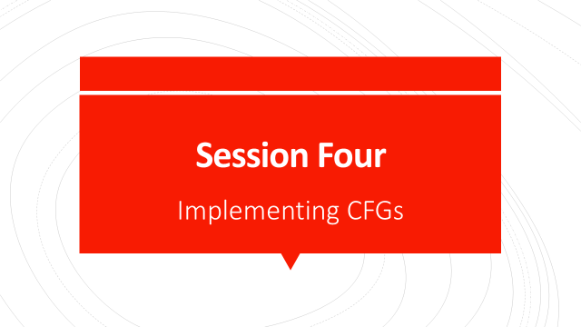
As participants arrive and settle in, ask them to sit with the same group they sat with for the previous session. Go over session agenda; then: If you’re here at this training, I’m assuming that you either haven’t implemented CFGs in your school, or are looking for ways to run them more effectively in your school. It’s important to remember that for many teachers, this approach to professional learning is a shift, or a change. So today, we are going investigate what that process looks like and how understanding that process leads to more effective implementation.

Implementation – (5 minutes)
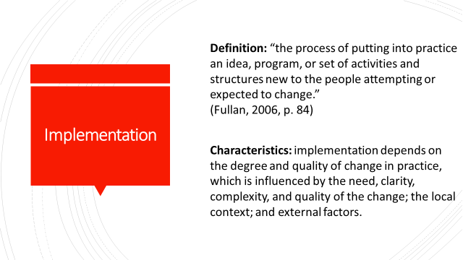
The implementation stage includes the “the process of putting into practice an idea, program, or set of activities and structures new to the people attempting or expected to change.”
(Fullan, 2006, p. 84)

The implementation stage takes the “on-paper” change into real life. Factors that contribute to change implementation are the characteristics and nature of the change (which we discussed in a previous session), the local context, and external factors.

I’ve already gone through the nature of my change effort, so I’ll spend a little time describing how the local context and external factors influenced the implementation of CFGs at my school. As I mentioned earlier, the current PD practices at my school consisted of bringing in content area experts to speak at one-time only events, and/or sending teachers out for conferences and workshops. Most discussions and meetings were conducted Quaker style – sitting in a circle and speakers sharing at-will. And – a huge part of our culture was food! Meetings took place weekly – full faculty meetings were 1.5 hours long and opened with a segment called reflections were faculty were invited to openly share anything personal or professional in a Quaker-style forum. The meetings lacked agendas, or pre-shared topics, and did not follow and procedures or protocols. Divisional meetings also occurred once a week for an hour and followed the same format. In my experience as a teacher at that school, I had never once been asked to bring student work, nor had we had any inquiry based learning experiences that put instruction and/or student learning at the center – almost all gatherings focused on procedural or topics relating to student diversity or social-emotional wellbeing.
I knew as a teacher that focusing on something specific and tangible like student writing gave all teachers an entry point to which they would feel a commitment. Teachers are busy – I wanted to take the thinking out of the process so I emailed reminders, protocols, agendas in advance, and assigned teachers to present on certain days so that all they had to think about was showing up and bringing student work when it was their turn. And of course, I continued our school culture of food at meetings! Fortunately for me, I was at an independent school, so there weren’t any government or state policies to consider. However, in your school setting, you may have to consider budget, PD policies, etc.

Next Steps (3-5 minutes)
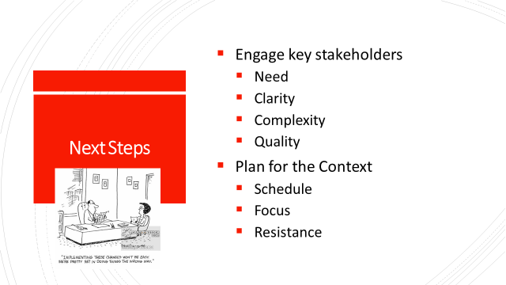
- As stated earlier during the initiation stage, it is important to engage key stakeholders in conversations about CFGs, why they are beneficial and why you believe they are an effective approach to the changes in practice you feel are important
- Plan the CFGs with your specific school setting as well as external factors (budgets, policies, standards, accreditation, etc.) in mind – what are the current practices? How would CFGs change those practices? What types of resistance might you expect?

What do we know? What do we suspect? What do we need to find out? (adapted from McDonald et al., 2013) – 40-45 minutes

Introduction (3 minutes)
Give an overall introduction to the protocol goals and steps: this protocol is a derivative of the protocol we used during our last session and encourages participants unpack reform action. You will work with a small group of 3-6 that best represents your school context. You can find this protocol on page 10 of your workbook.
Process – Conversation Rounds (25 minutes)
First, participants will address the “What do we know?” conversation prompt. After a round of responses, they will move on to the “What do we suspect?” conversation prompt. Finally, they will respond to the “What do we need to find out?” conversation prompt. Groups should be prepared to summarize and share a general theme or idea from each round with the group.

Round 1 - What do we know?
- What do you already know about the nature of CFGs in regards to implementing change?
  - Refer back to Session 2 where we discussed understanding change:
    - Consider the complexity, quality, culture, resilience of the change effort
- What do you already know about the local social, organizational, and cultural characteristics and factors of your organization or setting?
- What do you already know regarding broader societal and political characteristics and factors?

Round 2 – What do we suspect?
- What challenges do you suspect will occur in regards to implementing CFGs?

Round 3 - What do we need to find out?
- What do you need to find out more about in order to confirm, inform, or address some of the challenges you brought up?

Round 4 – Final Steps
- Discuss which of the inquiries from the previous round you want to commit to undertaking and how.

Sharing (5-7 minutes):
Volunteer representatives from each group will share a general theme or idea from each round with the group.
Closing and Debrief (5-7 minutes)
Lead participants in an open discussion regarding the activity:
- What worked about this process?
- What could be improved?
- Which question was most useful/lease useful?
- How might you use this in your work?

Session Five (Part A): Institutionalizing Critical Friends Groups
Objectives:
- Participants will learn about the characteristics of the institutionalization/continuation stage of change
- Participants will identify behaviors and factors that contribute to the success of a change effort
- Participants will identify implications for successful change and institutionalization in their schools
Materials Needed: Writing/drawing materials; chart paper; Participant Workbook; PowerPoint; Projector
Time: 70 minutes

Overview (5 minutes)
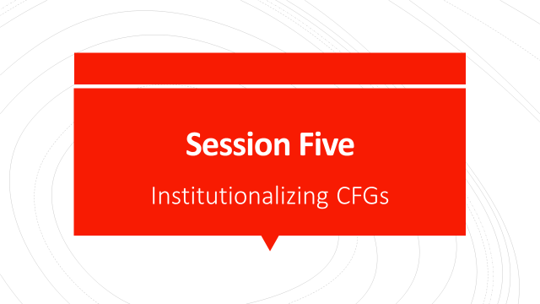

Institutionalization and Continuation (3-5 minutes)
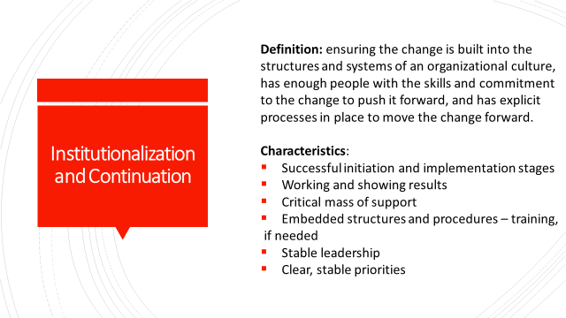 As participants arrive and settle in, ask them to sit with the same group they sat with for the previous session.
During this session, we will take a look at how CFGs look during the institutionalization and continuation stage of change. This is by far the most challenging part of a change effort. It involves ensuring the change has become built into the structures and systems of the organizational culture, has enough people with the skills and commitment to the change and has explicit processes in place to move the change forward. The factors that contribute towards sustaining a change effort include:
- Successful initiation and implementation stages
- Measurable results that demonstrate effectiveness
- Critical mass of support
- Embedded structures and procedures - training if needed
- Stable leadership
- Clear, stable priorities

Next Steps (3-5 minutes)
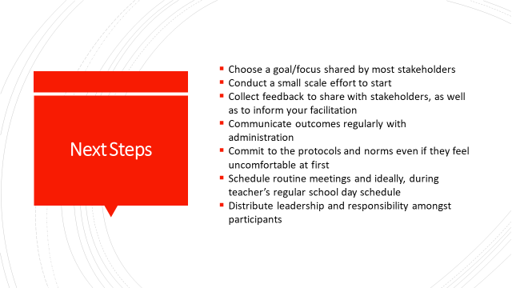
What does this mean for sustaining changes in your school? Focusing on a shared goal helps to create shared interest and motivation for stakeholders. Even small scale efforts can produce useful feedback to inform, revise, or encourage larger scale applications of the change. Try to reduce the discomfort of change by frequent communication with participants and administration, encourage participants to debrief on the process in order to acknowledge the benefits of a new and uncomfortable process, try to schedule meetings during times that are accessible for teachers (and bringing food never hurts!), and encourage leadership opportunities by normalizing the expectation that participants will fulfill a facilitation and presentation role at some point.
Continuous evaluation and assessment of the change enables change leaders to make improvements along the way and plan for the future. Throughout the duration of my CFG, I collected data and feedback from teachers that helped support its success and continuation.

Findings – The Data (5 minutes)

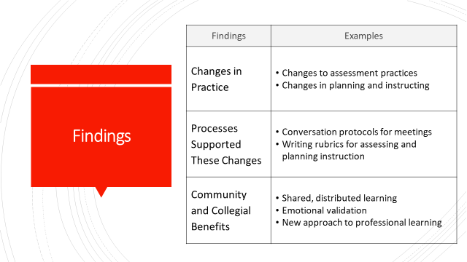 Analysis of the data from my study revealed many positive outcomes of participating in a CFG. These outcomes were communicated with the participating teachers, as well as with the administration and contributed to the enthusiasm, buy-in, and support from all stakeholders, which in turn, helped to institutionalize many of the CFG processes and protocols into the PD culture.
The three primary outcomes of the CFG were:
- Teachers reported making changes to their practices to improve their instruction
- Specific processes and protocols used during the CFG were instrumental in bringing about change. These were:
  - The use of conversation protocols which created norms, routines, and prompts to guide and structure collaboration and new knowledge generation, as well as the writing assessment text which provided a lens through which teachers were guided in their analysis of student work.
- Teachers experienced community and collegial benefits including shared learning, emotional validation, and positive regard for a new way to approach professional learning that participants felt fostered safe and productive conversations about teaching and learning.

The factors that helped support the success and continuation of the CFG at my school were the initial smaller scale efforts towards developing CFGs, communication between myself and the administration (sharing findings, rationale for CFG), the repeated use and practice of conversation protocols, meetings that were scheduled to ensure they were sustained over the duration of the year (not a one-time experience), facilitation, and the common goal of improving our instruction for the sake of student learning.

Success Analysis Protocol (adapted from McDonald et al., 2013) – 40-45 minutes
Introduction (3 minutes)
Give an overall introduction to the protocol goals and steps: this protocol engages participants in a collaborative analysis of cases from practice in order to understand the circumstances, contributions, and actions that make them successful ones, and then apply this understanding to future practice. You will work with a small group of 3-6 that best represents your school context.

First, you will individually consider the example I’ve described and make notes regarding what factors may underlie its success, including any favorable conditions present. Specifically focus on what contributed towards the institutionalization and continuation of the change effort such as:
- Components of the initiation and implementation stages
- Measurable results that demonstrated effectiveness
- Evidence of buy-in
- Embedded structures and procedures that supported the change
- Examples of stable leadership
- Examples of clear, stable priorities

Discussion Rounds (20 min)
Round 1 – Sharing (5 min)
- Participants share their reflections

Round 2 – Analysis and Discussion (5 min)
- The group reflects on the success, offering insights into what made this change effort successful
- They discuss specifically what they think the presenter may have done to contribute to the success and also name what they take to be other factors involved

Round 3 - Compilation (5 min)
- The group compiles a list (on chart paper) of specific successful behaviors and underlying principles that seem characteristic of the change effort

Participants will post their lists and “gallery walk” to read all the lists (5 min)

Discussion (10 minutes)
Lead participants in a discussion: Do the lists have elements in common? Do any contain behaviors or underlying principles that surprised you? What do the lists imply for your change effort and your school context?
Closing and Debrief (5-7 minutes)
Lead participants in an open discussion regarding the activity:
- What worked about this process?
- What could be improved?
- Which question was most useful/lease useful?
- How might you use this in your work?

Session Five (Part B): Institutionalizing Critical Friends Groups
Objectives:
- Participants will learn about characteristics of successful implementation
- Participants will reflect and evaluate training sessions
Materials Needed: Participant Workbook; PowerPoint; Projector
Time: ~20 minutes

Conclusion
Measuring Success (5 minutes)
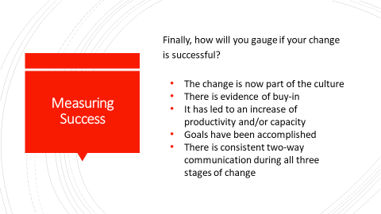
So, how will you know if you’ve been successful in initiating, implementing, and institutionalizing your change effort? Evidence of success examples can include:
- Full integration of the change into the culture of the organization: it is normalized and considered the “standard way”
- Attitudes and participation reflect buy-in
- Increased productivity and/or achievement
- Goal achievement has been made
- Consistent two-way communication between stakeholders during all three stages of change

Continuation in my situation was reflected in the adoption of a loose CFG approach to PD throughout the school. The following year after my writing instruction CFGs were conducted, “professional study groups” were introduced by the administration as a form of teacher led professional development and part of the faculty meeting schedule. Voluntarily facilitated by teachers (many who had been part of the CFGs), each group was made up of cross-grade and content level teachers focusing on a common, self-selected topic (i.e., essential questions, social-emotional learning, arts integration). While facilitators were given autonomy to conduct their groups in any way, quite a few of the facilitators opted to use conversation protocols to guide their discussions.
The next year, the groups evolved and focused on a single topic and school wide initiative: social-justice. This time around, teachers chose a professional text that situated their content area or area of interest within the lens of social justice. Then, heterogeneous groups were formed, again with volunteer facilitators. Facilitators were encouraged and required to use conversation protocols to lead their groups in conversation.
While these are not explicitly CFGs by NSRF definition, they are still teacher-led, teacher-topic driven small learning groups that meet once a month during faculty meeting time, and use conversation protocols. This new systemic, institutionalized practice reflects how over the course of the five years since CFGs were introduced, the structures to support change grew and enabled the cultural shift from a professional development culture that emphasized one-and-done teacher learning, to one that values teacher led, inquiry based PD. It is also a great example that change is a slow, incremental process.

Questions (10 minutes)
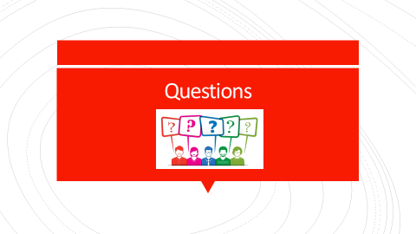

I hope you found this helpful in understanding the function and benefits of CFGs and how you may consider implementing them in in your own school settings. I’d like to open up the floor for questions now if anyone has one.

Thank You and Evaluations/Reflections (5-7 minutes)

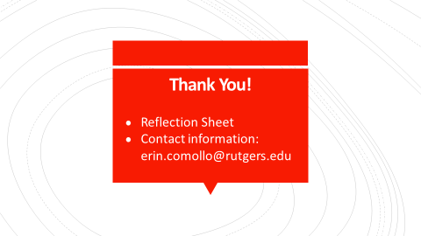
Thank you so much for coming and participating in this four-part series about CFGs, change, and how understanding change can support the successful implementation of CFGs in your school.
- Evaluation/Reflection Sheets
- Please feel free to reach out to me with any questions or concerns

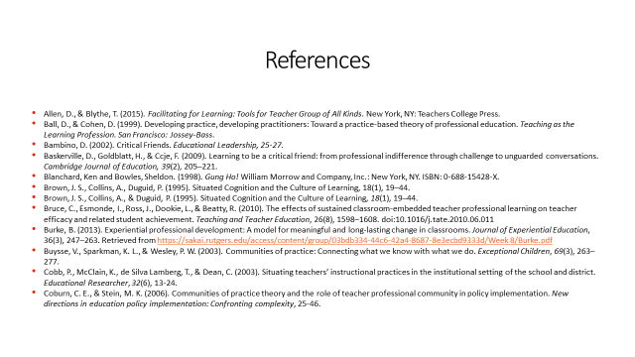
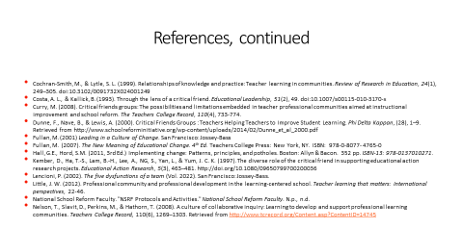

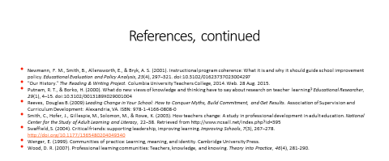

Critical Changes Through
Critical Friends

Participant Workbook
2018

Table of Contents

CRITICAL CHANGES THROUGH CRITICAL FRIENDS
Session 1:
Best Practices in Teacher Learning 125
Fears and Hopes Protocol 126
Session 2:
Turn and Talk 127
Closing Activity: Whip Around 132
Session Three:
Initiation/Planning 133
Session Four:
Implementation 134
Session Five:
Institutionalization/Continuation 136
Reflection Sheet 138
References 139

Session 1:

Reflection on a Word:
Best Professional Learning Experience

__________________________________________________________________________________________________________________________________________________________________________________________________________________________________________
__________________________________________________________________________________________________________________________________________________________________________________________________________________________________________
Group List:
- _____________________________________________________________
- _____________________________________________________________
- _____________________________________________________________
- _____________________________________________________________
- _____________________________________________________________

Fears and Hopes Protocol

Session 2: Turn and Talk
With a partner, discuss and write responses to the consideration questions with CFGs in mind:
Moral Purpose

What is the purpose of the change?

Who is involved in the change?

Why is the change important?

Understanding Change

The complexity of change – how complicated is this change?

Quality: What is the impact of the change?

What structures, processes, and habits of mind need to be re-cultured in order for the change to take place?

What challenges or resistance do you anticipate?

What’s an example of a change that was implemented at your school that did not take the change process into consideration? In what ways didn’t it? It what ways could it have?

Relationship Building
What communication will be necessary to build relationships? How and when will communications take place? To whom do you need to communicate with?

How will you foster collegial interactions not simply congenial ones?

How do you develop conflict resolution skills? What are the procedures or protocols for conflict/resolution?

What other factors contribute to building trust and relationships?

Knowledge Creation and Sharing

How will you develop contexts that are conducive to learning and sharing?

How will you foster relationships that support knowledge creation and sharing?

What resources would you need to support learning and sharing (fiscal, material, human, social)?

How or how isn’t your current context conducive to learning and sharing?

Building Coherence

Who and what are involved? How will you go about coordinating them?

How will you make the change a priority? How are you clarifying and articulating the change and the need for it?

How will people interpret the change and the need for it? How will you guide people through differences of opinions?

Closing Activity: Whip Around
(Allen & Blythe, 2015, p. 62)
Reflect on the following prompts:
- I have changed my views on…
- I have improved my skills in…
- I have learned new information and concepts regarding…
- I still have a question about…
Participants go around in a circle to share their phrase or short sentence, with no responses from others. Participants can say “pass” or “repeat” if needed.

Session Three: Initiation/Planning
What? So What? Now What? (adapted from Thompson-Grove, 2012)
This protocol allows participants to reflect and connect to one another and one another’s work. Participants will break into groups of five for discussion rounds.

Conversation Rounds (25 minutes)
First, participants will address the “What?” conversation prompt. After a round of responses, they will move on to the “So What?” conversation prompt. Finally, they will respond to the “Now What?” conversation prompt. Groups should be prepared to summarize and share a general theme or idea from each round with the group.

Round 1 - What:
- What aspects of initiation and planning CFGs stood out to you in regards to your school?
- What factors do you think will affect initiation in your context?
- What are potential challenges and what plans can be made to overcome them?

Round 2 - So What:
- How might CFGs connect to the needs at your school?
- How will moral purpose, understanding change, relationship building, knowledge creation and sharing, and coherence building play a part in this stage?

Round 3 - Now what?
- Based on what you’ve heard so far what might your next steps be?

Sharing (5-7 minutes):
Volunteer representatives from each group will share a general theme or idea from each round with the group.

Debrief and Closing (5-7 minutes)
Lead participants in an open discussion regarding the What, So What, Now What activity:
- What worked about this process?
- What could be improved?
- Which question was most useful/lease useful?
- How might you use this in your work?

Session Four: What do we know? What do we suspect? What do we need to find out? (adapted from McDonald et al., 2013) – 40-45 minutes

Introduction (3 minutes)
Give an overall introduction to the protocol goals and steps: this protocol is a derivative of the protocol we used during our last session and encourages participants unpack reform action. Participants will break into groups of five for discussion rounds.

Process – Conversation Rounds (25 minutes)
First, participants will address the “What do we know?” conversation prompt. After a round of responses, they will move on to the “What do we suspect?” conversation prompt. Finally, they will respond to the “What do we need to find out?” conversation prompt. Groups should be prepared to summarize and share a general theme or idea from each round with the group.

Round 1 - What do we know?
- What do you already know about the nature of CFGs in regards to implementing change?
  - Refer back to Session 2 where we discussed understanding change:
    - Consider the complexity, quality, culture, resilience of the change effort
- What do you already know about the local social, organizational, and cultural characteristics and factors of your organization or setting?
- What do you already know regarding broader societal and political characteristics and factors?

Round 2 – What do we suspect?
- What challenges do you suspect will occur in regards to implementing CFGs?

Round 3 - What do we need to find out?
- What do you need to find out more about in order to confirm, inform, or address some of the challenges you brought up?

Round 4 – Final Steps
- Discuss which of the inquiries from the previous round you want to commit to undertaking and how.

Sharing (5-7 minutes):
Volunteer representatives from each group will share a general theme or idea from each round with the group.

Closing and Debrief (5-7 minutes)
Lead participants in an open discussion regarding the activity:
- What worked about this process?
- What could be improved?
- Which question was most useful/lease useful?
- How might you use this in your work?

Session Five: Institutionalization/Continuation
Success Analysis Protocol (adapted from McDonald et al., 2013) – 40-45 minutes
Introduction (3 minutes)
Give an overall introduction to the protocol goals and steps: this protocol engages participants in a collaborative analysis of cases from practice in order to understand the circumstances, contributions, and actions that make them successful ones, and then apply this understanding to future practice. We will break into groups of 3-6 people, and you will need to be able to take notes.
First, you will individually consider the example I’ve described and make notes regarding what factors may underlie its success, including any favorable conditions present. Specifically focus on what contributed towards the institutionalization and continuation of the change effort such as:
- Components of the initiation and implementation stages
- Measurable results that demonstrated effectiveness
- Evidence of buy-in
- Embedded structures and procedures that supported the change
- Examples of stable leadership
- Examples of clear, stable priorities

Discussion Rounds (20 min)
Round 1 – Sharing (5 min)
- Participants share their reflections

Round 2 – Analysis and Discussion (5 min)
- The group reflects on the success, offering insights into what made this change effort successful
- They discuss specifically what they think the presenter may have done to contribute to the success and also name what they take to be other factors involved

Round 3 - Compilation (5 min)
- The group compiles a list (on chart paper) of specific successful behaviors and underlying principles that seem characteristic of the change effort

Participants will post their lists and “gallery walk” to read all the lists (5 min)

Discussion (10 minutes)
Lead participants in a discussion: Do the lists have elements in common? Do any contain behaviors or underlying principles that surprised you? What do the lists imply for your change effort and your school context?

Closing and Debrief (5-7 minutes)
Lead participants in an open discussion regarding the activity:
- What worked about this process?
- What could be improved?
- Which question was most useful/lease useful?
- How might you use this in your work?

Reflection Sheet
(Allen, D., & Blythe, T., 2015)

One thing I learned from today’s meeting:
__________________________________________________________________________________________________________________________________________________________________________________________________________________________________________
One question I leave the meeting with:
__________________________________________________________________________________________________________________________________________________________________________________________________________________________________________

One suggestion for the next meeting or future meetings - either content or process:
__________________________________________________________________________________________________________________________________________________________________________________________________________________________________________
Other comments about content or process:
__________________________________________________________________________________________________________________________________________________________________________________________________________________________________________

References
Allen, D., & Blythe, T. (2015). Facilitating for learning: tools for teacher groups of all kinds. New York: Teachers College Press.
Ball, D., & Cohen, D. (1999). Developing practice, developing practitioners: Toward a practice-based theory of professional education. Teaching as the Learning Profession. San Francisco: Jossey-Bass.
Bambino, D. (2002). Critical Friends. Educational Leadership, 25-27.
Baskerville, D., Goldblatt, H., & Ccje, F. (2009). Learning to be a critical friend: from professional indifference through challenge to unguarded conversations. Cambridge Journal of Education, 39(2), 205–221.
Blanchard, Ken and Bowles, Sheldon. (1998). Gung Ho! William Morrow and Company, Inc.: New York, NY. ISBN: 0-688-15428-X.
Brown, J. S., Collins, A., Duguid, P. (1995). Situated Cognition and the Culture of Learning, 18(1), 19–44.
Bruce, C., Esmonde, I., Ross, J., Dookie, L., & Beatty, R. (2010). The effects of sustained classroom-embedded teacher professional learning on teacher efficacy and related student achievement. Teaching and Teacher Education, 26(8), 1598–1608. doi:10.1016/j.tate.2010.06.011
Burke, B. (2013). Experiential professional development: A model for meaningful and long-lasting change in classrooms. Journal of Experiential Education, 36(3), 247–263. Retrieved from https://sakai.rutgers.edu/access/content/group/03bdb334-44c6-42a4-8687-8e3ecbd9333d/Week 8/Burke.pdf
Buysse, V., Sparkman, K. L., & Wesley, P. W. (2003). Communities of practice: Connecting what we know with what we do. Exceptional Children, 69(3), 263–277.
Cobb, P., McClain, K., de Silva Lamberg, T., & Dean, C. (2003). Situating teachers’ instructional practices in the institutional setting of the school and district. Educational Researcher, 32(6), 13-24.
Coburn, C. E., & Stein, M. K. (2006). Communities of practice theory and the role of teacher professional community in policy implementation. New directions in education policy implementation: Confronting complexity, 25-46.
Cochran-Smith, M., & Lytle, S. L. (1999). Relationships of knowledge and practice: Teacher learning in communities. Review of Research in Education, 24(1), 249–305. doi:10.3102/0091732X024001249
Costa, A. L., & Kallick, B. (1993). Through the lens of a critical friend. Educational Leadership, 51(2), 49. doi:10.1007/s00115-010-3170-x
Curry, M. (2008). Critical friends groups: The possibilities and limitations embedded in teacher professional communities aimed at instructional improvement and school reform. The Teachers College Record, 110(4), 733-774.
Dunne, F., Nave, B., & Lewis, A. (2000). Critical friends groups: Teachers helping teachers to improve student learning. Phi Delta Kappan, (28), 1–9. Retrieved from http://www.schoolreforminitiative.org/wp-content/uploads/2014/02/Dunne_et_al_2000.pdf
Fullan, M. (2001) Leading in a Culture of Change. San Francisco: Jossey-Bass
Fullan, M. (2007). The New Meaning of Educational Change. 4th Ed. Teachers College Press: New York, NY. ISBN: 978-0-8077- 4765-0
Hall, G.E., Hord, S.M. (2011, 3rd Ed.) Implementing change: Patterns, principles, and potholes. Boston: Allyn & Bacon. 352 pp. ISBN-13: 978-0137010271.
“Hopes and Fears Protocol.” School Reform Initiative. Retrieved January 31, 2019, from http://schoolreforminitiative.org/doc/fears_hopes.pdf
Kember, D., Ha, T.-S., Lam, B.-H., Lee, A., NG, S., Yan, L., & Yum, J. C. K. (1997). The diverse role of the critical friend in supporting educational action research projects. Educational Action Research, 5(3), 463–481. http://doi.org/10.1080/09650799700200036
Lave, J., & Wenger, E. (1991). Situated learning: Legitimate peripheral participation. Cambridge University Press.
Lencioni, P. (2002). The five dysfunctions of a team (Vol. 2022). San Francisco: Jossey-Bass.
Little, J. W. (2012). Professional community and professional development in the learning-centered school. Teacher learning that matters: International perspectives, 22-46.
McDonald, J. P., Mohr, N., Dichter, A., & McDonald, E. C. (2013). The power of protocols: An educator’s guide to better practice. Moorabbin, Vic.: Hawker Brownlow Education
National School Reform Faculty. "NSRF Protocols and Activities." National School Reform Faculty. N.p., n.d.
Nelson, T., Slavit, D., Perkins, M., & Hathorn, T. (2008). A culture of collaborative inquiry: Learning to develop and support professional learning communities. Teachers College Record, 110(6), 1269–1303. Retrieved from http://www.tcrecord.org/Content.asp?ContentID=14745
Newmann, F. M., Smith, B., Allensworth, E., & Bryk, A. S. (2001). Instructional program coherence: What it is and why it should guide school improvement policy. Educational Evaluation and Policy Analysis, 23(4), 297–321. doi:10.3102/01623737023004297
"Our History." The Reading & Writing Project. Columbia University Teachers College, 2014. Web. 28 Aug. 2015.
Putnam, R. T., & Borko, H. (2000). What do new views of knowledge and thinking have to say about research on teacher learning? Educational Researcher, 29(1), 4–15. doi:10.3102/0013189X029001004
Reeves, Douglas B. (2009) Leading Change in Your School: How to Conquer Myths, Build Commitment, and Get Results. Association of Supervision and Curriculum Development: Alanandria, VA. ISBN: 978-1-4166-0808-0
Smith, C., Hofer, J., Gillespie, M., Solomon, M., & Rowe, K. (2003). How teachers change: A study in professional development in adult education. National Center for the Study of Adult Learning and Literacy, 22–38. Retrieved from http://www.ncsall.net/index.php?id=395
Swaffield, S. (2004). Critical friends: Supporting leadership, improving learning. Improving Schools, 7(3), 267–278. http://doi.org/10.1177/1365480204049340
Thompson-Grove, G. (2012). What? So What? Now What? Protocol. Retrieved January 31, 2019, from http://schoolreforminitiative.org/doc/what_so_what.pdf
Wenger, E. (1999). Communities of practice: Learning, meaning, and identity. Cambridge University Press.
Wood, D. R. (2007). Professional learning communities: Teachers, knowledge, and knowing. Theory into Practice, 46(4), 281-290.

Chapter Four: Critical Friends Group Facilitation Guide
FACILITATING A CRITICAL FRIENDS GROUP:
A HANDBOOK FOR FACILITATORS
Erin Comollo
Rutgers University
2019

Table of Contents
Introduction 135
An Overview of the Literature 139
Getting Started: What is a Critical Friends Group? 146
The Facilitator’s Role: An Overview 147
Planning for Facilitation 152
Who: The Participants 152
What: Choosing a Problem of Practice 156
What: Working with Protocols and Professional Texts 160
What: Developing an Agenda 168
When: Scheduling your CFG 170
Facilitation in Action 175
Feedback, Evaluation, and Documentation 185
Closing 189
Appendix 190
References 200

Introduction
“A Critical Friends Group is a group of caring colleagues who are not necessarily like-minded, but who are unified in their desire to be open to reflection, growth, learning, change, receiving and giving feedback, and exploring best practices. A CFG must be brave and honest and trusting!”
Morgan, a CFG Participant
As a first grade teacher myself, I know that most teachers experience professional development through workshops and conferences. However, much of the research literature on teacher learning points to the fact that teachers are not learning as much as they need to through the traditional, one-shot conference and workshop approach to professional development. It suggests that a more effective approach is a teacher-driven, situated, collaborative, and sustained one (Ball & Cohen, 1999; Brown et al., 1995; Bruce, 2010; Burke, 2013; Cochran Smith & Lytle, 1999; Little, 2002; Nelson, Slavit, Perkins, & Hathorn, 2008; Putnam & Borko, 2000; Newmann, Smith, Allensworth, & Bryk, 2001; Smith, Hofer, Gillespie, Solomon, & Rowe, 2008; Wood, 2007). A growing number of studies are finding that Critical Friends Groups (CFGs), specifically, can be an effective approach because they give participants a structure for enacting these best practices (Bambino, 2002; Baskerville & Goldblatt, 2009; Curry, 2008; Dunne et al., 2000; Kember et al., 1997; Swaffield, 2004, 2005). The Annenberg Institute for School Reform founded the National School Reform Faculty (NSRF) in 1995 to support the development and training of CFGs. CFGs ask teachers “to construct their own learning through a repeating cycle of inquiry, reflection, and action” (Curry, 2008, p. 736). As a practitioner-driven professional learning experience, CFGs rely on participating teachers to share, generate, and co-construct their knowledge, experience, and expertise with the goal of increasing and improving student learning through evolving teacher practices.
In order to help teachers foster meaningful conversations about teaching and learning, I introduced Critical Friend Groups (CFGs) to the faculty at my school as part of a pilot study during the 2014-2015 academic school year. The CFG format is designed to solve problems and improve practice. During the months of October through March (2014-2015), teachers were invited to participate in the CFG meetings if they were available. On average, we had about seven participants at each meeting; they varied in years of experience, grade level, and content area. We sat in a circle, as we usually do at faculty meetings, but in contrast to our usual interactions, the conversation was focused and purposeful because we used structured conversation protocols. As part of this process, collectively, we established norms that were designed to ensure respectful, and professional dialogue where it was safe to take risk and discuss challenges. We used the bulk of our time to examine student work, a different participant voluntarily brought a piece to every meeting, to share with the group, using a protocol to make observations, inferences, and identify implications for future practice. Rather than having an overarching theme or focus, each conversation examined a different problem of practice. Based on the data I collected, I learned that the use of protocols supported our ability to give and receive constructive feedback in a “safe” way, increased participants’ professional purpose and productivity, and provided opportunities to learn from and with colleagues, resulting in positive changes in the teachers’ practices and interactions and emotions towards each other and themselves as teachers and learners. It is clear that the teachers previously had lacked the time, space, and leadership to participate in meaningful professional learning, but were very willing to do so when presented with a viable opportunity. When teachers’ need and desire to work together to learn and improve their practice is ignored, consistency and quality of instruction are at risk, a key opportunity to learn how to implement best practices effectively is lost, and student learning suffers. My experience facilitating this first CFG confirmed researchers’ findings that teachers benefit from opportunities to learn using a situated, collaborative, inquiry-based approach (Bolam et al., 2005; Day, 1999; Levine, 2011; Little, 2012; Wood, 2007).
Given the success of the pilot study, I felt confident that implementing another group would also be successful. This time, however, the group would focus on one problem of practice: improving writing instruction and student writing performance. This would address the need expressed during the pilot study for teachers to get beyond simply being congenial with each other to them becoming more collegial in their interactions by giving and receiving substantive feedback about practice, as well as satisfying the school administration’s desire to examine the writing curriculum. From October 2015 through May 2016, I facilitated CFG meetings at my school every three weeks for about 50 minutes during a faculty meeting time or shared prep period. The volunteer, participating teachers included first through third grade co-teachers and their associate teachers at Far Brook School, with occasional participation from the reading specialist, special areas teachers, middle school teachers, and the lower school director, as their schedules permitted. During the first meeting, we worked collaboratively to set goals and establish norms for future sessions. Each time we met, teachers took turns presenting a dilemma, challenge, or issue related to their writing instruction and/or student writing development. We used the book, Writing Pathways: Performance Assessments and Learning Progressions, Grades K-5 (Calkins, 2013) as a resource for writing assessment rubrics to use while looking at our student work. We used conversation protocols that guided teachers in thoughtful listening, reflecting, and collaborative problem solving routines. The protocols helped us keep our conversations focused on the meeting’s specific topic/dilemma, as well as to distribute participation evenly. At the end of each meeting, teachers completed an anonymous reflection slip to provide feedback on the meeting, its content, its implications for their work, and the process itself. I used this information to plan and improve future meetings.
The data from the study informed this handbook. They indicated that specific processes and tools used during the CFG supported teachers’ learning and changes in practice. The conversation protocols and the use of a professional text fostered safe and productive conversations about teaching and learning, facilitated the development of shared and distributed learning, and contributed to participants’ feeling professional validation. As a result, participants reported benefits to the community and their individual; most importantly, they changed their practices which improved their writing instruction.
This handbook has been developed using data from this study, as well as literature related to CFGs. It is intended for CFG facilitators who are developing an understanding of their role as well as the skills and tools needed to facilitate consistent, thoughtful, and effective teacher learning opportunities with their colleagues. This handbook is broken up into several sections: Background Information, Planning for Facilitation, Facilitation in Action, and Post-Facilitation Follow Up. Throughout the handbook, quotes and vignettes will be used to provide context while highlighting the critically important tasks and considerations facilitators need to engage with while preparing, facilitating, and following up. Each section includes “Bends in the Road” to recognize some of the challenges that may occur along the way and how to best troubleshoot, should they occur. Finally, the Appendix includes sample resources that I found helpful when facilitating my own CFG.

An Overview of the Literature
The purpose of the following overview of the literature is to provide the reader with an understanding of how and why CFGs are an effective approach to teacher professional learning. It is not only the topics, the structure, or facilitation, but a combination of important elements that contribute to meaningful learning opportunities. This section will review these elements and how CFGs operationalize them in order to support teacher learning.
Best Practices in Teacher Learning
Researchers have found that teachers construct new knowledge through a process called teacher inquiry. This is supported when teachers come together to engage in critical discussion and questioning about their practices, develop shared understandings of teaching and learning, students, content, and contexts (Nelson, 2005; Nelson, 2009) and engage in “systematic, intentional inquiry” (Cochran-Smith & Lytle, 1993, p.7). Social learning theory assumes that rather than building knowledge in a linear way, learning is an ongoing, bidirectional process of teaching and learning and building and acquiring knowledge through interactions with the environment and the social context (Buysse et al., 2003; Coburn & Stein, 2006). Collaborative reflection and critique of teaching practices and student learning are part of the inquiry process, as teachers use their combined experiences and knowledge to examine and question problems of practice (Putnam & Borko, 2000). According to Cochran-Smith and Lytle (1999), when teachers engage in inquiry, they grow in their understandings, and in turn, transform their practices.
The literature demonstrates that in addition to using an inquiry approach, situating learning within teachers’ places of practice fosters more meaningful learning and is more likely to be applied when it takes place within the context in which it is to be used (Brown, Collins, Duguid, 1995; Lave & Wenger, 1991). This is because situated learning provides opportunities for teachers to collaboratively examine and address authentic problems of practice, is more likely to be sustained over time, and encourages distributed learning across participants through the use of tools or artifacts – all of which are all essential factors contributing to supporting teacher instructional change and improvement (Cochran-Smith & Lytle, 1999; Garet et al., 2001; Wilson & Berne, 1999; Wood, 2007).
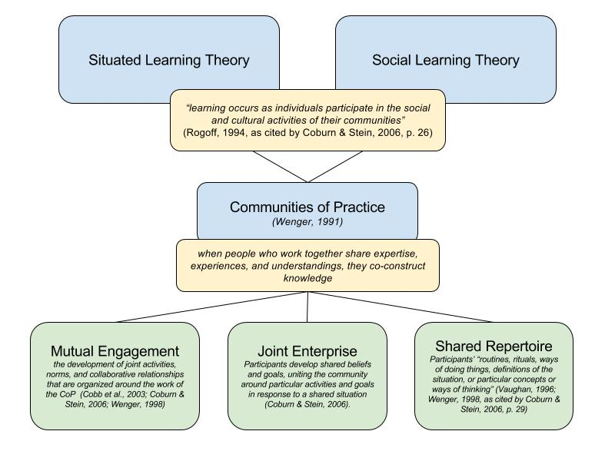
With these assertions in mind, the notion of Communities of Practice assumes that when people who work together to share expertise, experiences, and understandings, they co-construct knowledge. This is operationalized in the notion of Communities of Practice which integrates both social learning and situated learning theories. Wenger (1999) asserts that learning takes place within a CoP as participants engage in “the process of extending, redirecting, dismissing, reinterpreting, modifying, or confirming the histories of meanings” (p.52-53) and developing “concrete representations” (Coburn & Stein, 2006, p. 29) of their learning.
Figure 1. Communities of practice.

Critical Friends Groups
Critical Friends Groups are an enactment of both social learning and situated learning theories (Lave & Wenger, 1991; Wenger, 1998), contextualized through Wenger’s (1991) concept of Communities of Practice (CoPs). In numerous studies, teachers reported positive changes in their instructional practices due to their participation in teacher learning communities that have similar characteristics to CFGs (Graham, 2007; Nelson, 2009; Snow-Gerono, 2005). A growing number of studies are finding that CFGs, specifically, can be an effective approach to support teacher learning because they are a situated, sustained, and collaborative approach (Bambino, 2002; Baskerville & Goldblatt, 2009; Curry, 2008; Dunne et al., 2000; Kember et al., 1997; Swaffield, 2004, 2005). Teachers have reported that they become more reflective about their curriculum and their practices as a result of participating in CFGs (Dunne et al., 2000). Researchers have found that as teachers improve their self-efficacy through their inquiry into problems of practice, implement solutions based on best practices in their classrooms, and give and receive feedback from their peers, they have higher expectations for their students than their non-CFG peers and increase their willingness to try new strategies and instructional approaches (Bruce et al., 2013; Cantrell & Hughes, 2008; Dunne et al., 2000; Fairman & Mackenzie, 2012). An additional outcome of participation that Dunne et a., (2000) observed is that some teachers who participate in CFGs shifted from a teacher-centered instructional approach to a more student-centered one. Part of this shift included spending more time exploring topics in depth rather than rushing through curriculum.

Benefits of Critical Friends Groups
In addition to changes in teacher practices and instruction, CFGs can positively influence professional relationships among participants. For example, in a study that examined the experiences of two critical friends group participants who were serving in formalized, advisor roles, Baskerville & Goldblatt (2009) concluded that as a result of serving as critical friends, the participants cultivated their professional relationships, increased their ability to reflect, became more comfortable discussing and deprivatizing their problems of practice, and were more willing to seek out help and opinions from colleagues. Additional studies focusing on the experiences and engagement of participants in teacher learning communities generally and CFGs specifically have shown that the collaborative nature of these collegial conversations increase teachers’ appreciation of and access to their colleagues’ experiences, expertise, and perspectives (Graham, 2007; Snow-Gerono, 2005). Collaborative collegial work has other benefits. In a study that investigated the relationship between professional learning community activities and teacher improvement in a first year middle school, Graham (2007) found that one of the strongest themes that emerged from teacher interviews was that collaboration helped give participants a different perspective on their instructional dilemmas. Additionally, because teachers see each other as colleagues and as sources of support, their sense of empathy and collegiality towards one another increase (Dunne et al., 2000; Graham, 2007) and their feelings of uncertainty and isolation decrease (Snow-Gerono, 2005). In addition to strengthening relationships between colleagues through mutual engagement, the opportunity for teachers to collaborate and cooperate through CFGs increases school-wide communication and curricular coherence (Curry, 2008) as well as a sense of joint enterprise towards student learning (Graham, 2007).
The Structure of Critical Friends Groups
Conversation protocols are the principal activity of CFGs, and are used to foster collaboration between participants. Research on teacher learning groups that engage in conversations structured by the use of protocols have found that there are many benefits including changes in instructional practices, increased coherence, improved collegiality, and increased student achievement (Bruce et al., 2010, Garet et al., 2001; Graham, 2007; Nelson, 2009; Snow-Gerono, 2005). Protocols, which structure conversations around practice in systematic ways, can increase the capacity for learning, engaging teachers in critical reflection on their practices, providing opportunities for giving and receiving feedback through the development of a common language and a set of group norms, and distributing learning amongst participants; in effect, protocols create opportunities for teachers to improve their instructional practices through structured thinking, listening, and speaking routines that encourage deeper understanding and perspectives of a problem of practice before offering feedback, resulting in better quality feedback and new ideas (Baskerville & Goldblatt, 2009; Little, 2012; Nelson et al., 2008, 2009). The findings point towards the capacity of protocols to help facilitators and participants monitor and facilitate intentional conversations that support the development of collective understanding through a shared language and experience.
Collaboration in a Critical Friends Group
The collaborative experience and inquiry approach to learning fostered in CFGs seem to be cultivated because protocols encourage and require all participants’ perspectives and interpretations to be heard during the conversations. Nelson et al. (2008) documented this in a narrative case study that examined teachers’ engagement in collaborative professional learning community meetings. During unstructured discussions, some voices were more dominant than others, but teachers felt that conversation protocols helped to distribute participation more evenly across participants. This finding is consistent with Snow-Gerono’s (2005) finding that protocols help formalize teacher talk to create a more inclusive conversation that engages the voices of all the participants, thus providing greater diversity of perspectives. The inherent structure of protocols ensures integrity and direction for the conversation, as well as creates more opportunities for teachers to actively listen to one another within an inquiry-based examination of student work (Levine, 2011; Little, 2012; Nelson et al., 2008; Wood, 2007). As a result, teachers generate new knowledge and are able to offer more thoughtful feedback to one another based on a deeper, better understanding of a problem of practice and their colleagues’ perspectives.
Critical Friend Relationships
Developing trust between critical friends is critical to the success of the group, and yet it is one of the greatest challenges of implementing successful CFGs (Bambino, 2002; Dunne, 2000; Kember, 1997; Swaffield, 2004). This trust can be established through team-building activities, developing a sense of shared responsibility for student learning, as well as taking time given for critical friends to gain an understanding of each other’s contexts, purposes, and challenges which comes from sharing classroom and teaching data during the meetings (Bambino, 2002; Dana & Yendol-Hoppey, 2008; Dunne, 2000; Kember, 1997; Swaffield, 2004). Once trust is established, teachers are more likely to collaborate openly and honestly with one another, one of the most important aspects of CFGs and a cornerstone of all successful teacher learning communities. Without trust, none of the potential benefits are possible (Bambino, 2002; Dunne et al., 2000; Storey & Richard, 2015; Swafield, 2004).
If teacher learning communities such as CFGs truly commit to improving practice, focusing on student learning, collaboratively setting goals, and establishing action plans to meet those goals, the findings described in the studies above suggest student achievement would increase, although this has not been empirically demonstrated.

Getting Started: What is a Critical Friends Group?
Typically, CFG are comprised of “5-12 members who commit to improving their practice through collaborative learning and structured interactions (protocols), and meet at least once a month for about two hours.” (NSRF, n.d.). This definition can be viewed merely as suggestions rather than stipulations for an optimal experience, but may be tailored to fit each group’s needs. However, all CFGs have some common features regarding the work they do together.
“A CFG is a group of caring colleagues who are not necessarily like-minded, but who are unified in their desire to be open to reflection, growth, learning, change, receiving and giving feedback, and exploring best practices. A CFG must be brave and honest and trusting!”
Morgan G,
Far Brook School CFG Participant

What do Critical Friends Groups Do Together?
Critical Friends Groups commit to meeting regularly in order to:
- Identify issues, challenges, and dilemmas relating to teaching and student learning
- Use close observation and analysis of student work (writing samples, assessments), teacher work (lesson plans, classroom observations), or other forms of data (assessment data) to inform decisions about improving practice
- Collaboratively generate potential solutions (NSRF, n.d.)

Who can be a Critical Friend?
“A critical friend is a trusted person who asks provocative questions, provides data to be examined through another lens, and offers critique of a person’s work as a friend. A critical friend takes the time to fully understand the context of the work presented and the outcomes that the person or group is working toward. The friend is an advocate for the success of that work”
Costa & Kallick, 1993, p. 50
Facilitators and CFG participants can come from a wide range of roles within their schools.
Critical Friends can be:
- formalized coaches and advisors (Baskerville & Goldblatt, 2009; Costa & Kallick, 1993; Swaffield, 2004, 2005),
- administrators (Dunne, 2000; Swaffield, 2004),
- university researchers (Kember, 1997),
- teachers (Bambino, 2002; Curry, 2008; Dunne, 2000; Swaffield, 2004),
- students (Costa & Kallick, 1993).
What are the Characteristics of a Critical Friend? Critical Friends should have:
- well-developed communication skills,
- strong content knowledge,
- trustworthiness,
- the ability to be supportive,
- the ability to stimulate thinking, and
- the ability offer constructive feedback. (Bambino, 2002; Dunne, 2000; Kember, 1997; Swaffield, 2004)

The Facilitator’s Role: An Overview
Skilled facilitation includes the careful and intentional planning of activities, resources, structures, and conditions that encourage teacher participation and learning. As depicted in the vignette below, facilitation requires much more than simply setting up a room, or printing an agenda.
Facilitator: Today we're going to look at a piece of student writing from second grade. It's a Halloween story, so it's a little dated, but we're going to use a very specific protocol to guide our conversation. For those of you who have not participated before, the way that it works is that we're going to be going around in a circle and respond to each of these prompts. The goal of the protocol is to give everyone an opportunity to voice their opinion and their thoughts; it also gives you some time to process before you jump into the conversation. You wait your turn, you can say pass, and you can repeat. In fact, repeating is actually pretty powerful because we might notice some certain themes or patterns that are emerging.
If you'll notice on the back of the agenda, we have the rubric for narrative writing from a book, Writing Pathways. It's Lucy Calkins' book for rubrics and assessments. Since we're really trying to, in lower school, align our practices with the Teacher’s College Writer's Workshop approach, Jamie [a graduate student at Teacher’s College] suggested this resource for us.
After the meeting, I'm going to send you a request for reflection. It'll be anonymous. If there are kinks or things you are uncomfortable with, it's great to get honest criticism so that we can work those out and see how everybody feels about the process.
We're going to start ... We're talking about our framing question which is going to be, “What are the characteristics of proficient writing in 2nd grade?” We're going to be using our rubric to determine that. What are the characteristics and does this piece of work demonstrate characteristics of proficient writing? If not, where do we go with this student? If it does, still where do we go with this student? The rubric gives us a continuum of lower school grade levels. Morgan or Joan, do one of you want to give the context for this writing piece since it was your student piece?
Morgan: Sure, we were writing small moment stories, a unit on that, and although this is a Halloween story that wasn't part of the assignment. The student just chose to write about Halloween. Students were writing things of their own choosing, trying to isolate something that would not be a moment that lasted for a whole day. Some people were more successful with that than others, but he spent a lot of time on this story. He came back to it over and over again.
Facilitator: Were there any other specific assignment guidelines you gave them?
Morgan: This was an on-demand I do know…small moment writing.

As featured in the sample Facilitator To-Do List on this page, the facilitator’s responsibilities cover a wide range of tasks and skills. The National School for Reform Faculty lays out three domains and the associated tasks that fall under the responsibilities of a facilitator: Learning, Logistics, and Longevity (see figure on p. 20).
Learning
While the learning that occurs during a CFG is generated by the group as a whole, it is the facilitator who is responsible for ensuring the group knows the purpose and focus for their work. This can be accomplished as simply as stating the overarching goal or focusing question at the start of each meeting. Facilitation also involves guiding participants through the conversation protocol being used. This includes transitioning the discussion between conversation rounds, as well as synthesizing and summarizing the big ideas. Facilitators document and acknowledge the group’s work and progress to move the work forward. Finally, it is the facilitator’s job to check in with participants on their experience during the learning process and offer support if needed. In order to promote learning I made sure to use on-going evaluation throughout the CFG meetings to gauge how teachers felt about the process and the impact of the meetings on their practices. Based on their feedback, I would adjust and plan future meetings accordingly.
Facilitator To-Do List
- Meet with administration advocate for CFGs
- Choose a topic and participant group (this was decided by administration after CFG approval was given)
- Secure a meeting time and schedule
- Decide on a problem of practice based on the assigned topic
- Select a conversation protocol to match the intended outcomes of the group, as well as the problem of practice
- Gather any relevant materials (in this case, a professional text)
- Decide on a facilitator and presenter
- Develop and share an agenda with group
- Prepare relevant materials (writing materials, copies of professional text, protocol, student work, agendas)
- Secure and prepare learning space (my classroom)
- Purchase refreshments
- Communicate schedule, agenda, protocol, and meeting details with participants
- Open the meeting
- Facilitate the conversation protocol, redirecting and synthesizing as needed
- Close the meeting
- Document meeting activities, outcomes, and next steps
- Check in with participants
- Prepare for next meeting

Logistics
Ensuring the process runs smoothly is also part of the facilitator’s job. This includes managing and organizing the space, schedule, and stuff. For me this meant securing and reserving a meeting time and room, providing snacks, preparing materials and agendas, and assigning roles which are all part of this domain.
Longevity
Finally, it is the facilitator’s job to ensure the work of the CFG is sustained over time through the motivation and commitment of its participants, but also through secured support via funding and/or time. This involves identifying and linking the CFG’s goals to the school’s overall goals and communicating the progress to stakeholders. An effective facilitator also uses distributed leadership to mentor and build efficacy amongst its participants. In order to distribute leadership amongst my teachers, I set the expectation that all teachers would have the opportunity to present their work at one of the CFG meetings. I also offered teachers the opportunity to facilitate a meeting.
It is important to note that each domain is equally important, there are many overlaps, and that understanding the complicated role of facilitator is crucial to the success of the group.

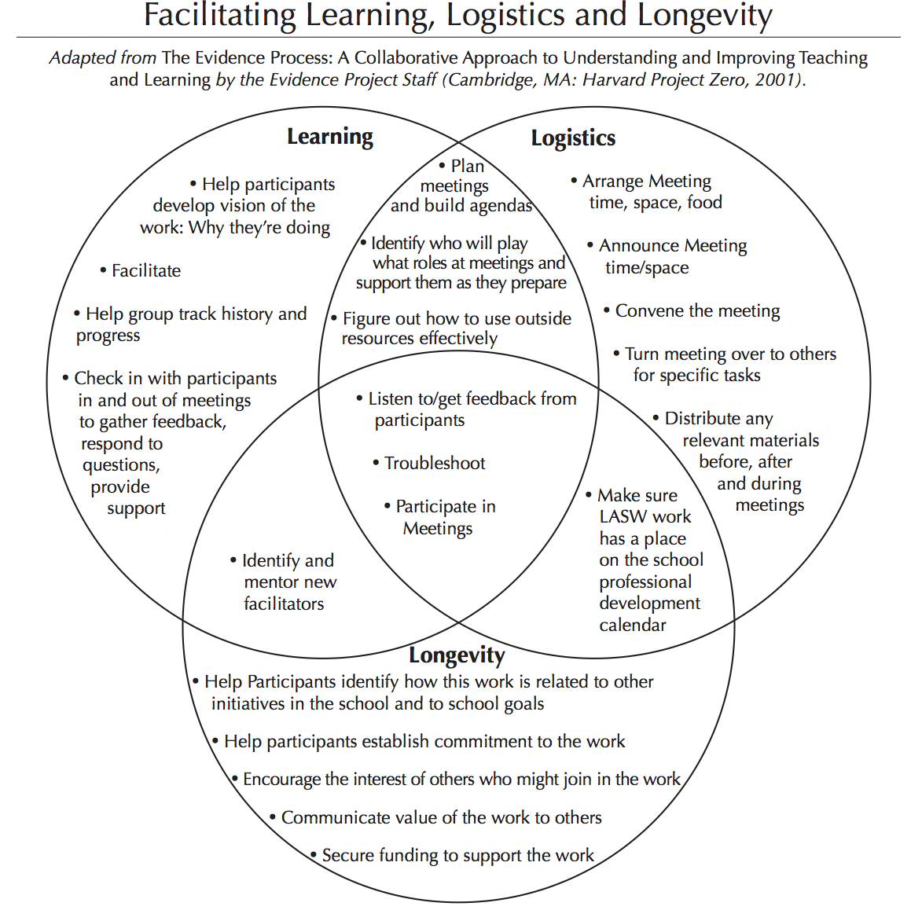
CFG
Determine
NSRF, n.d.

Planning for Facilitation
Planning for facilitation of a CFG involves determining who will be involved, what the group will focus on, and when the group will meet. The following sections will outline specific facilitator responsibilities before, during, and after leading a CFG meeting as an effort to strengthen CFG facilitator capacity to be effective.

Who: The Participants
The first step towards successful facilitation of a CFG is figuring out who is going to participate: Will they be voluntary? Required to participate? Will they be a homogeneous group of similar content area or grade level teachers, or will the participants represent a diverse array of content areas and grade levels? Depending on who the participants are will help to decide what the group will focus on, and when the group will meet.
In an initial pilot study, I began CFGs with voluntary participants outside of the school day, opening it up to any grade level or content area teachers who wanted to present a dilemma. As a result of the participants’ positive experiences, I was able to advocate to the administration for a more formalized CFG that was built into teachers’ schedule. While the built-in nature of the sessions supported greater attendance and sustainability, it did limit who could participate to only lower school, classroom teachers.
Distributing facilitation and leadership. Democratic structures of distributed leadership and equal opportunities for leading help flatten the hierarchy of power, and are key components of CFGs. CFGs run on the premise that all members of the learning community have a stake in their own and their students’ learning and can all contribute to making change and generating knowledge (Timperly, 2005). Therefore, as participants become more comfortable with the format and process of CFGs, it is important to offer everyone the opportunity to present and facilitate in order to foster distributed leadership and increase buy-in. Setting the intention early on of distributing the facilitation and presenter roles to others will encourage participants to observe the facilitation process as they prepare to take on this role. A Google Doc is a great resource for record keeping and storing a schedule of presenters and facilitators (see Appendix for sample sign-up/schedule).

Troubleshooting participant bends in the road. While distributed leadership can be seen as an act of empowerment, it is important to note that not all participants may feel this way due to fear, lack of experience, lack of understanding, or lack of time. The table below features some potential challenges when offering distributed leadership opportunities to participants and potential solutions should they occur.
Bend in the Road | Possible Explanation | Possible Solution
Lack of presenter volunteers | - Fear of volunteering  - School culture is one in which teachers only share successes | - Establish the norm, or expectation, that everyone will share data on a rotating basis and create a collaborative schedule – when I first introduced CFGs, I stated from the start that each week a different grade level would be responsible for sharing their student work for analysis  - Discuss the problem with the group and brainstorm solutions
 | Participant is unsure of what to present | - Provide a limited menu of options to choose from: generally, work that is presented should reflect one of the following:  - Something that you’re wondering about  - Something you want to revise or improve  - Something that raises a dilemma  - Help the person identify a current challenge or concern as a source of work to present – as facilitator, I visited classrooms to look through student work to help teachers select which student work samples would be appropriate to share
 | Participant feels uncomfortable/ vulnerable sharing work | - Meet with the participant to explore reasons they may feel uncomfortable sharing their work – if the lesson or product seems flawed, frame it as a problem of practice to be problem solved  - Model the process using your own, or anonymous, work to demonstrate the purpose of the process is not blaming or shaming, but rather problem solving  - Invite more readily willing participants to present first to give more hesitant participants time to build trust and see that the effort is worthwhile
 | Participant lacks time to gather or prepare materials | - Offer to make copies of student/teacher work, as well as protocols for the meeting
Lack of facilitator volunteers | Fear of volunteering | - Establish a norm, or expectation, at everyone will facilitate a meeting on a rotating basis and create a collaborative schedule
 | Participant is unsure what protocol to use | - Model think alouds to give facilitators an understanding of the process employed to select a protocol  - Work as a group to select a protocol, debrief the process, so that participants feel confident in their ability to choose their own protocol (with support)
 | Participants feel like they lack the skill or knowledge to facilitate | - Model facilitation, using think alouds to provide insight on decisions made as the facilitator  - Provide opportunities for supported practice with coaching and feedback  - Co-facilitate with gradual release of responsibility  - Provide coaching and feedback  - Debrief after each session to make the facilitation process as transparent and accessible as possible
 | Participant lacks time to gather or prepare materials | - Offer to make copies of student/teacher work, as well as protocols for the meeting
In order to build facilitation capacity within the group, it will be important to model the facilitator roles, responsibilities, and dispositions outlined in this handbook. As mentioned earlier, facilitation is not simply setting an agenda and overseeing a meeting so meeting with facilitators ahead of time to clarify and confirm what aspects of learning, logistics, and longevity they will be responsible for when it is their turn to facilitate is an important step.
The presenter is responsible for presenting a problem of practice, as well as any data (student work, teacher work, assessment data, professional text) that reflects or will help support the group in understanding the problem. To best prepare presenters ahead of time, you should meet ahead to discuss the nature of the work being presented, as well as the purpose for sharing the particular piece of work to ensure that both lend themselves towards reflecting a problem of practice that invites feedback (see page 25 for more details on how to choose a problem of practice). During this time, you should also collaboratively choose a protocol that matches the presenter’s desired outcome (see page 32 for more details on how to choose a protocol).
It is important to note that while the facilitator and presenter have designated roles with specific responsibilities, it is truly the participants of the group who carry the real responsibility of listening, reflecting, problem solving, and contributing towards changes in practice.

What: Choosing a Problem of Practice.

The vignette below reflects the process in which CFG participants discussed and decided upon a topic (the communication of student progress from year to year) and a problem of practice (lack of systems) that the teachers felt needed to be addressed. It also illustrates the importance of a facilitator to listen and synthesize the participants’ comments to best summarize the group’s thoughts and ideas.
Morgan: Pretty much, the year wraps up, we write our reports. Personally though, my impression is that it's often a lot more social, emotional feedback and we don't really communicate a lot of academic progress…they’re written more for the parents – tricky parents.

Jennifer: I think that's true. I think the hard thing is, with portfolios, when the year starts you never look at them. We have everything else to read. It would have to be something simple. If I got 10 pages of reports, I wouldn't read it. I never look at reports either unless it's a kid who you know that parent is going to come in and be like "Have you read the evaluation, have you read it?"

Joan: We do transition meetings.

Jennifer: That's all we've ever done to my knowledge.

Joan: Well you’ve given us one sheet of paper that had every kid's name on it and had what their reading level, where they ended their reading level, where you saw them in math at the end of the year.

Morgan: Last year I, because it was driving me crazy, because I knew the class you currently had had so many needs and there was so much to talk about, I created a Google doc for Joan and I to fill out, a very, very brief version of those reports - reading level, math, and just very generalized. High, medium, low basically, just so you had a snapshot of patterns. That's what we did. I'll admit I haven't done that this year.

Facilitator: Just to restate, the problem of practice seems to be that we do not have a consistent, efficient or useful way of communicating academic progress.

What do we think about the dilemma? Is this something worth thinking about? What assumptions do we have? What have we done in similar situations?

Morgan: I definitely think it's issue we should be talking about. Especially when you restate it as a dilemma, it seems like a problem that there isn't a way to pass on academic information in an efficient way. All the academic information is out there, like reading reports, it's out there if we wanted it. It's about patience. There's ways to get the information, but once school starts those ways don't feel preferable.
Topic selection in a CFG can be a collaborative decision made by the group with support from the facilitator, or pre-determined (which may often be the case if there is a department or school initiative being imposed upon teachers). The selection should consider who the primary participants will be and whether focusing on multiple topics, content areas, grade levels or a single one is best, as well as whether or not the topic will be sustained long term, or exist for a single meeting. No matter what, the importance, relevance, and focus on student learning of the topic should always be the top priority when choosing a topic for your group’s inquiry.
The table below delineates the differences, advantages, and disadvantages to choosing different topics for each meeting versus having a longer term theme or focus. Some CFGs switch topics each meeting, while in contrast, others focus on an overarching theme for a longer duration such as a semester or year.
 | Single Meeting Topics: | Long Term Topics:
Example | A CFG comprised of teachers from diverse content areas and grade levels were invited to present on problems of practice from their respective heterogeneous content areas and grade levels. | A CFG comprised of first through third grade classroom teachers focused on writing instruction through the analysis of student writing was the theme for an entire year.
How the Topic was Selected | The topic for each specific meeting were determined and discussed by the facilitator and designated presenter ahead of time.  If given the freedom to choose, topics should be selected and decided upon between the designated presenter and facilitator; additionally, they could potentially be selected collaboratively at a previous meeting. | This topic was selected based on an expressed need by teachers, as well as an administrative request based on that need.  If given the freedom to choose, selecting a longer term topic should be a collaborative decision based on an expressed need of those participating in the group.
Advantages | Changing topics each meeting encouraged a wide array of perspectives, as well as “looks” into classrooms teachers might not have otherwise had an opportunity to see or hear about. It also helped inform teachers of language, skills, and strategies being used in various classrooms and content areas that could be applied in their own, building consistency and coherence across the school. | Focusing on a single theme for the year enables teachers to build upon each meeting’s outcomes with new learnings and a deeper understanding of a single topic. It also looks at a single content area to see how it develops and evolves throughout the year.
Disadvantages | A disadvantage to this approach was that each meeting’s content and outcome occurred in isolation, rather than building upon each other. However, because the group used conversation protocols each time, the group was still able to develop and grow in their familiarity with the CFG process, which contributed to more ease of use, and potentially more thoughtful contributions. | A disadvantage to this approach was that some teachers who wished to participate didn’t feel they could contribute as much as they’d like because they were special area teachers, not classroom teachers who taught writing. This experience, however did provide those teachers with insight into the skills, strategies, and practices that their mutual students were using.

The following questions can help guide the process of choosing topics:
- What needs improving?
- What could we be doing better?
- What school-wide initiatives do we need to respond to?
- What are students resisting?
- What do we want to improve?
- Based on assessment data, what needs improvement?

Turning a Topic into a Dilemma. Once a topic has been selected, a problem of practice or dilemma related to the topic is needed for the group to address. NSRF defines a dilemma as: “a puzzle, an issue that raises questions, an idea that seems to have conceptual gaps, something about process or product that you just can’t figure out” (n.d.)
Examples of dilemmas your CFG may consider focusing on:
- A disconnect between theory and practice
- Unmet learning goals
- Lack of assessment tools or methods
- Inconsistent or difficulties implementing curriculum
- Lack of differentiation in a content area

What: Working with Protocols and Professional Texts
The CFG that informed this handbook utilized two processes that were instrumental in supporting teacher learning and changes in practice. These were the use of conversation protocols and the professional text, Writing Pathways: Performance Assessments and Learning Progressions, Grades K-5 (Calkins, 2013). Conversation protocols were used to organize the structure and schedule of the meeting, while the contents were driven by whichever grade level teacher was presenting student writing during that session and the corresponding grade level writing assessment rubric from Writing Pathways.

Why protocols? One factor that contributes to effective teacher learning during CFGs is the use of structured conversation protocols to foster collaborative learning conversations (Baskerville & Goldblatt, 2009; Levine, 2011; Little, 2012; Nelson et al., 2008; Snow-Gerono, 2005; Swaffield, 2005; Wilson & Berne, 1999; Wood, 2007). The quote provides an overview to a conversation protocol called the Constructivist Protocol for Adult Work, which was used in a CFG to structure a conversation around a note keeping tool developed by a second grade teacher.
Facilitator: We're going to be using this Constructivist Protocol for Adult Work. If you look at the different rounds, we have number one, where Jamie will present and share her work. Number two is clarifying questions. Number three, reflecting on the qualities of the work. The third round will have two parts. We'll do that warm feedback, so the strengths. Then, we'll do cool, like concerns that you might have. Then, we'll also do maybe suggestions for tweaking. Finally, we'll have Jamie reflect, because she's actually created and used this tool. She can maybe address some of our concerns or suggestions. After we celebrate her work we’ll have a debriefing. We can talk about the process, and you guys can also jot it down on your reflections for me, which have been really helpful. (Video Transcript, Session 6)
The National School of Reform Faculty (http://www.nsrfharmony.org) is the leading resource for protocols used by Critical Friends Groups. There are a wide variety of protocols available on their website and by simply googling for them that offer a range of specific prompts for discussion, but the general format of protocols that guide discussions start with the presenter’s framing question or dilemma, followed by participants’ questions that clarify and provide details to their understanding of the dilemma, a close, descriptive examination of data (e.g., student work, teacher work, assessment results), rounds of responses to discussion prompts that focus on description, recommendations or implications for practice or next steps, the presenter’s reflection and response, and finally, a debriefing of the process and protocol. See Appendix for sample protocols.
The following table highlights the potential benefits of using a protocol, the reasoning behind the benefit, and testimonies from CFG participants as to how and why protocols improved their learning experiences.
Potential Benefits of Protocols | Why? | What Teachers Say
Changes the ways that teachers speak to and with one another. | Protocols provide norms, or guidelines, that foster safe, respectful environment for giving and receiving feedback by using specific prompts that prevent a group from straying off topic, judging, or criticizing, thus increasing conversation’s substance and professionalism (Levine, 2011; Little, 2012; Nelson et al., 2008; Wood, 2007)  Structuring conversations around practice in systematic ways increases the capacity for learning, engaging teachers in critical reflection on their practices, provides opportunities for giving and receiving feedback through the development of a common language and norms, and distributes learning amongst participants; in effect, protocols create opportunities for teachers to improve their instructional practices through more effective communication (Baskerville & Goldblatt, 2009; Little, 2012; Nelson et al., 2008, 2009) | “The difference between other meetings and CFG was that we had a focused question and had to stay on topic. With the format of going in a circle and having everyone respond in order, it forced us to stay on topic and not get pulled in a different direction.”  Marissa, Far Brook School CFG Participant  “The formality of protocol usage created a sense of order and safety in sharing and receiving feedback.”  Morgan, Far Brook School CFG Participant  “[I would advise someone just starting CFGs to their school] to be disciplined about sticking to a scheduled time and following the rules for speaking.” Jennifer, Far Brook School CFG Participant
Encourages collaboration and equitable participation | Protocols encourage and require all participants’ voices to be heard during the conversations (Nelson et al., 2008)  Problems are addressed as a joint effort and a shared concern (Storey, 2015) | Because of the way protocols require participants to take turns speaking, they provided an opportunity for teachers “to hear from people who may not normally talk or share during meetings” Marissa, Far Brook School CFG Participant
Increases productivity | Conversation protocols help structure conversations so that they are more likely to be productive, particularly because of their use of inquiry, data, and relationships (DuFour, 2004; Earl & Timperly, 2008 as cited by Selkrig & Keamy, 2015; Levine, 2011; Little, 2012; Nelson et al., 2008; Wood, 2007) | “I really value protocol usage as an efficient and valuable tool in shaping a conversation to be action/outcome driven.”  Morgan G, Far Brook School CFG Participant  “The conversations were much more productive. I think they were more productive because the group was very focused and had one objective to accomplish. The CFG stayed on topic and did not go in 10 different directions with only 1 or 2 people talking the entire time.”  Marissa, Far Brook School CFG Participant
Encourages reflection. | Critical reflection on practices occurs because the “the political nature of CFG conversations often precipitated disputes that required members to articulate positions, unpack assumptions, clarify terms, and challenge each other’s reasoning” (Curry, 2008, p. 752) | “I was thinking, just sitting here, it's always great that we can take the time to really zero in on somebody's work and to really be thoughtful about what's going on in that moment for them. I think it's a great process and for me personally, forces me to sit down, and really look at this work when we're multitasking in so many different ways.”  Pamela, Far Brook School CFG Participant
Upholds integrity and progression of the conversation | Protocol rounds slow the rush to judgement and still move participants productively toward developing concrete implications for practice. (Levine, 2011; Little, 2012; Nelson et al., 2008; Wood, 2007) | “You can’t interrupt, you can listen and reflect.” Jennifer, Far Brook School CFG Participant
Supports changes in practice | Structuring conversations around practice in systematic ways increases the capacity for learning, engaging teachers in critical reflection on their practices, providing opportunities for giving and receiving feedback through the development of a common language and norms, and distributing learning amongst participants; in effect, protocols create opportunities for teachers to improve their instructional practices through more effective communication (Baskerville & Goldblatt, 2009; Little, 2012; Nelson et al., 2008, 2009) | “The focus on the actual work of students and the range of [my colleagues’] responses helped me to be more observant and discerning about the subtleties of students' understanding and ability to actualize what they are learning.”  Joy, Far Brook CFG Participant

Using a professional text. In my experience, I have used professional texts within the context of a professional book study group in order to increase content knowledge with little opportunity to really synthesize, interpret, critique, and apply the learning. In the CFG that informed this handbook, the use of the professional text, Writing Pathways: Performance Assessments and Learning Progressions, Grades K-5 (Calkins, 2013) in conjunction with the conversation protocols added even greater focus and productivity of conversations. The use of an external source is a deviation from the traditional CFG process of looking at student work, teacher work, or assessment data, however, using the professional text has potential to deepen the group’s collective content knowledge, thus increasing the application and understanding of text and, as a result, curricular cohesion and implementation fidelity.
This particular text provided content knowledge and assessment rubrics that teachers were able to refer to while analyzing student work. Here are some tips for using a professional text in conjunction with conversation protocols during your CFG:
- Provide copies of the text for your participants in advance of the meeting so they can become acquainted with the material
- Build time into meetings for participants to read or re-read the material – don’t assume everyone was able to read it ahead of time
- If you are short on time or want a narrower focus, use portions of a text such as chapters, paragraphs, or tables for participants to examine
- Match protocols to the text (see more in the next section on choosing protocols)– protocols that are appropriate for using with a text include:
  - Final Word Protocol – expands text interpretation through collaborative input
  - The Text Rendering Protocol – increases understanding around a common topic
  - The Four A’s Protocol – to analyze the content of a text taking into consideration one’s assumptions, agreements, arguments, and aspirations
  - Rich Text Protocol – helps to unpack dense or complicated text for better understanding

Choosing protocols. The presenter and facilitator should communicate ahead of time to discuss what is to be presented and what protocol best fits the discussion. In The Facilitator’s Book of Questions, Allen & Blythe (2004) state that protocols have the capacity to identify problems, deepen understanding, or combine the two through the use of open-ended questions or problem solving steps. The selection of the protocol will depend on what the group’s goals and/or problems of practice are which is why it is so important to have the problem of practice identified first. Together, the facilitator and presenter should look at various protocols’ purposes and match them with their data and intended outcomes. To expedite this process, many resources have been developed featuring condensed versions of popular protocols and their purposes in order to support matching:
Books:
- Allen, D., & Blythe, T. (2004). The facilitators book of questions: Tools for looking together at student and teacher work. New York: Teachers College.
- McDonald, J. P., Mohr, N., Dichter, A., & McDonald, E. C. (2013). The power of protocols: An educators guide to better practice. Moorabbin, Vic.: Hawker Brownlow Education.
Websites:
- School Reform Initiative (https://www.schoolreforminitiative.org/tag/choosing-a-protocol/)
- National School Reform Faculty (https://www.nsrfharmony.org/protocol-matching-tool/)

Troubleshooting protocol bends in the road. Despite the many benefits to protocols outlined in the section above, they are not without their challenges, particularly if participants are new to them. For example, participants in my CFG were unaccustomed to waiting for a designated turn to speak and would often try to jump in to add their input, or respond mid-round as a presenter. Being prepared with ways to redirect, while reminding participants of the purpose of the protocol helps to build in habits and routines as participants become accustomed to the practice.
Bend in the Road | Possible Explanation | Possible Solution
Participants say that protocols make conversations too awkward or too structured | Using conversation protocols is a very different and specific way of engaging with each other. It can feel stilted until people begin to get a feel for the benefits of the process. | Encourage participants to trust the process, and debrief about the process afterwards by asking for observations about what went well, what didn’t, and ow did using a protocol move the conversation along? How did it not?  Discuss the benefits of controlling the conversation even if it sometimes feels awkward or stilted – remind participants that as they get better and more familiar with the structures, this will become less of an issue.  Don’t use protocols as the only form of interaction in the group, or modify them to be used in more flexible ways that suit the group and the goals of the group  Discuss the benefits of structured conversations
Participants do not adhere to the protocol | It could be that some people are resistant, or that they have simply forgotten the norms and protocol because it is new to them or don’t understand the value of sticking with it. Other reasons could be that they are excited and tempted to jump to implications and recommendations before fully exploring the data. | Gently redirect participants back to the protocol, referring to the agreed upon norms.  Remind everyone that the purpose of the rounds is to move the learning forward and give everyone an opportunity to speak and to keep the conversation focused and “safe” for the presenter  Designate and rotate the role of a participant to keep the group on track with the protocol; remind the group of this role  If an issue continues despite redirection, consider a one-on-one conversation with the participant outside of the meeting to understand what factors are affecting their participation.
The presenter forgets to bring student data | The presenter may have forgotten, or not had a chance to prepare for it due to a busy workload and/or schedule | Give presenters a reminder a day in advance that they’ll be responsible for bringing data
One participant repeatedly passes on participating | Resistance to the process, shyness, lack of confidence | Be patient and encouraging to passing participants; indicate that their voice is valued  Consider a one-on-one conversation with the participant outside of the meeting to understand what factors are involved in the non-participation.
Participants do not feel the process yielded new learning | The shared data or focusing question or dilemma is not rich enough, the protocol was a poor match for the problem, or the group does not feel engaged | Reflect as a group on why the process may not have worked – was it the problem of practice? The protocol? The group engagement?

What: Developing an Agenda
Creating an agenda is an important way to ensure that the time allocated for a CFG is being used in a focused, organized, and efficient way. Providing participants with an agenda before the meeting lets them know what to expect. It also helps them to be better participants because it gives them a chance to prepare materials, questions, or concerns they may have regarding the topic, and previews the process and any protocol you may be using. The vignette below illustrates how an agenda that structures and organizes meeting time can move conversations forward.
Researcher: What exactly is frustrating about the current faculty meeting and professional development time - is it the quantity of time, misallocation of time, how the time is spent?
Marissa: How the time is spent is one problem. The way the time is arranged is also a problem. There are no plans, agendas, goals, so it just feels unclear and ambiguous.
When developing an agenda, the facilitator must balance the content of the meeting with the allotted time, while ensuring that the purpose and goal of the meeting is met. The agenda I created and used with my participants generally followed this format:
- Facilitator Introduction (5 min) –
  - Check in with participants to get a read on the room – how was their day, what pressing issues might they have, questions or concerns regarding to or that may impact the impending meeting
Tips for Setting an Agenda
Write time allotments down to each activity so you know how much time to designate to each
Overestimate time allotted for activities to build in a time “buffer” – better to end ahead of schedule than run out of time or worse, go late
Use previous meeting closures to inform future meeting agendas
Send agendas to participants ahead of time to give them a preview and the opportunity for revisions
Make hard copies to share at the actual meeting
  - Review the agenda and see if there are any revisions that need to be made
  - Set, review, or revise norms
  - Debrief on previous meetings, action steps, etc. – what have people tried or done as follow up from the last meeting?
  - Review the purpose and steps of the protocol
  - Introduce the presenter and problem of practice (or dilemma or focusing question)
- Conversation Protocol: Discussion Rounds and Process Debrief (time dependent on protocol selection, number of participants, and the nature of the data)
- Next Steps (5-7 min)
  - Make plans for next steps/future meetings
  - Announcements

When: Scheduling your CFG
“I wish CFGs were a regular part of our faculty meeting time, that they could extend beyond a single school year. I always wanted more, or better time to meet - after school sometimes felt hard to be as mentally available as I wanted to be.”
Morgan G, Far Brook School CFG Participant

One of the most challenging aspects of CFGs is finding a common time for participants to meet. As Snow-Gerono (2008) points out, “﻿[Teachers] rarely have time that is not additional to their school lives where they may engage in conversation groups with professional colleagues, whether in their school sites or across multiple school sites and districts.” Therefore, this time is ideally built into teachers’ days as part of their professional development. However, often times, that is not the case.
Using Built-In Time for CFGs. Having CFGs built into teachers’ daily schedule increases attendance, and the consistency of who is attending the meetings. Teachers that are required to participate in a CFG during their work day, either during a scheduled prep period, professional learning, or meeting time engages participants who might otherwise be hesitant or resistant to participating. It also provides more consistency in scheduling and increases the potential that the CFG will be sustained once part of a school’s routine schedule.
In order to advocate for teachers to have time built into their schedules for CFGs, it is important to ensure that the various stakeholders understand the importance of using time for this purpose and what it is being used for. Engaging stakeholders and decision makers in a conversation about school-wide initiatives or problems of practice can help to create buy-in. Meeting with administration to present why time should be allocated for CFGs is critical to securing scheduled time. During this meeting, the process, potential topics, and potential outcomes of CFGs should be presented, and how the CFG addresses learning needs. For the CFG work that informed this guide, I met with administration to see what concerns or initiatives they felt needed to be addressed. When the administration requested that we focus on more effective implementation of the Teacher’s College Writer’s Workshop curriculum, I consulted with one of our teachers who was a graduate student at Teacher’s College at the time, and she recommended focusing on using assessment rubrics.
When preparing to meet with administrators to advocate for time, facilitators should also take a look at potential places in the schedule that this work could take place – is it during a common prep time? Faculty meeting time? Designated PD time? Then, decide how the work that normally takes place during that time can be re-allocated or accomplished in a different way – can information be disseminated electronically? Could there be a rotating schedule of agendas? Using the answers to these questions, facilitators can make suggestions and proposals to administrators. Finally, in order for administrators to see and feel that the time is being spent wisely, it will be important to share how the work of the group has impacted teachers’ practices, and student learning.

Troubleshooting Scheduling Bends in the Road. The following table describes possible challenges and solutions that may arise when working with formalized, mandated CFGs:
Bend in the Road | Possible Explanation | Possible Solution
Failure to attain buy-in from all participants | The process, goals, and work is new, misunderstood, or unknown | - Conduct a needs assessment to identify the needs of potential participants and then choose a topic that will likely be of interest to participants  - Share an example agenda and protocol to give participants and idea of the activities  - Highlight opportunities for distributed leadership  - Invite hesitant potential participants to sit in and observe a session
Scheduling may be controlled by administration and therefore can be re-assigned, re-scheduled, etc. | Administration doesn’t fully understand the importance of the work | - Use email or a Google doc to conduct a virtual meeting for the missed time  - Present work to administration to advocate for the time being made up  - Communicate the importance of the work by consistently sharing progress and learning outcomes
As part of providing time for CFGs, administration may also prescribe the topic for CFG. | Administration has time-pressing information or initiatives they have to prioritize | - Engage participants in identifying the problems of practice relating to that topic to create a sense of ownership  - Ask to compromise and request possible topics/initiatives from the administration that the group could work on; then as a group, identify which would be the most impactful to study

Finding Time to Work with Volunteer Participants. If time during the school day is unavailable, working with teachers who volunteer their own time can be another option. While gaining administration buy-in isn’t necessarily part of this process, it is still important to share the benefits and potential outcomes for participating in a CFG. This can be done via email, face to face conversations, or if the school provides opportunities for announcements (i.e., school newsletter, faculty meeting announcements, etc.). One of the primary benefits towards using volunteered time is that by volunteering, the participants are demonstrating buy-in and are willing and motivated to be part of the CFG. Because the schedule is not limited to specific or mandated meetings times such as divisional or grade level prep or meeting times, this approach can also encourage diversity amongst its participants as. On the other hand, it can also result in limiting potential participants who find it hard to commit to the time or are hesitant or resistant due to the unfamiliarity of the process. Even with willing and volunteer participants, scheduling conflicts if the CFG is being scheduled outside of the school day and using a Doodle poll or Google form to survey participants on best possible meeting times and days is a helpful way to schedule your meetings. Eventually, sharing the learning outcomes of these meetings can be helpful in securing a more formalized, built-in time from administration (see above). The following table describes possible challenges and solutions that may arise when working with CFGs that are scheduled based on volunteer availability:

Bend in the Road | Possible Explanation | Possible Solution
Finding a common time that works for everyone | Outside responsibilities, commutes, and schedules all vary | Use a survey tool such as Doodle or Google Forms to schedule meetings  Use virtual meeting platforms such as Google Hangouts, Zoom, or Google docs to do the work via writing instead of face to face
Limited number of people can and will participate | People have limited time outside of their regular work hours  People limit the time for outside activities they don’t feel are worthwhile | Start with those who can and will participate. Share outcomes and create buzz as a way to encourage others to participate.
Difficulty sustaining the work over time | Missed meetings, other initiatives, or poor attendance slow the momentum of the group  Starting a group back up after a new school year or semester begins | - Create an on-going schedule  - Distribute leadership to build motivation and incentive to participate  - Collaboratively reflect on the process and whether or not the group is meeting its intended outcomes – if not, what needs to change?  - Celebrate and acknowledge positive outcomes  - Communicate outcomes to administration to advocate for time to be built in for CFGs to sustain the work and grow within the context

Final Tips on Planning for Facilitation
- E-mail the participants details for upcoming meeting (at least 24 hours prior to meeting)
- Remind teachers to bring any necessary materials to share
- Create an agenda to keep the meeting focused
- Choose a discussion topic, conversation presenter, and protocol (if not selected by the presenter)
- Prepare the meeting space and materials (refreshments, chairs, writing utensils, copies of protocols, writing samples, agendas)
- Share the work and progress of the group to key stakeholders involved in decision making to sustain motivation, buy-in, as well as advocate for, or protect time; examples include:
  - Inviting administrators to attend meetings
  - Asking participants at the start of meetings to share actions they’ve taken as result of previous meetings
  - Meeting with administration to share evidence of changes made in teachers’ practices and student learning (lesson plans, student work, achievement data, etc.)

Facilitation in Action
It is not enough to simply rely on an agenda and conversation protocol to move the group’s work forward. In order to cultivate professional interactions and meaningful conversations, effective facilitators support learning by developing and upholding group norms and by synthesizing emerging themes or ideas that arise in order to help participants think more deeply about a problem of practice.

Setting Norms for Meaningful Conversations
Setting and upholding explicitly stated meeting norms is an important part of the CFG process. The following vignette provides an example of a CFG participant speaking out of order, and how the facilitator redirected.
CFG Participant: I think there's always kids you have to go back and follow up on. Usually it's enough to get started. You know the main things, but I think then we never have time once school gets started. We recheck with them. What about this, what about this? There's always questions that come up after.
Facilitator: Let's try and stick to the rounds. That way, everyone gets their turn.
CFG Participant: Are we supposed to go in order?
Facilitator: Yeah. You can also pass.
CFG Participant: Sorry, sorry, sorry!

Facilitator: That's okay. We can go back around.
Norms are the community agreements regarding how the group will function in order to support safe, honest, productive learning conversations that include everyone’s voices. Norm setting is a process of naming the behaviors and routines which support productive, safe, and open conversation about teaching and learning. Norms can be developed in a variety of ways, but generally groups can establish their own norms from scratch, or they can use a sample list and revise as they need to based on specific needs and circumstances (See Appendix for sample norms). If groups seem to be having trouble developing their own norms from scratch, using a pre-existing list of norms can help generate ideas and discussion. Either way, developing norms as a group creates greater buy-in. Norms also give facilitators something to refer to if and when participants engage in non-normative behavior. Using norms to hold participants accountable for their behaviors, versus a person, decreases a sense of power hierarchy within the group. Generally, the process includes group brainstorming, revising, agreeing, and continued revisiting to ensure the norms are supporting the group’s learning. In the CFG at Far Brook, we established and stuck to norms using a pre-developed list (See Appendix). This set of norms has been used many times during professional development workshops, faculty meetings, and is even referred to during student meetings and advisory sessions. After following the steps laid out below, our group agreed to add “Assume good intentions” under the “Really Listen” category.
The following table outlines suggested steps for setting norms. The examples of questions were used by my CFG as we developed our set of norms and the examples of responses were ways that we addressed the associated challenges.

Norm Setting Steps | Example Discussion Questions | Example Responses
Clarification: Identify the goals of the group’s work. | What are the goals of our group? | “Improve writing instruction.” “Improve assessment practices”
Discussion: Brainstorm, discuss, and chart what types of norms will support that work. | - What norms will support the achievement of those goals? | “Listen to understand.”  “Lean into discomfort.”  “Start and end on time.”  “Assume good intentions”
Revision: Revise wording, add, or remove norms based on group consensus. Combine similar responses together when appropriate. | - What norms do you want to keep?  - What norms have you used in the past? Do we want to include these?  - Which of these do you want to revise or get rid of?  - What do you think is missing? | “One speaker at a time” and “Only speak when it is your turn” essentially meant the same thing, so it only needs to be stated once
Agreement: Get group consensus on the final list of norms. Discuss which norms might be challenging, and how we might proactively address those challenges. | - Is everyone comfortable with adhering to the norms?  - Are there any norms that feel challenging to adhere to? | Highlight the norms that feel challenging (perhaps by circling or putting a star next to on the list) to bring heightened awareness to these
Redirect: Reach consensus on how they would like to handle when norms are not being upheld. | - What signals or reminders should we use if we stray from our norms?  - Whose role it is to uphold the norms? | The group can choose something like a silent signal, verbal redirection, etc. as reminders  The facilitator, or a designated participant could be assigned the role of upholding norms
Revisit: Ensure that the norms are a working document and can be revised along the way to fit the needs of the group. | - How are our norms working?  - Do we need to add, drop, or revise any?  - What norms are being upheld?  - Which norms have been a challenge to adhere to? | Some norms may prove irrelevant or too limiting. For example, one of our CFG norms was “Stick to the protocol.” However, as the facilitator, I had to be flexible and responsive to the needs of the group. When I sensed that strictly adhering to the protocol would be at the expense of learning, we allowed one round to “go off protocol,” allowing for a more open discussion.

Synthesizing
An important part of the facilitator’s job is to help pull out and synthesize the big ideas and learning that occur during the conversation in order to confirm, clarify, and/or move the learning forward. The following vignette illustrates how the facilitator opens the round and then synthesizes the individual teachers’ responses in order to highlight broad themes and ideas.
Facilitator: Now we're going to dive into more detailed aspects of the writing. Our next area we're going to talk about is the organization. How did this writer organize her story? Including, leads, endings. Are there hooks? Are there ending sentences? Are there transitions? What's missing? We'll take just about 30 seconds. Whoever feels comfortable starting and we'll just go around from there.

Participant 1: I'm not sure if she understands the idea of an introduction or lead sentence, but that she did attempt an ending. For the second chapter on bark, you see that she did attempt a beginning, a hook, a question, but not the ending. She has one missing from each part. She does attempts though.

Participant 2: I'm agreeing with everyone with the transitional sentences or phrases. It sounds very conversational. She seems to have gotten that part about voice really well. Like you were saying, and I agree, she has one ending for one and one beginning for another.

Participant 3: I don't think I have anything other than what they said.

Participant 4: I agree. I felt the same thing, she listed things, and the information is organized. She wrote the last part on the last page. I did notice that she had something a bit flipped at the beginning of the first part and same thing for the second part where she's talking about the bark.

Participant 5: I agree with what's been said so I'm not going to repeat it. My only additional comment would be that she did repeat herself about the living fossils in China and that would be a good thing to reread it and see if she can tighten it up a little bit. I love the order of the sentences too. I thought she built her case for the interesting fact about the leaves and then also about the bark.

Facilitator: Okay. For the most part we felt that the student really organized her information well. It flowed from beginning to end. A lot of us did notice that in the first section there was a lead sentence missing. It went back to using the language from the rubric. I noted down that she didn't actually state what her topic was going to be, she jumped right into the facts. That would be both a lead, but also stating the topic was missing.

We did feel that she was attempting this transition work. We started judging upon a little bit on that voice in craft which is actually our next round that we're going to do.

If you look carefully we're going to be looking at some elements of writing. Elaboration, we did start to talk about that. How does the writer use details to create mental images? And craft, so word choice, repetition, is she intentionally choosing words or creating mental images and how is she doing that? Again, checking with our rubric and what our rubric is expecting for first graders on matching that against our writers writing. Anyone who would like to start can jump in.
When facilitating and synthesizing rounds of conversation, Blythe and Allen (2004) recommend and approach they call “listen-describe-invite-propose” (p.52).
Listen: What common themes or patterns emerge as you listen and observe your participants? What unspoken messages are being conveyed through body language, or tone of voice? Who is participating and who is not?
Describe: Share specific observations with group. For example, point out if comments have drifted towards a different topic than intended; describe ideas and themes that seem to be emerging.
Invite: Ask participants for their input on your observations – do they agree? Disagree? What are the next steps? Is a drift in conversation topic signaling a group need, or is it just natural off topic talk?
Propose: Explicitly state the next steps, with the group’s consensus, whether it is scheduling time to discuss a different topic at a future meeting, switching gears to address a perceived need of the group, or moving forward with the conversation as planned.
Helping the participants synthesize and think deeply about a problem of practice and possible solutions is one of the most challenging aspects of facilitating because you are multitasking listening, redirecting, time keeping, note taking, and synthesizing all the same time! As the facilitator in my group, I kept careful notes of each participants’ contributions during each round. After each round was finished, I would look across the comments for broad themes, ideas, or issues that were arising. To close each round, I would restate the problem of practice, the conversation prompt, and share the patterns that emerged from that round of conversation. Then, I would use that as a segue into introducing the next conversation round.

Troubleshooting Facilitation Bends in the Road
Setting and upholding norms and synthesizing the group’s learning to move it forward can be rewarding, but also pose challenges, especially if using conversation norms is a new or unfamiliar practice to participants or synthesizing is a new practice for the facilitator. The table below describes commonly experienced challenges to facilitating, the possible reasons behind these challenges, and potential solutions based on the study that informed this handbook.

Bend in the Road | Possible Explanation | Possible Solution
The group disagrees on norms | - Previous negative experiences with a norm  - Fear of change | Use a session to unpack, revise, and create new norms.
The group strays from the norms | - Participants are adjusting to a change in practice  - Participants forgot the norms  - Participants disagree with the norms  - The norms are difficult to stick to | Assign the role of “norm keeper” to one of the participants. This role would use group agreed upon signals or redirections to remind participants of the norms. At the end of the meetings, the norm keeper can reflect on the strengths and challenges of adhering to norms with the intent to revise or reinforce group norms.
A participant feels hurt or shut down following a redirection | - Participants are adjusting to a change in practice and way of engaging with one another  - Feelings of embarrassment for redirection | Refer to relevant norms and their purposes  Check in with the participant via one-on-one conversation outside of the meeting to better understand what caused their feelings to be hurt, and develop a plan for more effective redirection in future meetings.
The facilitator has trouble keeping up with the content of the conversation round, or is unable to identify themes or patterns | - The facilitator listens to each contribution in isolation rather than listening for general themes | Take brief notes while the participants are speaking – if the same topic comes up multiple times, use tallies next to the topic to indicate this – topics with many tallies indicate common themes and patterns that are worth mentioning
The facilitator’s multitasking reduces his/her ability to listen carefully and synthesize | - The facilitator has taken on too many roles and responsibilities to do his/her facilitation role well | Limit your role within the group to facilitator, not facilitator and/or participant and/or presenter to narrow your focus  Delegate the roles of time keeper and norm upholder to other participants to reduce your responsibilities

Final Tips for Facilitation in Action
- Open the meeting:
  - Review the norms
  - Introduce the protocol, dilemma, and presenter
- Remain objective by focusing on the group’s dilemma, rather than your own emotions or agenda regarding an issue
- Uphold conversation norms such a limiting speaking time, turn taking, and adhering to protocol prompts
- Redirect conversations that may stray from the protocol or that may deviate from the order of speakers taking turns. Remind participants that you (or whoever is responsible for upholding the norms) will be doing this and that they should try not to take this personally
- Encourage participants to provide constructive and thoughtful feedback to each other
- Synthesize each round of the protocol:
  - Make clarifications, if needed
  - Paraphrase the main themes and patterns of response that arise
  - Put off-topic, but important issues, in the “parking lot” for follow up at a later time
- Transition the conversation between rounds of protocol prompts
- Conclude the meeting
  - Encourage group reflection on the content and process of the meeting
  - Identify next steps for participants’ practice, as well as future meetings
  - Express appreciation for participation
  - Attend to the meeting space (cleaning, restoring)

Feedback, Evaluation, and Documentation
It is important as a facilitator to document the learning that has occurred during the CFG meetings and to get feedback. This is helpful for planning and improving future meetings, making responsive adjustments based on the needs of the group, sharing the outcomes of CFG meetings with stakeholders such as administrators, and communicating about the activities to non-participants. Meeting minutes and participant check-ins are two quick and easy ways that facilitators can document, get feedback, and reflect on how to deepen and sustain learning. More impactful ways of getting feedback from participants is to engage them in debriefing during sessions to reflect on the process or to share learnings or changes they’ve made along the way. As the facilitator, I made sure to engage in conversations with participants formally (interviews) and informally (casual conversations) to check in on their experiences, and if and how their experiences were impacting their classroom practice. Participants could also take ownership in sharing the work by presenting the group’s outcomes to administration, or even other faculty or inviting non-participants to observe a meeting.

Meeting Minutes
During the meeting, it is helpful to have someone take notes or minutes on the content of the meeting so that participants can refer back to strategies, suggestions, etc. that were offered during the session. Creating a shared Google Doc makes this information accessible to all participants and administrators. During my CFG, participants who couldn’t attend meetings would refer to the Google Doc to see what content they had missed. See Appendix for sample meeting minutes.

Participant Check-Ins
To gauge the effectiveness and quality of this professional development experience and to move learning forward, it is important for participants to do some reflection and evaluation following each session. Having teachers reflect immediately about how the work of the group relates to their practice will most likely capture more thoughtful responses than questioning them later about their reactions, so oral responses as part of a concluding discussion or an on-the-spot written exit slip are two effective methods for doing this.
What will you do differently as a result of our conversation?
- Try to use the rubrics for writing more frequently when planning lessons and when conferring with students.
- I should look beyond lack of punctuation and sentence structure, (that can come later) and focus on the "meat" of the writing.
- I would like to differentiate my mentor texts
- Try out “Partner 1 and 2” when doing “turn and talks”
- Pay more attention to assessments: how are we using them effectively? Are we making the most of the data they provide?
- Try to teach small groups more often. Maybe do cross-grouping with my co-teacher’s groups. Use planning time to look at student writing (suggestion too). Also, do this for math!
- Structure the lessons differently, and realize we need the duration of the project will be longer, whole group into individual needs
- I will look for patterns among student behavior and student work.
- Try to be more focused with conferencing comments.
- Read student with 3 lenses ahead of conferencing & having teaching points ready
- Incorporate on demands after units (haven’t done this)
- Keep better record of assessments and notes to pass on to other grades
- Try to do more on-demand writing, use rubrics. More focus on grammar, mechanics
(Anonymous Teacher Reflection Forms)
Some questions you may consider asking your participants to reflect upon are:
- What did you learn about students, about colleagues, and/or about yourself?
- What implications emerged for your own practice as a result of participating in today’s session?
- In what ways did the process we used today help you think in new ways about your practices?
- In what ways did the process we used today help you think about what you want to improve or change in your practice?
- What went well in our CFG? What could be improved?
There is also a benefit to having participants reflect on their learning over time as a result of their work in the CFG. In addition to informal conversation between meetings, it is beneficial to come back at subsequent meetings and discuss what has happened as a result of a previous meeting. It is important to check in and evaluate the effectiveness of the CFG in terms of its ability to address dilemmas or change teachers’ practices. Sample questions:
- What have you changed as a result of your participation in the CFG? How did it go?
- What additional support or help do you need to make changes/improvement in your practice?
It is also helpful at the conclusion of the group, for example, at the end of the year, to assess the group’s work and process as whole. This data can be used to sustain motivation and commitment to the work, as well as be used to share with additional stakeholders and decisions makers such as administration. Questions that are helpful in assessing the overall success of a CFG are as follows:
- Were the outcomes of the CFG met? How or how were they not?
- In what ways did the work of Critical Friends Group impact teaching/learning?
See Appendix for Sample Exit Slip and CFG Outcome Form

Final Tips on Post-Facilitation Follow Up
- Reflect on the meeting by considering your observations and/or responses on teacher exit slips, perhaps using a facilitator’s log or journal. Use this to:
  - Think through how to redirect or continue positive conversation in future CFGs
    - Possible reflection prompt: What went well during the CFG? What challenges occurred and what steps can be taken to address them?
  - Document and acknowledge the work of the group through follow up communication
    - Possible reflection prompt: How will you acknowledge and communicate the accomplishments of the group?
  - Make plans and improvements for the next meeting
    - Possible reflection prompt: What needs to change for the next meeting?
  - Interface with administration and other members of leadership about the work of the group
    - Possible reflection prompt: What evidence is there to reflect the learning of the group?

Closing
In the introduction, I stated that the purpose of this handbook was to give potential CFG facilitators an understanding of their role in CFGs, as well as the skills and tools needed to provide consistent, thoughtful, and effective teacher learning opportunities to their colleagues. Being a facilitator is no easy feat – it requires passion, dedication, and vision not to mention strong social and organizational skills. There will be many challenges ahead, some logistical, some cultural. However, when done right, facilitation can also be incredibly empowering, rewarding, and inspirational. I hope this handbook offers support and insight to those of you who are motivated and committed to fostering rich learning experiences that benefit teachers, students, and school cultures.

Appendix
- Sample Meeting Agenda
- Sample Norms 1 (NSRF, n.d.)
- Sample Norms 2
- Sample Protocol: Consultancy (NSRF, n.d.)
- Sample Protocol: Tuning (NSRF, n.d.)
- Sample Protocol: Describing Student Work - A Slice of Writing (NSRF, n.d.)
- Sign-Up/Schedule Sheet for Distributing Facilitation and Presenting
- Facilitator Training Activity (NSRF, n.d.)
- Guide and Suggestions for Bringing Student Work (NSRF, n.d.)
- Meeting Minutes Record Keeping Sheet
- Exit Slip and CFG Outcome Form

Appendix A: Sample Norms 1
Although these norms are for one particular protocol, these can be generalized and adapted for the work of any CFG.

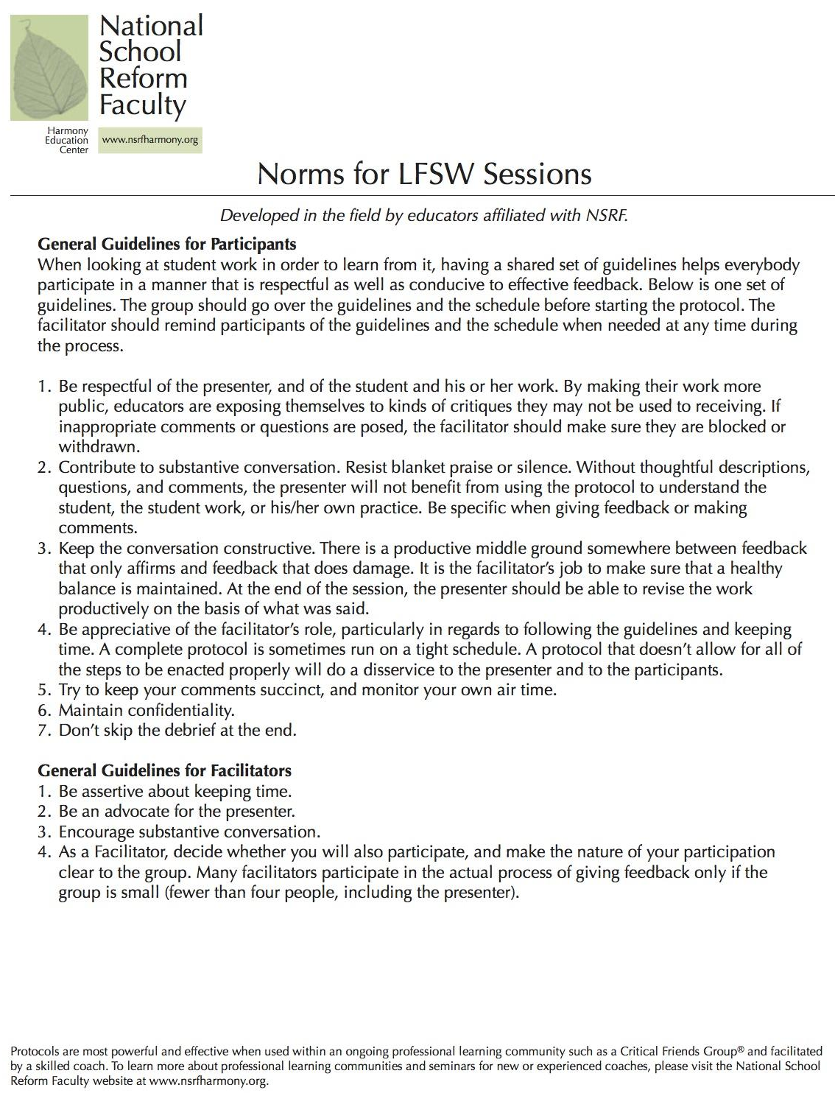
Appendix B: Sample Norms 2

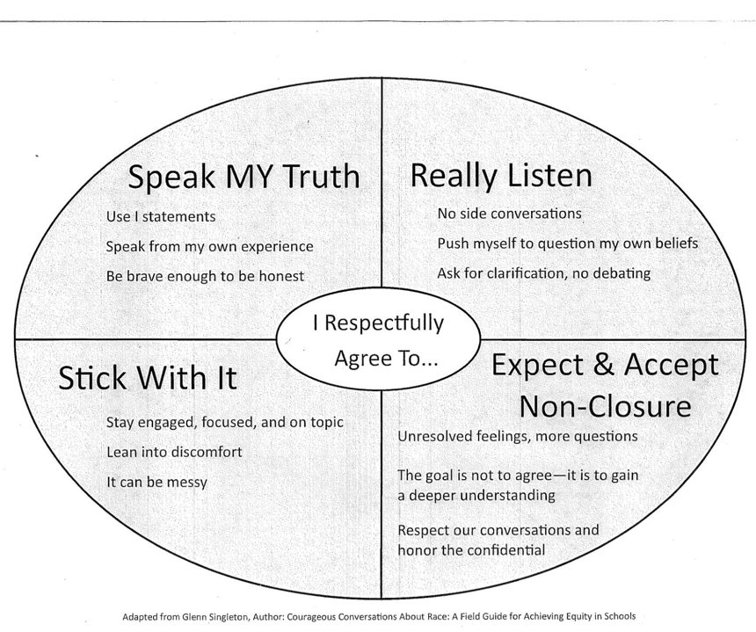

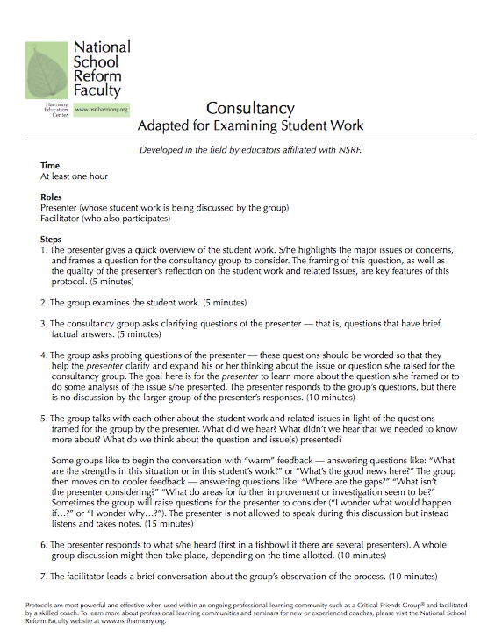
Appendix C: Sample Protocol - Consultancy

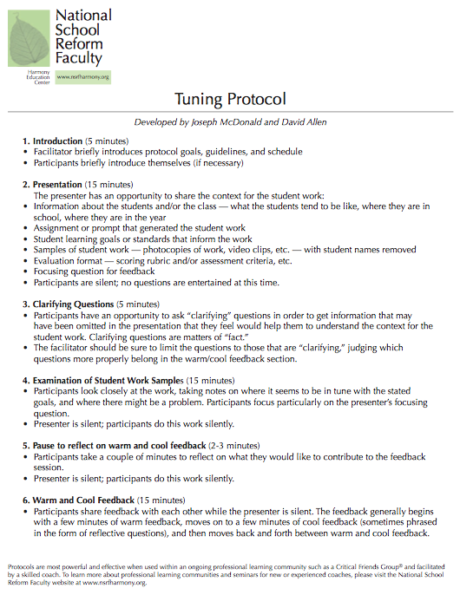
Appendix D: Sample Protocol - Tuning

Appendix E: Sample Protocol - Describing Student Work, A Slice of Writing

Appendix F: Sign-Up/Schedule Sheet for Distributing Facilitation & Presenting
Critical Friends Group Schedule of Facilitation and Presenters

Date | Facilitator | Presenter | Topic | Protocol

Appendix G: Meeting Minutes Record Keeping Sheet
Critical Friends Group Meeting Minutes

Recorder: ________________________ Date/Time: _________________ Session #: _______
Facilitator:
Presenter:
Participants:
Protocol Used:
Dilemma/Focusing Question:
Implications for Practice (Skills or Strategies Identified):
Reflections on the Protocol/Process:
Next Steps:
Additional comments:

Appendix H: Exit Slip

Exit Slip: Teacher Reflection

What did you learn about the student, about colleagues and/or about yourself as a result of participating in today’s CFG?

What implications emerged for your own practice as a result of participating in today’s session?

In what ways did the process we used today help you think in new ways about your practices?

In what ways did the process we used today help you think about what you want to improve or change in your practice?

What went well in our CFG today? What could be improved?

Appendix I: CFG Outcome Form

Names of Participants: __________________________________________________________

Start Date: ____________ End Date: ______________ Number of Sessions: ____

What were the objectives of the CFG? ____________________________________________________________________________________________________________________________________________________________

Were the objectives of the CFG met? How? ____________________________________________________________________________________________________________________________________________________________

Give examples of how you have improved or changed your practice and/or more effectively addressed student learning as a result of your participation in the CFG. ____________________________________________________________________________________________________________________________________________________________

Give examples on how your participation in the CFG had an impact on student learning and/or achievement. ____________________________________________________________________________________________________________________________________________________________

Additional comments, concerns, questions: ____________________________________________________________________________________________________________________________________________________________

References
Allen, D., & Blythe, T. (2004). The facilitators book of questions: Tools for looking together at student and teacher work. New York: Teachers College.
Ball, D. L., & Cohen, D. K. (1999). Developing practice, developing practitioners: Toward a practice-based theory of professional education. Teaching as the learning profession: Handbook of policy and practice, 1, 3-22.
Bolam, R., McMahon, A., Stoll, L., Thomas, S., Wallace, M., Greenwood, A., Hawkey, K., & Smith, M. (2005). Creating and sustaining effective professional learning communities. London: Department for Education and Skills.
Bransford, J. D., Brown, A. L., & Cocking, R. R. (2000). How people learn: Brain, mind, experience, and school. Washington DC: National Academies Press.
Brown, J. S., Collins, A., & Duguid, P. (1989). Situated cognition and the culture of learning. Educational Researcher, 18(1), 32-42.
Bruce, C., Esmonde, I., Ross, J., Dookie, L., & Beatty, R. (2010). The effects of sustained classroom-embedded teacher professional learning on teacher efficacy and related student achievement. Teaching and Teacher Education, 26(8), 1598–1608. doi:10.1016/j.tate.2010.06.011
Burke, B. (2013). Experiential professional development: A model for meaningful and long-lasting change in classrooms. Journal of Experiential Education, 36(3), 247–263. Retrieved from https://sakai.rutgers.edu/access/content/group/03bdb334-44c6-42a4-8687-8e3ecbd9333d/Week 8/Burke.pdf
Cantrell, S. C., & Hughes, H. (2008). Teacher efficacy and content literacy implementation: An exploration of the effects of extended professional development with coaching. Journal of Literacy Research, 40(1), 95–127. doi:10.1080/10862960802070442
Cobb, P., McClain, K., de Silva Lamberg, T., & Dean, C. (2003). Situating teachers’ instructional practices in the institutional setting of the school and district. Educational Researcher, 32(6), 13-24.
Coburn, C. E., & Stein, M. K. (2006). Communities of Practice Theory and the Role of Teacher Professional Community in Policy Implementation. In New Directions in Education Policy Implementation: Confronting Complexity. State University of New York Press.
Cochran-Smith, M., & Lytle, S. L. (1999). Chapter 8: relationships of knowledge and practice: teacher learning in communities. Review of Research in Education, 24(1), 249–305. doi:10.3102/0091732X024001249
Common Core State Standards: Development Process. (2015). Retrieved June 30, 2015, from http://www.corestandards.org/about-the-standards/development-process/
Common Core State Standards: Frequently Asked Questions. (2015). Retrieved June 30, 2015, from http://www.corestandards.org/about-the-standards/development-process/
Costa, A. L., & Kallick, B. (1993). Through the lens of a critical friend. Educational Leadership, 51(2), 49. doi:10.1007/s00115-010-3170-x
Creswell, J. W. (2007). Qualitative inquiry and research design: Choosing among five approaches, Second edition. Thousand Oaks, CA: Sage.
Creswell, J. W. & Plano-Clark, V. L. (2007) Designing and conducting mixed methods research. Thousand Oaks, CA: Sage Publications, Inc.
Creswell, J.W. (2009). Research design: qualitative, quantitative and mixed methods approaches 3rd ed. Thousand Oaks, CA: Sage.
Curry, M. (2008). Critical friends groups: The possibilities and limitations embedded in teacher professional communities aimed at instructional improvement and school reform. The Teachers College Record, 110(4), 733-774.
Dana, N. F., & Yendol-Hoppey, D. (2008). The reflective educator’s guide to professional development: Coaching inquiry-oriented learning communities. Corwin Press.
Darling-Hammond, L. (2004). Standards, Accountability, and School Reform. Teachers College Record, 106(6), 1047–1085.
Day, C. (2006). Developing teachers: The challenges of lifelong learning. London: Routledge.
Desimone, L. M., Porter, A. C., Garet, M. S., Yoon, K. S., & Birman, B. F. (2002). Effects of professional development on teachers’ instruction: Results from a three-year longitudinal study. Educational Evaluation and Policy Analysis, 24(2), 81-112.
Dufour, R. (2004). What is a professional learning community? Educational Leadership (May), 1–6.
Dunne, F., Nave, B., & Lewis, A. (2000). Critical friends groups: Teachers helping teachers to improve student learning. Phi Delta Kappan, 28(4), 31-37.
Fairman, J., & Mackenzie, S. (2012). Spheres of teacher leadership action for learning. Professional Development in Education. 38(2), 229–246. Retrieved from http://www.tandfonline.com/doi/abs/10.1080/19415257.2012.657865
Feiman-Nemser, S. (2001). From preparation to practice: Designing a continuum to strengthen and sustain teaching. Teachers College Record, 103(6), 1013–1055. doi:10.1111/0161-4681.00141
Franke, M. L., & Kazemi, E. (2001). Learning to Teach Mathematics: Focus on Student Thinking. Theory Into Practice, 40(2), 102-109. doi:10.1207/s15430421tip4002_
Franke, M. L., Kazemi, E., Shih, J., Biagetti, S., & Battey, D. (2005). Changing teachers’ professional work in mathematics: One school’s journey. Understanding mathematics and science matters, 209-230. London: Routledge.
Fullan, M. (2001) Leading in a Culture of Change. San Francisco: Jossey-Bass
Fullan, M. (2007). The New Meaning of Educational Change. 4th Ed. Teachers College Press: New York, NY. ISBN: 978-0-8077- 4765-0
Garet, M. S., Porter, a. C., Desimone, L., Birman, B. F., & Yoon, K. S. (2001). What makes professional development effective? Results from a national sample of teachers. American Educational Research Journal, 38(4), 915–945. doi:10.3102/00028312038004915
Graham, P. (2007). Improving teacher effectiveness through structured collaboration: A case study of a professional learning community. RMLE Online, 31(1), 1–17.
Guskey, T. R. (2002). Professional development and teacher change. Teachers and Teaching: Theory and Practice, 8(3). Retrieved from http://www.tandfonline.com/doi/abs/10.1080/135406002100000512
Horn, I. S., & Little, J. (2014). Attending to problems of practice: Routines and resources for professional learning in teachers’ workplace interactions. American Educational Research Journal, 47(1), 181–217.
Kazemi, E., & Stipek, D. (2001). Promoting Conceptual Thinking in Four Upper-Elementary Mathematics Classrooms. The Elementary School Journal, 102(1), 59. doi:10.1086/499693
Kruse, S. D., & Louis, K. S. (1993). An Emerging Framework for Analyzing School-Based Professional Community. Washington, D.C.: Distributed by ERIC Clearinghouse.
Lave, J., & Wenger, E. (2016). Situated learning: Legitimate peripheral participation. Cambridge, United Kingdom: Cambridge University Press.
Levine, T. H. (2011). Experienced teachers and school reform: Exploring how two different professional communities facilitated and complicated change. Improving Schools, 14(1), 30–47. doi:10.1177/1365480211398233
Little, J. W. (2012). Professional community and professional development in the learning-centered school. In Teacher learning that matters (pp. 42-64). London: Routledge.
Louis, K. S., & Marks, H. M. (1998). Does professional community affect the classroom? Teachers' work and student experiences in restructuring schools. American Journal of Education, 106(4), 532-575.
McDonald, J. P., Mohr, N., Dichter, A., & McDonald, E. C. (2013). The power of protocols: An educator's guide to better practice. Teachers College Press: New York, NY.
Merriam, S. (2009). Qualitative research: A guide to design & implementation. San Francisco: Jossey-Bass.
National School Reform Faculty. "NSRF Protocols and Activities." National School Reform Faculty. N.p., n.d.
Nelson, T. (2009). Teachers’ collaborative inquiry and professional growth: Should we be optimistic? Science Education, 93, 548–580. doi:10.1002/sce.20302
Nelson, T., Slavit, D., Perkins, M., & Hathorn, T. (2008). A culture of collaborative inquiry: Learning to develop and support professional learning communities. Teachers College Record, 110(6), 1269–1303. Retrieved from http://www.tcrecord.org/Content.asp?ContentID=14745
Newmann, F. M., Smith, B., Allensworth, E., & Bryk, a. S. (2001). Instructional program coherence: What it is and why it should guide school improvement policy. Educational Evaluation and Policy Analysis, 23(4), 297–321. doi:10.3102/01623737023004297
"Our History." The Reading & Writing Project. Columbia University Teachers College, 2014. Web. 28 Aug. 2015.
Patton, M. Q. (1990) Qualitative Interviewing. Qualitative evaluation and research methods. Thousand Oaks, CA: Sage Publications.
Putnam, R. T., & Borko, H. (2000). What do new views of knowledge and thinking have to say about research on teacher learning? Educational Researcher, 29(1), 4–15. doi:10.3102/0013189X029001004
Rowe, K. J. (1989). The impact of professional development on teachers’ self perceptions. Teaching and Teacher Education, 5(2), 129–141. Retrieved from http://www.sciencedirect.com/science/article/pii/0742051X89900115
Selkrig, M., & Keamy, (. K. (2014). Promoting a willingness to wonder: Moving from congenial to collegial conversations that encourage deep and critical reflection for teacher educators. Teachers and Teaching, 21(4), 421-436. doi:10.1080/13540602.2014.969104
Snow-Gerono, J. L. (2005). Professional development in a culture of inquiry: PDS teachers identify the benefits of professional learning communities. Teaching and Teacher Education, 21, 241–256. doi:10.1016/j.tate.2004.06.008
Timperley, H. S. (2005). Distributed leadership: developing theory from practice. Journal of Curriculum Studies, 37(37), 395–420. http://doi.org/10.1080/00220270500038545
Tschannen-Moran, M., & McMaster, P. (2009). Sources of self-efficacy: Four professional development formats and their relationship to self-efficacy and implementation of a new teaching strategy. The Elementary School Journal, 110(2), 228–245.
Tyack, D. & Cuban, L. (1995). Tinkering toward utopia: A century of public school reform. Cambridge, MA: Harvard University Press.
Wallender, J. (2014). The common core state standards in American public education: Historical underpinnings and justifications. Delta Kappa Gamma Bulletin, 80(4), 7.
Wenger, E. (1999). Communities of practice: Learning, meaning, and identity. Cambridge: Cambridge University Press.
Wilson, S. M., & Berne, J. (1999). Chapter 6: Teacher learning and the acquisition of professional knowledge: An examination of research on contemporary professional development. Review of Research in Education, 24(1), 173–209. doi:10.3102/0091732X024001173
Wood, D. R. (2007). Professional learning communities: Teachers, knowledge, and knowing. Theory into Practice, 46(4), 281-290.

Chapter Five: Conclusion
The completion of this dissertation enabled me to explore a problem of practice related to the quality of professional development in my school and that examined the impact of implementing high-quality, teacher-driven professional development in the form of Critical Friends Groups to improve it. As a result of the experience, I created three products that share my findings with colleagues and outside stakeholders who may be interested in the benefits, implementation process, and facilitation of Critical Friends Groups. The creation of each product in the dissertation refined my skills as a change agent and researcher, compelling me to look more closely at my data to inform the development of practical products.
General Implications
Writing the practitioner article revealed key findings relating to changes in teachers’ learning and teaching practices as a result of their participation in the CFG. It highlighted the processes that supported changes, and how using a professional text (a deviation from the traditional approach to CFGs) increased the benefits of CFG participation by focusing the conversations around additional data. The study findings add to the growing body of literature focusing on the outcomes of CFGs as an approach to professional development.
Developing the Critical Friends Group change presentation helped me consider the barriers and supports that influenced the implementation of a new approach to professional development in a school steeped in tradition and a specific culture that strongly influenced how things are done. It highlighted the importance of understanding and being patient with the change process and expecting it to occur in small, incremental ways. Both Fullan (2007) and Reeves (2009) make the case that in order for meaningful change to take place, change agents need to respect their expertise and the complex job that teachers have and allow them time to reflect on their practices in order for improvement to occur. With this understanding, the CFGs gave teachers an opportunity to share, distribute, and celebrate their learning, as well as cultivate a collaborative positive pressure and team-like attitude to accomplish a common goal (Fullan, 2007). I believe this supported the sustainability and success of the group.
Finally, the facilitator handbook encouraged me to reflect on the challenges a skilled facilitator faces when considering the learning, logistics, and longevity (Allen & Blythe, 2014) of a CFG. Deconstructing the entire process of starting a CFG from start to finish, capturing the logistics, responsibilities, and obstacles I faced when acting as the CFG facilitator helped me to consider how to mitigate those challenges in the future, offering advice and examples from my experiences along the way.
Implications for Practice
As evidenced in this study, most teachers consider themselves learners, are open minded, and motivated to learn. The teachers in this study had a strong desire to implement best practices in both teacher learning and writing instruction. They were interested and enthusiastic about using formative assessments to inform instruction, data collection and analysis, and assessing and communicating their findings to their students, families, and colleagues. It is clear that this school has an incredibly dedicated and motivated faculty. It is important to recognize and honor this by capitalizing on their desire to implement best practices in instruction and PD. In order for this to occur, the structures and systems must be in place so that teachers’ schedules have built in time for teacher reflection, planning, and learning (Storey & Richard, 2015). Opportunities for teacher led professional development is crucial to addressing the daily problems of practice that teachers encounter on a constant basis (Cochran-Smith & Lytle, 1999; Garet et al., 2001; Wilson & Berne, 1999; Wood, 2007).
It is also important to note that teachers expressed a need for more support and sustainability in their learning. Ensuring that CFGs were an ongoing, sustained practice built into teachers’ schedule is an important aspect of maintaining changes in practice. Research has also shown that the support of a coach or peer observer can further support continuous teacher change through the use of consistent feedback and accountability (Kruse & Zimmerman, 2012, Neuman & Cunningham, 2008) and could be used as a supplement to CFGs.
Additionally, the study reiterates DuFour’s (2007) claim that in order to establish a true professional learning community, it is essential for schools to develop the systems and structures that make collaboration meaningful rather than artificial, to guarantee time for collaboration during the contractual day, and to establish clear priorities and parameters so that teachers focus on the right topics.
Supports and Barriers. While teachers embraced the use of CFGs as an approach to professional development, it is important to recognize the supports that promoted its success. Time was provided during faculty meeting schedules so that teachers did not have to find extra time to participate. Due to the small size of the school, the group was inherently cross grade level because there is only one class per grade level (with co-teachers and an associate). Additionally, administration supported the participation of other visiting teachers such as the resource room teacher, literacy consultant, specials area teachers, or upper grade level teachers. As stated earlier, the faculty participating in the study were a notably enthusiastic, dedicated, and passionate group of teachers who were open to new ways of learning and teaching.
However, CFG implantation was not without barriers. Despite scheduling CFGs into the faculty meeting rotation, inevitably things happened, such as snow days, absences, administrative decisions to change the schedule, parent/teacher conferences, that got in the way of our meeting times. Additionally, while teachers felt that their time was used well and felt energized by their learning, the new approach contributed to their sense of “initiative fatigue” (Reeves, 2009, p. 14), particularly for the teachers during the week when they presented at a CFG meeting. Their role had to be to define a problem of practice and find data that illustrated that problem to the group. As a new practice, this was cognitively taxing and an additional responsibility on top of an already burdensome workload.
Implications for Further Research
Many of the study’s findings support the growing literature on CFGs as an effective approach to teacher learning. Additional areas for future research could investigate whether collaborative time across grade levels and content area actually does result in a more cohesive scope and sequence across curriculum. It would also be worthwhile to examine what specific contextual factors contribute to the sustainability of CFGs (time, coaches, administrative support).
As evidenced by this study, teacher learning and teacher emotions are connected and could be examined in order to mitigate issues of teacher attrition and job satisfaction. Other studies could look at the impact of CFGs on teacher burn out, as well as teacher self-efficacy, both relating to job satisfaction. Connected to this topic, studies focusing on teacher emotion and teacher change could look at how CFGs can be used to support teachers’ personal and professional growth and well-being.
Finally, the goal of improving teacher learning is to improve practice and increased student learning, so another important area of research could be investigating the impacts of CFGs on student learning. One area that relates to this study would be to look at whether or not student learning is improved with the consistent use of writing rubrics for assessment, planning, and instruction.
Cultivating Change
Ultimately, my research revealed that most teachers are passionate and willing and able to learn, try new things and improve their practice under the right circumstances. The success of the Critical Friends Group was due to the administrative support that enabled the meetings to be part of the teachers pre-existing schedule, the teachers’ dedication and willingness to participate, and thoughtful planning and facilitation of the sessions. While Critical Friends Groups have the potential to be seen as another initiative added to already busy agendas, hopefully teachers will perceive the increased collegiality, congeniality, and cohesion from their teacher learning experience productive and worthwhile.
Since the introduction of the CFGs to the lower school teachers, Far Brook School has implemented professional study groups (PSGs) across all grade levels and content areas during designated faculty meeting time as a result of the positive outcomes and feedback relating to the work of the CFGs. Drawing upon elements of best practices in professional development, the PSGs are teacher-led, and teachers formed groups around topics of their choice. At their start, the groups were facilitated by faculty volunteers, but had inconsistent meeting practices, norms, topics, and goals that were based on the facilitator’s personal experiences and preferences. The following year, the PSG coordinator (and school librarian) consulted me on ways to improve the groups. Based on our conversations, facilitator meetings were held to debrief, share, and create plans on how the groups’ learning could move forward and be shared. The PSGs continue to evolve and as of this year, the PSGs are all focused on a single topic: social justice. Teachers chose a professional text based on a wide range of titles focusing on social justice from various perspectives and content areas suggested by the coordinator. Faculty were organized into groups based on their text selection, making sure the groups had diverse representation across grade levels and content areas. As a result of my sharing the importance of protocols and professional texts during CFGs, the PSG coordinator advocated for and implemented this approach to the PSG groups. During facilitator meetings, the PSG coordinator provided resources such as conversation protocols and sample norms to standardize the approach to facilitation. A follow up study could look at how participants compared a more traditional approach to CFGs to the adapted version of the PSG. Changing the culture of a school requires the timely, intensive process of individual and collective decisions to adapt new materials, approaches, and beliefs (Fullan, 2007). The evolution of professional learning communities at Far Brook reflects the incremental, but eventual and successful adoption of an effective approach to teacher learning at a school that previously had nothing of this nature in place.
Since the culmination of this study, I have since left my role as a classroom teacher to become a develop a school program to support the health and wellness of children across the state of New Jersey. Despite leaving the K-12 educational setting, I have used and applied so much of what I learned about being a change agent into my role regarding organizational change, research design, and adult learning to design this program.
First, to develop a plan for working with schools, I have had to apply what I have learned about implementing change, the factors that affect change implementation, and the stages required for each step. To start, I examined the mission and objectives of the grant to develop a logic plan outlining the planned work, intended results, and potential outcomes, as well as assumptions, local context, and external factors that could potentially influence the implementation. Next, I used Fullan’s (2007) initiation/planning, implementation, and institutionalization stages of change in order to create a schedule and timeline for the intended program activities and tasks. I also developed a plan for on-going assessment of the program, and an overall program evaluation with plans for documented outcomes. The program is currently in the initiation/planning stage of change. In addition to open and frequent communication with others working on the grant, I have been keeping a researcher log of completed tasks and objectives to document the implementation process. One of my intended outcomes is to use the implementation as a research focus.
My combined understanding of change implementation and qualitative research design has been instrumental in developing a needs assessment to measure teachers’ readiness for change, a document review, and an observation tool to assess the need for change during this initiation/planning stage of change. My understanding of designing effective data collection protocols was applied in the development of these tools, and I am currently conducting focus groups with the undergraduate research assistants who ran the observations to assess the reliability, validity, and feasibility of the tool.
In addition to designing, developing, and evaluating a school program, one of my additional responsibilities in my new role has been to work with undergraduate students in designing a research study that contributes towards children’s health and wellness. This process has required me to call upon skills I’ve learned as a result of the EdD program such as working with adults, facilitating small groups, and research design.
Finally, outside of my role as program development administrator, I work as a strength and conditioning trainer at a CrossFit gym and have helped to develop a plan for coaches’ professional development. I consulted with the organization’s owners on how to effectively observe, coach, and provide feedback to their coaches applying best practices of andragogy such as self-directed learning, experiential learning, and motivation.
As a result of my learning, I feel that I am a more reflective and knowledgeable facilitator, researcher, and teacher leader. Consequently, moving forward with my new role, I am hopeful that these skills and understandings will contribute to successful program implementation. I can say with confidence that my accumulation of knowledge relating to organizational change, change implementation, research design, working with adult learners, and developing best practices for teaching and learning has affected my life professionally and personally.

References
Allen, D., & Blythe, T. (2014). Facilitating for learning: tools for teacher groups of all kinds. New York: Teachers College Press.
Cochran-Smith, M., & Lytle, S. L. (1999). Chapter 8: relationships of knowledge and practice: teacher learning in communities. Review of Research in Education, 24(1), 249–305. doi:10.3102/0091732X024001249
DuFour, R. (2007). What is a" professional learning community"? Educational leadership, 61(8), 6-11.
Fullan, M. (2007). The New Meaning of Educational Change. 4th Ed. Teachers College Press: New York, NY. ISBN: 978-0- 8077- 4765-0
Garet, M. S., Porter, a. C., Desimone, L., Birman, B. F., & Yoon, K. S. (2001). What makes professional development effective? Results from a national sample of teachers. American Educational Research Journal, 38(4), 915–945. doi:10.3102/00028312038004915
Kruse, S., Louis, K., & Bryk, A. (1995). An emerging framework for analyzing school-based professional community. In Professionalism & Community: Perspectives on Reforming Urban Schools (pp. 23–44). Thousand Oaks, CA. Retrieved from http://www.eric.ed.gov/ERICWebPortal/recordDetail?accno=ED358537
Neuman, S. B., & Cunningham, L. (2009). The impact of professional development and coaching on early language and literacy instructional practices. American educational research journal, 46(2), 532-566.
Reeves, D. B. (2009). Leading change in your school: How to conquer myths, build commitment, and get results. Association for Supervision and Curriculum Development: Alanandria, VA.
Storey, V. A. & Richard, B. (2015). The role of critical friends in supporting institutional change: Developing a collaborative environment. Journal of Applied Research in Higher Education, 7(2), 412-428.
Wilson, S. M., & Berne, J. (1999). Chapter 6: Teacher learning and the acquisition of professional knowledge: An examination of research on contemporary professional development. Review of Research in Education, 24(1), 173–209. doi:10.3102/0091732X024001173
Wood, D. R. (2007). Professional learning communities: Teachers, knowledge, and knowing. Theory into Practice, 46(4), 281-290.

