Welcome to the SoN Instructional Design Team's Training on Microsoft Office 365!
To access this HYPERLINKED doc, go to http://go.rutgers.edu/xspocpbn

FAQ's:
How do I access O365?
- Rutgers Connect / O365: connect.rutgers.edu
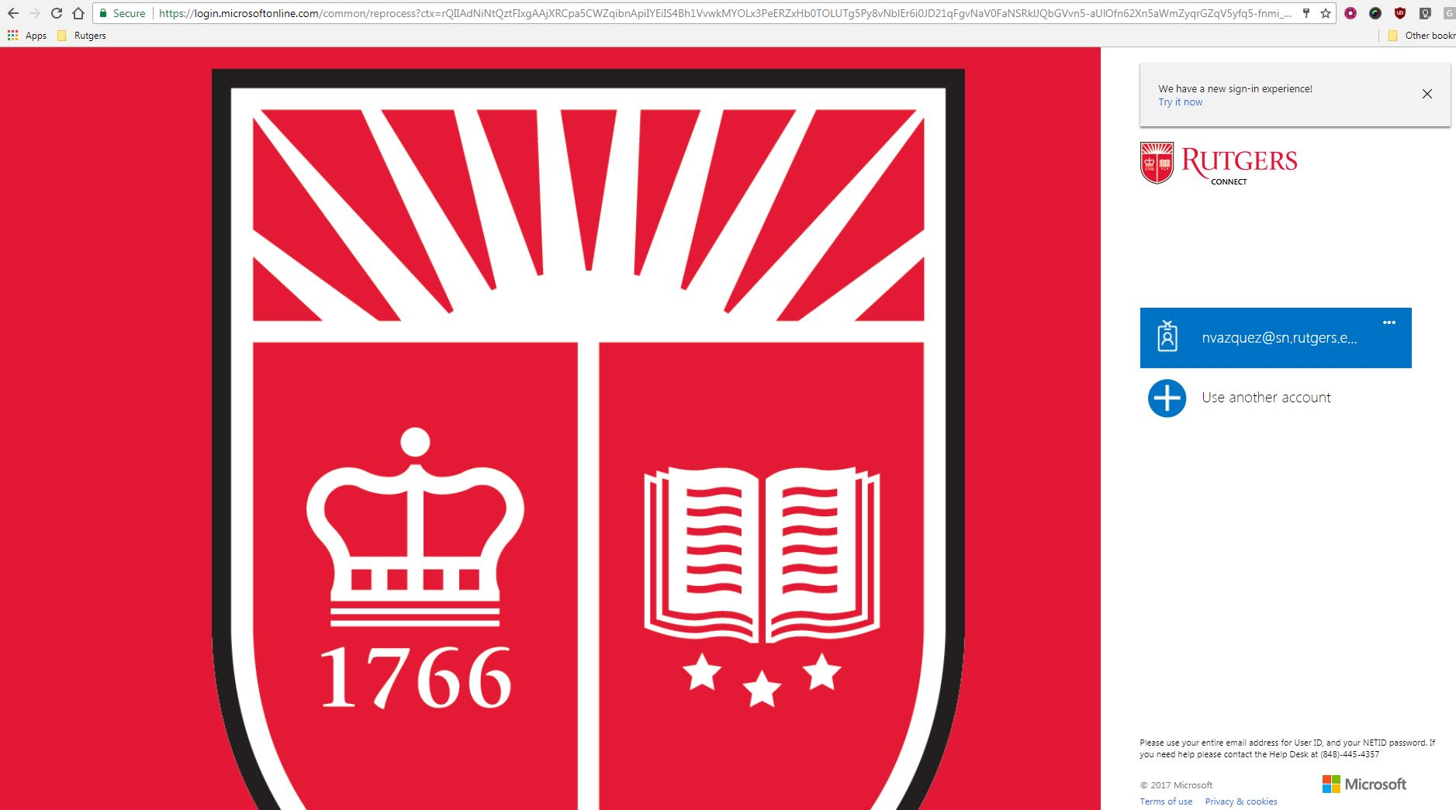
- Learn more about Rutgers Connect from OIT
What is O365?
- Cloud based suite of tools to enhance your workflow and productivity.
What are the most common applications within O365?
- Mail
- Calendar
- OneDrive
  - Word
  - Excel
  - PowerPoint
  - OneNote
- Forms
- People
- Planner
How do I locate the O365 apps?
- Log in to your connect.rutgers.edu account using your email address (net id @sn.rutgers.edu) and password
- Click the app launcher in the top left
- You should see O365 apps available to you 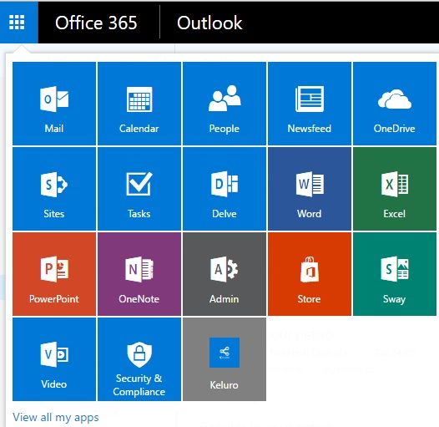
- Activity: Log into your Connect Account
What can I do in my One Drive?
- Create files (Word Docs, PowerPoints, Excel Spreadsheets)
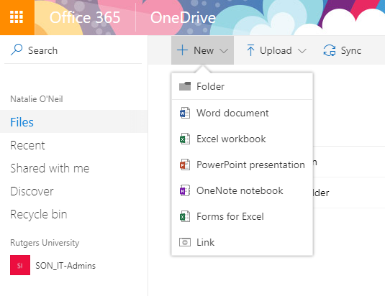
- Create and Organize Folders
- Backup files from your desktop, thumb drives, external drives, etc.
- Sync files in the Cloud to your desktop
- File actions and information
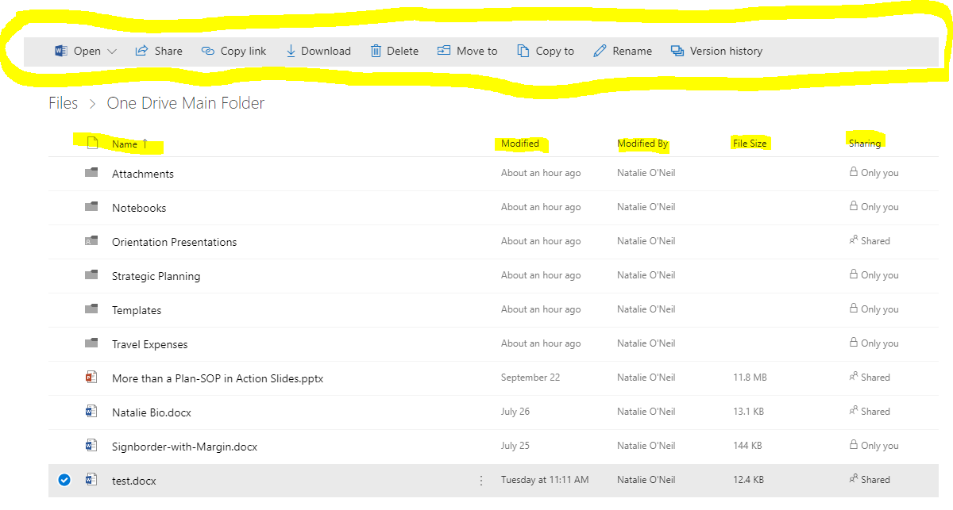
- Activity: Access your OneDrive, create a "Practice Folder," and create a "Practice Doc" inside the "Practice Folder"
How do I collaborate on files and set sharing permissions?
- Access sharing setting from OneDrive
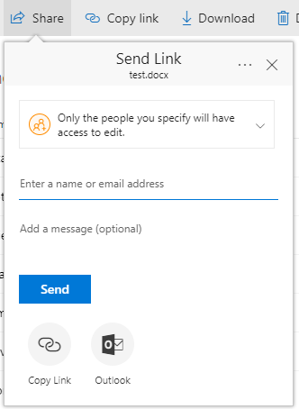
- Change Sharing Permissions to VIEW access only
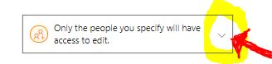
- Uncheck Allow Editing (optional – Select People in RU for bulk setting)
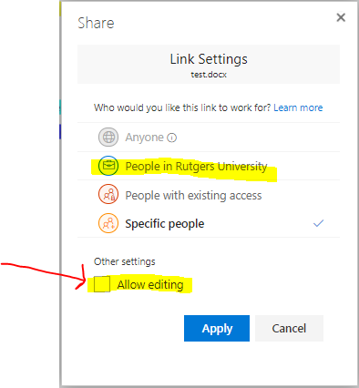
- Activity: Share "Practice Doc" with 2 people sitting near you. Give 1 person ONLY VIEW access, and give the other person EDIT access.
How do I access my Outlook email, Calendar, OneDrive, Word, PowerPoint, etc. on my mobile device?
- On Android, go to Google Play Store, and download each app individually.
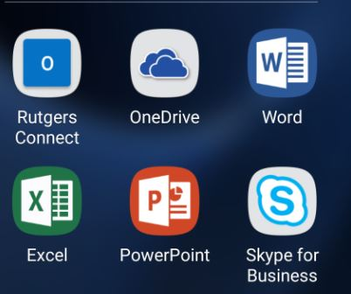
- On iOS, go to iTunes and download each app individually.
What does it mean to sync filed from OneDrive to my Desktop?
- Make edits to files on your desktop that automatically save and are stored in the Cloud

