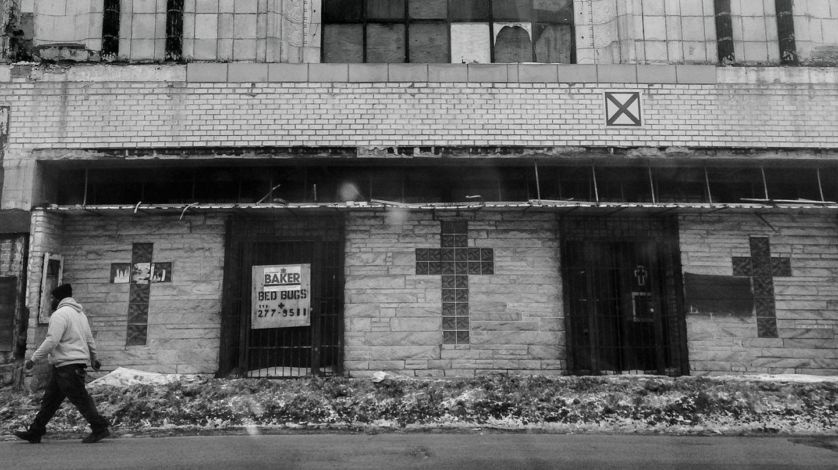
Carlos Javier Ortiz
Business

The Case for Reparations
Two hundred fifty years of slavery. Ninety years of Jim Crow. Sixty years of separate but equal. Thirty-five years of racist housing policy. Until we reckon with our compounding moral debts, America will never be whole.
By Ta-Nehisi Coates
June 2014 Issue
Editor’s Note: We’ve gathered dozens of the most important pieces from our archives on race and racism in America. Find the collection here.
And if thy brother, a Hebrew man, or a Hebrew woman, be sold unto thee, and serve thee six years; then in the seventh year thou shalt let him go free from thee. And when thou sendest him out free from thee, thou shalt not let him go away empty: thou shalt furnish him liberally out of thy flock, and out of thy floor, and out of thy winepress: of that wherewith the LORD thy God hath blessed thee thou shalt give unto him. And thou shalt remember that thou wast a bondman in the land of Egypt, and the LORD thy God redeemed thee: therefore I command thee this thing today.
— Deuteronomy 15: 12–15
Besides the crime which consists in violating the law, and varying from the right rule of reason, whereby a man so far becomes degenerate, and declares himself to quit the principles of human nature, and to be a noxious creature, there is commonly injury done to some person or other, and some other man receives damage by his transgression: in which case he who hath received any damage, has, besides the right of punishment common to him with other men, a particular right to seek reparation.
— John Locke, “Second Treatise”
By our unpaid labor and suffering, we have earned the right to the soil, many times over and over, and now we are determined to have it.
— Anonymous, 1861
Listen to the audio version of this article:Feature stories, read aloud: download the Audm app for your iPhone.

I. “So That’s Just One Of My Losses”
Clyde Ross was born in 1923, the seventh of 13 children, near Clarksdale, Mississippi, the home of the blues. Ross’s parents owned and farmed a 40-acre tract of land, flush with cows, hogs, and mules. Ross’s mother would drive to Clarksdale to do her shopping in a horse and buggy, in which she invested all the pride one might place in a Cadillac. The family owned another horse, with a red coat, which they gave to Clyde. The Ross family wanted for little, save that which all black families in the Deep South then desperately desired—the protection of the law.
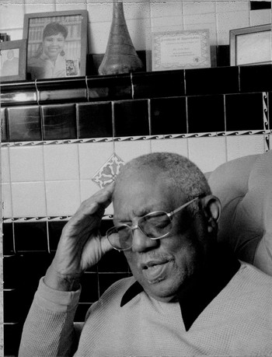Clyde Ross, photographed in November 2013 in his home in the North Lawndale neighborhood of Chicago, where he has lived for more than 50 years. When he first tried to get a legitimate mortgage, he was denied; mortgages were effectively not available to black people. (Carlos Javier Ortiz)
In the 1920s, Jim Crow Mississippi was, in all facets of society, a kleptocracy. The majority of the people in the state were perpetually robbed of the vote—a hijacking engineered through the trickery of the poll tax and the muscle of the lynch mob. Between 1882 and 1968, more black people were lynched in Mississippi than in any other state. “You and I know what’s the best way to keep the nigger from voting,” blustered Theodore Bilbo, a Mississippi senator and a proud Klansman. “You do it the night before the election.”
The state’s regime partnered robbery of the franchise with robbery of the purse. Many of Mississippi’s black farmers lived in debt peonage, under the sway of cotton kings who were at once their landlords, their employers, and their primary merchants. Tools and necessities were advanced against the return on the crop, which was determined by the employer. When farmers were deemed to be in debt—and they often were—the negative balance was then carried over to the next season. A man or woman who protested this arrangement did so at the risk of grave injury or death. Refusing to work meant arrest under vagrancy laws and forced labor under the state’s penal system.
Well into the 20th century, black people spoke of their flight from Mississippi in much the same manner as their runagate ancestors had. In her 2010 book, The Warmth of Other Suns, Isabel Wilkerson tells the story of Eddie Earvin, a spinach picker who fled Mississippi in 1963, after being made to work at gunpoint. “You didn’t talk about it or tell nobody,” Earvin said. “You had to sneak away.”
“Some of the land taken from black families has become a country club in Virginia,” the AP reported.
When Clyde Ross was still a child, Mississippi authorities claimed his father owed $3,000 in back taxes. The elder Ross could not read. He did not have a lawyer. He did not know anyone at the local courthouse. He could not expect the police to be impartial. Effectively, the Ross family had no way to contest the claim and no protection under the law. The authorities seized the land. They seized the buggy. They took the cows, hogs, and mules. And so for the upkeep of separate but equal, the entire Ross family was reduced to sharecropping.
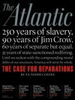

From our June 2014 issue
Check out the full table of contents and find your next story to read.
See More
This was hardly unusual. In 2001, the Associated Press published a three-part investigation into the theft of black-owned land stretching back to the antebellum period. The series documented some 406 victims and 24,000 acres of land valued at tens of millions of dollars. The land was taken through means ranging from legal chicanery to terrorism. “Some of the land taken from black families has become a country club in Virginia,” the AP reported, as well as “oil fields in Mississippi” and “a baseball spring training facility in Florida.”
Clyde Ross was a smart child. His teacher thought he should attend a more challenging school. There was very little support for educating black people in Mississippi. But Julius Rosenwald, a part owner of Sears, Roebuck, had begun an ambitious effort to build schools for black children throughout the South. Ross’s teacher believed he should attend the local Rosenwald school. It was too far for Ross to walk and get back in time to work in the fields. Local white children had a school bus. Clyde Ross did not, and thus lost the chance to better his education.
Then, when Ross was 10 years old, a group of white men demanded his only childhood possession—the horse with the red coat. “You can’t have this horse. We want it,” one of the white men said. They gave Ross’s father $17.
“I did everything for that horse,” Ross told me. “Everything. And they took him. Put him on the racetrack. I never did know what happened to him after that, but I know they didn’t bring him back. So that’s just one of my losses.”
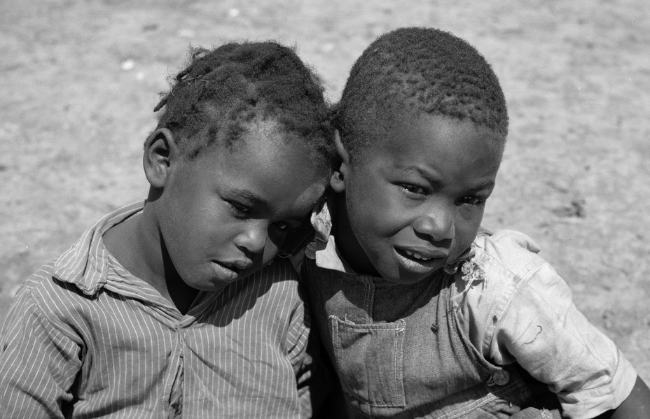Sharecropper boys in 1936 (Carly Mydans/Library of Congress)
The losses mounted. As sharecroppers, the Ross family saw their wages treated as the landlord’s slush fund. Landowners were supposed to split the profits from the cotton fields with sharecroppers. But bales would often disappear during the count, or the split might be altered on a whim. If cotton was selling for 50 cents a pound, the Ross family might get 15 cents, or only five. One year Ross’s mother promised to buy him a $7 suit for a summer program at their church. She ordered the suit by mail. But that year Ross’s family was paid only five cents a pound for cotton. The mailman arrived with the suit. The Rosses could not pay. The suit was sent back. Clyde Ross did not go to the church program.
reporter’s notebook
Elegant Racism
“If you sought to advantage one group of Americans and disadvantage another, you could scarcely choose a more graceful method than housing discrimination.”
Read more
It was in these early years that Ross began to understand himself as an American—he did not live under the blind decree of justice, but under the heel of a regime that elevated armed robbery to a governing principle. He thought about fighting. “Just be quiet,” his father told him. “Because they’ll come and kill us all.”
Clyde Ross grew. He was drafted into the Army. The draft officials offered him an exemption if he stayed home and worked. He preferred to take his chances with war. He was stationed in California. He found that he could go into stores without being bothered. He could walk the streets without being harassed. He could go into a restaurant and receive service.
Ross was shipped off to Guam. He fought in World War II to save the world from tyranny. But when he returned to Clarksdale, he found that tyranny had followed him home. This was 1947, eight years before Mississippi lynched Emmett Till and tossed his broken body into the Tallahatchie River. The Great Migration, a mass exodus of 6 million African Americans that spanned most of the 20th century, was now in its second wave. The black pilgrims did not journey north simply seeking better wages and work, or bright lights and big adventures. They were fleeing the acquisitive warlords of the South. They were seeking the protection of the law.
Clyde Ross was among them. He came to Chicago in 1947 and took a job as a taster at Campbell’s Soup. He made a stable wage. He married. He had children. His paycheck was his own. No Klansmen stripped him of the vote. When he walked down the street, he did not have to move because a white man was walking past. He did not have to take off his hat or avert his gaze. His journey from peonage to full citizenship seemed near-complete. Only one item was missing—a home, that final badge of entry into the sacred order of the American middle class of the Eisenhower years.
In 1961, Ross and his wife bought a house in North Lawndale, a bustling community on Chicago’s West Side. North Lawndale had long been a predominantly Jewish neighborhood, but a handful of middle-class African Americans had lived there starting in the ’40s. The community was anchored by the sprawling Sears, Roebuck headquarters. North Lawndale’s Jewish People’s Institute actively encouraged blacks to move into the neighborhood, seeking to make it a “pilot community for interracial living.” In the battle for integration then being fought around the country, North Lawndale seemed to offer promising terrain. But out in the tall grass, highwaymen, nefarious as any Clarksdale kleptocrat, were lying in wait.
From the 1930s through the 1960s, black people across the country were largely cut out of the legitimate home-mortgage market.
Three months after Clyde Ross moved into his house, the boiler blew out. This would normally be a homeowner’s responsibility, but in fact, Ross was not really a homeowner. His payments were made to the seller, not the bank. And Ross had not signed a normal mortgage. He’d bought “on contract”: a predatory agreement that combined all the responsibilities of homeownership with all the disadvantages of renting—while offering the benefits of neither. Ross had bought his house for $27,500. The seller, not the previous homeowner but a new kind of middleman, had bought it for only $12,000 six months before selling it to Ross. In a contract sale, the seller kept the deed until the contract was paid in full—and, unlike with a normal mortgage, Ross would acquire no equity in the meantime. If he missed a single payment, he would immediately forfeit his $1,000 down payment, all his monthly payments, and the property itself.
The men who peddled contracts in North Lawndale would sell homes at inflated prices and then evict families who could not pay—taking their down payment and their monthly installments as profit. Then they’d bring in another black family, rinse, and repeat. “He loads them up with payments they can’t meet,” an office secretary told The Chicago Daily News of her boss, the speculator Lou Fushanis, in 1963. “Then he takes the property away from them. He’s sold some of the buildings three or four times.”
Ross had tried to get a legitimate mortgage in another neighborhood, but was told by a loan officer that there was no financing available. The truth was that there was no financing for people like Clyde Ross. From the 1930s through the 1960s, black people across the country were largely cut out of the legitimate home-mortgage market through means both legal and extralegal. Chicago whites employed every measure, from “restrictive covenants” to bombings, to keep their neighborhoods segregated.
Their efforts were buttressed by the federal government. In 1934, Congress created the Federal Housing Administration. The FHA insured private mortgages, causing a drop in interest rates and a decline in the size of the down payment required to buy a house. But an insured mortgage was not a possibility for Clyde Ross. The FHA had adopted a system of maps that rated neighborhoods according to their perceived stability. On the maps, green areas, rated “A,” indicated “in demand” neighborhoods that, as one appraiser put it, lacked “a single foreigner or Negro.” These neighborhoods were considered excellent prospects for insurance. Neighborhoods where black people lived were rated “D” and were usually considered ineligible for FHA backing. They were colored in red. Neither the percentage of black people living there nor their social class mattered. Black people were viewed as a contagion. Redlining went beyond FHA-backed loans and spread to the entire mortgage industry, which was already rife with racism, excluding black people from most legitimate means of obtaining a mortgage.

Explore Redlining in Chicago
A 1939 Home Owners’ Loan Corporation “Residential Security Map” of Chicago shows discrimination against low-income and minority neighborhoods. The residents of the areas marked in red (representing “hazardous” real-estate markets) were denied FHA-backed mortgages. (Map development by Frankie Dintino)
“A government offering such bounty to builders and lenders could have required compliance with a nondiscrimination policy,” Charles Abrams, the urban-studies expert who helped create the New York City Housing Authority, wrote in 1955. “Instead, the FHA adopted a racial policy that could well have been culled from the Nuremberg laws.”
The devastating effects are cogently outlined by Melvin L. Oliver and Thomas M. Shapiro in their 1995 book, Black Wealth/White Wealth:
Locked out of the greatest mass-based opportunity for wealth accumulation in American history, African Americans who desired and were able to afford home ownership found themselves consigned to central-city communities where their investments were affected by the “self-fulfilling prophecies” of the FHA appraisers: cut off from sources of new investment[,] their homes and communities deteriorated and lost value in comparison to those homes and communities that FHA appraisers deemed desirable.
In Chicago and across the country, whites looking to achieve the American dream could rely on a legitimate credit system backed by the government. Blacks were herded into the sights of unscrupulous lenders who took them for money and for sport. “It was like people who like to go out and shoot lions in Africa. It was the same thrill,” a housing attorney told the historian Beryl Satter in her 2009 book, Family Properties. “The thrill of the chase and the kill.”
reporter’s notebook
The American Case Against a Black Middle Class
“When a black family in Chicago saves up enough to move out of the crowded slums into Cicero, the neighborhood riots.”
Read more
The kill was profitable. At the time of his death, Lou Fushanis owned more than 600 properties, many of them in North Lawndale, and his estate was estimated to be worth $3 million. He’d made much of this money by exploiting the frustrated hopes of black migrants like Clyde Ross. During this period, according to one estimate, 85 percent of all black home buyers who bought in Chicago bought on contract. “If anybody who is well established in this business in Chicago doesn’t earn $100,000 a year,” a contract seller told The Saturday Evening Post in 1962, “he is loafing.”
Contract sellers became rich. North Lawndale became a ghetto.
Clyde Ross still lives there. He still owns his home. He is 91, and the emblems of survival are all around him—awards for service in his community, pictures of his children in cap and gown. But when I asked him about his home in North Lawndale, I heard only anarchy.
“We were ashamed. We did not want anyone to know that we were that ignorant,” Ross told me. He was sitting at his dining-room table. His glasses were as thick as his Clarksdale drawl. “I’d come out of Mississippi where there was one mess, and come up here and got in another mess. So how dumb am I? I didn’t want anyone to know how dumb I was.
“When I found myself caught up in it, I said, ‘How? I just left this mess. I just left no laws. And no regard. And then I come here and get cheated wide open.’ I would probably want to do some harm to some people, you know, if I had been violent like some of us. I thought, ‘Man, I got caught up in this stuff. I can’t even take care of my kids.’ I didn’t have enough for my kids. You could fall through the cracks easy fighting these white people. And no law.”
Blacks were herded into the sights of unscrupulous lenders who took them for money and for sport.
But fight Clyde Ross did. In 1968 he joined the newly formed Contract Buyers League—a collection of black homeowners on Chicago’s South and West Sides, all of whom had been locked into the same system of predation. There was Howell Collins, whose contract called for him to pay $25,500 for a house that a speculator had bought for $14,500. There was Ruth Wells, who’d managed to pay out half her contract, expecting a mortgage, only to suddenly see an insurance bill materialize out of thin air—a requirement the seller had added without Wells’s knowledge. Contract sellers used every tool at their disposal to pilfer from their clients. They scared white residents into selling low. They lied about properties’ compliance with building codes, then left the buyer responsible when city inspectors arrived. They presented themselves as real-estate brokers, when in fact they were the owners. They guided their clients to lawyers who were in on the scheme.
The Contract Buyers League fought back. Members—who would eventually number more than 500—went out to the posh suburbs where the speculators lived and embarrassed them by knocking on their neighbors’ doors and informing them of the details of the contract-lending trade. They refused to pay their installments, instead holding monthly payments in an escrow account. Then they brought a suit against the contract sellers, accusing them of buying properties and reselling in such a manner “to reap from members of the Negro race large and unjust profits.”

Video: The Contract Buyers League
The story of Clyde Ross and the Contract Buyers League
In return for the “deprivations of their rights and privileges under the Thirteenth and Fourteenth Amendments,” the league demanded “prayers for relief”—payback of all moneys paid on contracts and all moneys paid for structural improvement of properties, at 6 percent interest minus a “fair, non-discriminatory” rental price for time of occupation. Moreover, the league asked the court to adjudge that the defendants had “acted willfully and maliciously and that malice is the gist of this action.”
Ross and the Contract Buyers League were no longer appealing to the government simply for equality. They were no longer fleeing in hopes of a better deal elsewhere. They were charging society with a crime against their community. They wanted the crime publicly ruled as such. They wanted the crime’s executors declared to be offensive to society. And they wanted restitution for the great injury brought upon them by said offenders. In 1968, Clyde Ross and the Contract Buyers League were no longer simply seeking the protection of the law. They were seeking reparations.

II. “A Difference of Kind, Not Degree”
According to the most-recent statistics, North Lawndale is now on the wrong end of virtually every socioeconomic indicator. In 1930 its population was 112,000. Today it is 36,000. The halcyon talk of “interracial living” is dead. The neighborhood is 92 percent black. Its homicide rate is 45 per 100,000—triple the rate of the city as a whole. The infant-mortality rate is 14 per 1,000—more than twice the national average. Forty-three percent of the people in North Lawndale live below the poverty line—double Chicago’s overall rate. Forty-five percent of all households are on food stamps—nearly three times the rate of the city at large. Sears, Roebuck left the neighborhood in 1987, taking 1,800 jobs with it. Kids in North Lawndale need not be confused about their prospects: Cook County’s Juvenile Temporary Detention Center sits directly adjacent to the neighborhood.
North Lawndale is an extreme portrait of the trends that ail black Chicago. Such is the magnitude of these ailments that it can be said that blacks and whites do not inhabit the same city. The average per capita income of Chicago’s white neighborhoods is almost three times that of its black neighborhoods. When the Harvard sociologist Robert J. Sampson examined incarceration rates in Chicago in his 2012 book, Great American City, he found that a black neighborhood with one of the highest incarceration rates (West Garfield Park) had a rate more than 40 times as high as the white neighborhood with the highest rate (Clearing). “This is a staggering differential, even for community-level comparisons,” Sampson writes. “A difference of kind, not degree.”

Interactive Census Map
Explore race, unemployment, and vacancy rates over seven decades in Chicago. (Map design and development by Frankie Dintino)
In other words, Chicago’s impoverished black neighborhoods—characterized by high unemployment and households headed by single parents—are not simply poor; they are “ecologically distinct.” This “is not simply the same thing as low economic status,” writes Sampson. “In this pattern Chicago is not alone.”
The lives of black Americans are better than they were half a century ago. The humiliation of Whites Only signs are gone. Rates of black poverty have decreased. Black teen-pregnancy rates are at record lows—and the gap between black and white teen-pregnancy rates has shrunk significantly. But such progress rests on a shaky foundation, and fault lines are everywhere. The income gap between black and white households is roughly the same today as it was in 1970. Patrick Sharkey, a sociologist at New York University, studied children born from 1955 through 1970 and found that 4 percent of whites and 62 percent of blacks across America had been raised in poor neighborhoods. A generation later, the same study showed, virtually nothing had changed. And whereas whites born into affluent neighborhoods tended to remain in affluent neighborhoods, blacks tended to fall out of them.
This is not surprising. Black families, regardless of income, are significantly less wealthy than white families. The Pew Research Center estimates that white households are worth roughly 20 times as much as black households, and that whereas only 15 percent of whites have zero or negative wealth, more than a third of blacks do. Effectively, the black family in America is working without a safety net. When financial calamity strikes—a medical emergency, divorce, job loss—the fall is precipitous.
And just as black families of all incomes remain handicapped by a lack of wealth, so too do they remain handicapped by their restricted choice of neighborhood. Black people with upper-middle-class incomes do not generally live in upper-middle-class neighborhoods. Sharkey’s research shows that black families making $100,000 typically live in the kinds of neighborhoods inhabited by white families making $30,000. “Blacks and whites inhabit such different neighborhoods,” Sharkey writes, “that it is not possible to compare the economic outcomes of black and white children.”
A national real-estate association advised not to sell to “a colored man of means who was giving his children a college education.”
The implications are chilling. As a rule, poor black people do not work their way out of the ghetto—and those who do often face the horror of watching their children and grandchildren tumble back.
Even seeming evidence of progress withers under harsh light. In 2012, the Manhattan Institute cheerily noted that segregation had declined since the 1960s. And yet African Americans still remained—by far—the most segregated ethnic group in the country.
With segregation, with the isolation of the injured and the robbed, comes the concentration of disadvantage. An unsegregated America might see poverty, and all its effects, spread across the country with no particular bias toward skin color. Instead, the concentration of poverty has been paired with a concentration of melanin. The resulting conflagration has been devastating.
One thread of thinking in the African American community holds that these depressing numbers partially stem from cultural pathologies that can be altered through individual grit and exceptionally good behavior. (In 2011, Philadelphia Mayor Michael Nutter, responding to violence among young black males, put the blame on the family: “Too many men making too many babies they don’t want to take care of, and then we end up dealing with your children.” Nutter turned to those presumably fatherless babies: “Pull your pants up and buy a belt, because no one wants to see your underwear or the crack of your butt.”) The thread is as old as black politics itself. It is also wrong. The kind of trenchant racism to which black people have persistently been subjected can never be defeated by making its victims more respectable. The essence of American racism is disrespect. And in the wake of the grim numbers, we see the grim inheritance.
The Contract Buyers League’s suit brought by Clyde Ross and his allies took direct aim at this inheritance. The suit was rooted in Chicago’s long history of segregation, which had created two housing markets—one legitimate and backed by the government, the other lawless and patrolled by predators. The suit dragged on until 1976, when the league lost a jury trial. Securing the equal protection of the law proved hard; securing reparations proved impossible. If there were any doubts about the mood of the jury, the foreman removed them by saying, when asked about the verdict, that he hoped it would help end “the mess Earl Warren made with Brown v. Board of Education and all that nonsense.”
An unsegregated America might see poverty spread across the country, with no particular bias toward skin color.
The Supreme Court seems to share that sentiment. The past two decades have witnessed a rollback of the progressive legislation of the 1960s. Liberals have found themselves on the defensive. In 2008, when Barack Obama was a candidate for president, he was asked whether his daughters—Malia and Sasha—should benefit from affirmative action. He answered in the negative.
The exchange rested upon an erroneous comparison of the average American white family and the exceptional first family. In the contest of upward mobility, Barack and Michelle Obama have won. But they’ve won by being twice as good—and enduring twice as much. Malia and Sasha Obama enjoy privileges beyond the average white child’s dreams. But that comparison is incomplete. The more telling question is how they compare with Jenna and Barbara Bush—the products of many generations of privilege, not just one. Whatever the Obama children achieve, it will be evidence of their family’s singular perseverance, not of broad equality.

III. “We Inherit Our Ample Patrimony”
In 1783, the freedwoman Belinda Royall petitioned the commonwealth of Massachusetts for reparations. Belinda had been born in modern-day Ghana. She was kidnapped as a child and sold into slavery. She endured the Middle Passage and 50 years of enslavement at the hands of Isaac Royall and his son. But the junior Royall, a British loyalist, fled the country during the Revolution. Belinda, now free after half a century of labor, beseeched the nascent Massachusetts legislature:
The face of your Petitioner, is now marked with the furrows of time, and her frame bending under the oppression of years, while she, by the Laws of the Land, is denied the employment of one morsel of that immense wealth, apart whereof hath been accumilated by her own industry, and the whole augmented by her servitude.
WHEREFORE, casting herself at your feet if your honours, as to a body of men, formed for the extirpation of vassalage, for the reward of Virtue, and the just return of honest industry—she prays, that such allowance may be made her out of the Estate of Colonel Royall, as will prevent her, and her more infirm daughter, from misery in the greatest extreme, and scatter comfort over the short and downward path of their lives.
Belinda Royall was granted a pension of 15 pounds and 12 shillings, to be paid out of the estate of Isaac Royall—one of the earliest successful attempts to petition for reparations. At the time, black people in America had endured more than 150 years of enslavement, and the idea that they might be owed something in return was, if not the national consensus, at least not outrageous.
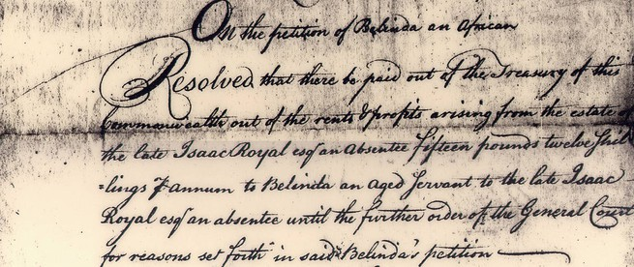Click the image above to view the full document.
“A heavy account lies against us as a civil society for oppressions committed against people who did not injure us,” wrote the Quaker John Woolman in 1769, “and that if the particular case of many individuals were fairly stated, it would appear that there was considerable due to them.”
As the historian Roy E. Finkenbine has documented, at the dawn of this country, black reparations were actively considered and often effected. Quakers in New York, New England, and Baltimore went so far as to make “membership contingent upon compensating one’s former slaves.” In 1782, the Quaker Robert Pleasants emancipated his 78 slaves, granted them 350 acres, and later built a school on their property and provided for their education. “The doing of this justice to the injured Africans,” wrote Pleasants, “would be an acceptable offering to him who ‘Rules in the kingdom of men.’ ”
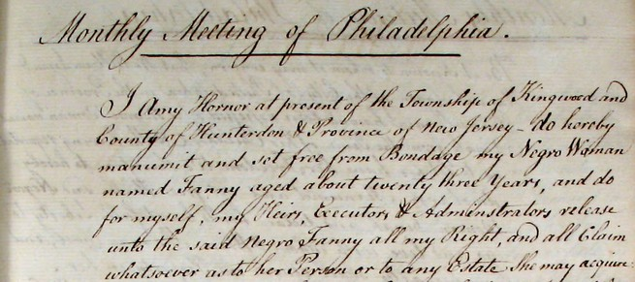Click the image above to view the full document.
Edward Coles, a protégé of Thomas Jefferson who became a slaveholder through inheritance, took many of his slaves north and granted them a plot of land in Illinois. John Randolph, a cousin of Jefferson’s, willed that all his slaves be emancipated upon his death, and that all those older than 40 be given 10 acres of land. “I give and bequeath to all my slaves their freedom,” Randolph wrote, “heartily regretting that I have been the owner of one.”
In his book Forever Free, Eric Foner recounts the story of a disgruntled planter reprimanding a freedman loafing on the job:
Planter: “You lazy nigger, I am losing a whole day’s labor by you.”
Freedman: “Massa, how many days’ labor have I lost by you?”
In the 20th century, the cause of reparations was taken up by a diverse cast that included the Confederate veteran Walter R. Vaughan, who believed that reparations would be a stimulus for the South; the black activist Callie House; black-nationalist leaders like “Queen Mother” Audley Moore; and the civil-rights activist James Forman. The movement coalesced in 1987 under an umbrella organization called the National Coalition of Blacks for Reparations in America (N’COBRA). The NAACP endorsed reparations in 1993. Charles J. Ogletree Jr., a professor at Harvard Law School, has pursued reparations claims in court.
But while the people advocating reparations have changed over time, the response from the country has remained virtually the same. “They have been taught to labor,” the Chicago Tribune editorialized in 1891. “They have been taught Christian civilization, and to speak the noble English language instead of some African gibberish. The account is square with the ex-slaves.”
Not exactly. Having been enslaved for 250 years, black people were not left to their own devices. They were terrorized. In the Deep South, a second slavery ruled. In the North, legislatures, mayors, civic associations, banks, and citizens all colluded to pin black people into ghettos, where they were overcrowded, overcharged, and undereducated. Businesses discriminated against them, awarding them the worst jobs and the worst wages. Police brutalized them in the streets. And the notion that black lives, black bodies, and black wealth were rightful targets remained deeply rooted in the broader society. Now we have half-stepped away from our long centuries of despoilment, promising, “Never again.” But still we are haunted. It is as though we have run up a credit-card bill and, having pledged to charge no more, remain befuddled that the balance does not disappear. The effects of that balance, interest accruing daily, are all around us.
Broach the topic of reparations today and a barrage of questions inevitably follows: Who will be paid? How much will they be paid? Who will pay? But if the practicalities, not the justice, of reparations are the true sticking point, there has for some time been the beginnings of a solution. For the past 25 years, Congressman John Conyers Jr., who represents the Detroit area, has marked every session of Congress by introducing a bill calling for a congressional study of slavery and its lingering effects as well as recommendations for “appropriate remedies.”
A country curious about how reparations might actually work has an easy solution in Conyers’s bill, now called HR 40, the Commission to Study Reparation Proposals for African Americans Act. We would support this bill, submit the question to study, and then assess the possible solutions. But we are not interested.
reporter’s notebook
What We Should Be Asking About Reparations
“Any contemplation of compensated emancipation must grapple with how several counties, and some states in the South, would react to finding themselves suddenly outnumbered by free black people.”
Read more
“It’s because it’s black folks making the claim,” Nkechi Taifa, who helped found N’COBRA, says. “People who talk about reparations are considered left lunatics. But all we are talking about is studying [reparations]. As John Conyers has said, we study everything. We study the water, the air. We can’t even study the issue? This bill does not authorize one red cent to anyone.”
That HR 40 has never—under either Democrats or Republicans—made it to the House floor suggests our concerns are rooted not in the impracticality of reparations but in something more existential. If we conclude that the conditions in North Lawndale and black America are not inexplicable but are instead precisely what you’d expect of a community that for centuries has lived in America’s crosshairs, then what are we to make of the world’s oldest democracy?
One cannot escape the question by hand-waving at the past, disavowing the acts of one’s ancestors, nor by citing a recent date of ancestral immigration. The last slaveholder has been dead for a very long time. The last soldier to endure Valley Forge has been dead much longer. To proudly claim the veteran and disown the slaveholder is patriotism à la carte. A nation outlives its generations. We were not there when Washington crossed the Delaware, but Emanuel Gottlieb Leutze’s rendering has meaning to us. We were not there when Woodrow Wilson took us into World War I, but we are still paying out the pensions. If Thomas Jefferson’s genius matters, then so does his taking of Sally Hemings’s body. If George Washington crossing the Delaware matters, so must his ruthless pursuit of the runagate Oney Judge.
Black families making $100,000 typically live in the kinds of neighborhoods inhabited by white families making $30,000.
In 1909, President William Howard Taft told the country that “intelligent” white southerners were ready to see blacks as “useful members of the community.” A week later Joseph Gordon, a black man, was lynched outside Greenwood, Mississippi. The high point of the lynching era has passed. But the memories of those robbed of their lives still live on in the lingering effects. Indeed, in America there is a strange and powerful belief that if you stab a black person 10 times, the bleeding stops and the healing begins the moment the assailant drops the knife. We believe white dominance to be a fact of the inert past, a delinquent debt that can be made to disappear if only we don’t look.
There has always been another way. “It is in vain to alledge, that our ancestors brought them hither, and not we,” Yale President Timothy Dwight said in 1810.
We inherit our ample patrimony with all its incumbrances; and are bound to pay the debts of our ancestors. This debt, particularly, we are bound to discharge: and, when the righteous Judge of the Universe comes to reckon with his servants, he will rigidly exact the payment at our hands. To give them liberty, and stop here, is to entail upon them a curse.

IV. “The Ills That Slavery Frees Us From”
America begins in black plunder and white democracy, two features that are not contradictory but complementary. “The men who came together to found the independent United States, dedicated to freedom and equality, either held slaves or were willing to join hands with those who did,” the historian Edmund S. Morgan wrote. “None of them felt entirely comfortable about the fact, but neither did they feel responsible for it. Most of them had inherited both their slaves and their attachment to freedom from an earlier generation, and they knew the two were not unconnected.”
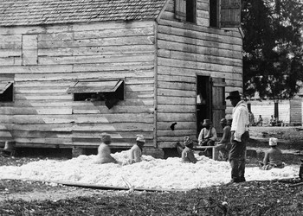Slaves in South Carolina prepare cotton for the gin in 1862. (Timothy H. O’sullivan/Library of Congress)
When enslaved Africans, plundered of their bodies, plundered of their families, and plundered of their labor, were brought to the colony of Virginia in 1619, they did not initially endure the naked racism that would engulf their progeny. Some of them were freed. Some of them intermarried. Still others escaped with the white indentured servants who had suffered as they had. Some even rebelled together, allying under Nathaniel Bacon to torch Jamestown in 1676.
One hundred years later, the idea of slaves and poor whites joining forces would shock the senses, but in the early days of the English colonies, the two groups had much in common. English visitors to Virginia found that its masters “abuse their servantes with intollerable oppression and hard usage.” White servants were flogged, tricked into serving beyond their contracts, and traded in much the same manner as slaves.
This “hard usage” originated in a simple fact of the New World—land was boundless but cheap labor was limited. As life spans increased in the colony, the Virginia planters found in the enslaved Africans an even more efficient source of cheap labor. Whereas indentured servants were still legal subjects of the English crown and thus entitled to certain protections, African slaves entered the colonies as aliens. Exempted from the protections of the crown, they became early America’s indispensable working class—fit for maximum exploitation, capable of only minimal resistance.
For the next 250 years, American law worked to reduce black people to a class of untouchables and raise all white men to the level of citizens. In 1650, Virginia mandated that “all persons except Negroes” were to carry arms. In 1664, Maryland mandated that any Englishwoman who married a slave must live as a slave of her husband’s master. In 1705, the Virginia assembly passed a law allowing for the dismemberment of unruly slaves—but forbidding masters from whipping “a Christian white servant naked, without an order from a justice of the peace.” In that same law, the colony mandated that “all horses, cattle, and hogs, now belonging, or that hereafter shall belong to any slave” be seized and sold off by the local church, the profits used to support “the poor of the said parish.” At that time, there would have still been people alive who could remember blacks and whites joining to burn down Jamestown only 29 years before. But at the beginning of the 18th century, two primary classes were enshrined in America.
“The two great divisions of society are not the rich and poor, but white and black,” John C. Calhoun, South Carolina’s senior senator, declared on the Senate floor in 1848. “And all the former, the poor as well as the rich, belong to the upper class, and are respected and treated as equals.”
In 1860, the majority of people living in South Carolina and Mississippi, almost half of those living in Georgia, and about one-third of all Southerners were on the wrong side of Calhoun’s line. The state with the largest number of enslaved Americans was Virginia, where in certain counties some 70 percent of all people labored in chains. Nearly one-fourth of all white Southerners owned slaves, and upon their backs the economic basis of America—and much of the Atlantic world—was erected. In the seven cotton states, one-third of all white income was derived from slavery. By 1840, cotton produced by slave labor constituted 59 percent of the country’s exports. The web of this slave society extended north to the looms of New England, and across the Atlantic to Great Britain, where it powered a great economic transformation and altered the trajectory of world history. “Whoever says Industrial Revolution,” wrote the historian Eric J. Hobsbawm, “says cotton.”
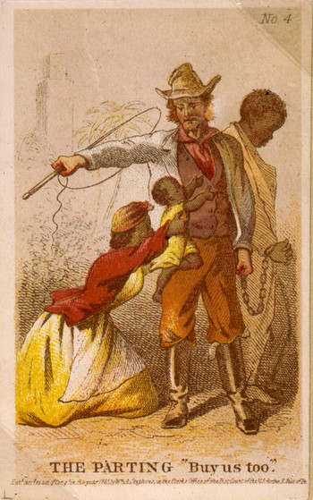In this artistic rendering by Henry Louis Stephens, a well-known illustrator of the era, a family is in the process of being separated at a slave auction. (Library of Congress)
The wealth accorded America by slavery was not just in what the slaves pulled from the land but in the slaves themselves. “In 1860, slaves as an asset were worth more than all of America’s manufacturing, all of the railroads, all of the productive capacity of the United States put together,” the Yale historian David W. Blight has noted. “Slaves were the single largest, by far, financial asset of property in the entire American economy.” The sale of these slaves—“in whose bodies that money congealed,” writes Walter Johnson, a Harvard historian—generated even more ancillary wealth. Loans were taken out for purchase, to be repaid with interest. Insurance policies were drafted against the untimely death of a slave and the loss of potential profits. Slave sales were taxed and notarized. The vending of the black body and the sundering of the black family became an economy unto themselves, estimated to have brought in tens of millions of dollars to antebellum America. In 1860 there were more millionaires per capita in the Mississippi Valley than anywhere else in the country.
Beneath the cold numbers lay lives divided. “I had a constant dread that Mrs. Moore, her mistress, would be in want of money and sell my dear wife,” a freedman wrote, reflecting on his time in slavery. “We constantly dreaded a final separation. Our affection for each was very strong, and this made us always apprehensive of a cruel parting.”
Forced partings were common in the antebellum South. A slave in some parts of the region stood a 30 percent chance of being sold in his or her lifetime. Twenty-five percent of interstate trades destroyed a first marriage and half of them destroyed a nuclear family.
When the wife and children of Henry Brown, a slave in Richmond, Virginia, were to be sold away, Brown searched for a white master who might buy his wife and children to keep the family together. He failed:
The next day, I stationed myself by the side of the road, along which the slaves, amounting to three hundred and fifty, were to pass. The purchaser of my wife was a Methodist minister, who was about starting for North Carolina. Pretty soon five waggon-loads of little children passed, and looking at the foremost one, what should I see but a little child, pointing its tiny hand towards me, exclaiming, “There’s my father; I knew he would come and bid me good-bye.” It was my eldest child! Soon the gang approached in which my wife was chained. I looked, and beheld her familiar face; but O, reader, that glance of agony! may God spare me ever again enduring the excruciating horror of that moment! She passed, and came near to where I stood. I seized hold of her hand, intending to bid her farewell; but words failed me; the gift of utterance had fled, and I remained speechless. I followed her for some distance, with her hand grasped in mine, as if to save her from her fate, but I could not speak, and I was obliged to turn away in silence.
In a time when telecommunications were primitive and blacks lacked freedom of movement, the parting of black families was a kind of murder. Here we find the roots of American wealth and democracy—in the for-profit destruction of the most important asset available to any people, the family. The destruction was not incidental to America’s rise; it facilitated that rise. By erecting a slave society, America created the economic foundation for its great experiment in democracy. The labor strife that seeded Bacon’s rebellion was suppressed. America’s indispensable working class existed as property beyond the realm of politics, leaving white Americans free to trumpet their love of freedom and democratic values. Assessing antebellum democracy in Virginia, a visitor from England observed that the state’s natives “can profess an unbounded love of liberty and of democracy in consequence of the mass of the people, who in other countries might become mobs, being there nearly altogether composed of their own Negro slaves.”

V. The Quiet Plunder
The consequences of 250 years of enslavement, of war upon black families and black people, were profound. Like homeownership today, slave ownership was aspirational, attracting not just those who owned slaves but those who wished to. Much as homeowners today might discuss the addition of a patio or the painting of a living room, slaveholders traded tips on the best methods for breeding workers, exacting labor, and doling out punishment. Just as a homeowner today might subscribe to a magazine like This Old House, slaveholders had journals such as De Bow’s Review, which recommended the best practices for wringing profits from slaves. By the dawn of the Civil War, the enslavement of black America was thought to be so foundational to the country that those who sought to end it were branded heretics worthy of death. Imagine what would happen if a president today came out in favor of taking all American homes from their owners: the reaction might well be violent.
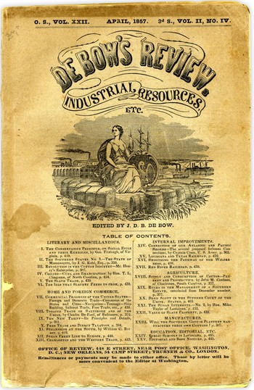Click the image above to view the full document.
“This country was formed for the white, not for the black man,” John Wilkes Booth wrote, before killing Abraham Lincoln. “And looking upon African slavery from the same standpoint held by those noble framers of our Constitution, I for one have ever considered it one of the greatest blessings (both for themselves and us) that God ever bestowed upon a favored nation.”
In the aftermath of the Civil War, Radical Republicans attempted to reconstruct the country upon something resembling universal equality—but they were beaten back by a campaign of “Redemption,” led by White Liners, Red Shirts, and Klansmen bent on upholding a society “formed for the white, not for the black man.” A wave of terrorism roiled the South. In his massive history Reconstruction, Eric Foner recounts incidents of black people being attacked for not removing their hats; for refusing to hand over a whiskey flask; for disobeying church procedures; for “using insolent language”; for disputing labor contracts; for refusing to be “tied like a slave.” Sometimes the attacks were intended simply to “thin out the niggers a little.”
Terrorism carried the day. Federal troops withdrew from the South in 1877. The dream of Reconstruction died. For the next century, political violence was visited upon blacks wantonly, with special treatment meted out toward black people of ambition. Black schools and churches were burned to the ground. Black voters and the political candidates who attempted to rally them were intimidated, and some were murdered. At the end of World War I, black veterans returning to their homes were assaulted for daring to wear the American uniform. The demobilization of soldiers after the war, which put white and black veterans into competition for scarce jobs, produced the Red Summer of 1919: a succession of racist pogroms against dozens of cities ranging from Longview, Texas, to Chicago to Washington, D.C. Organized white violence against blacks continued into the 1920s—in 1921 a white mob leveled Tulsa’s “Black Wall Street,” and in 1923 another one razed the black town of Rosewood, Florida—and virtually no one was punished.
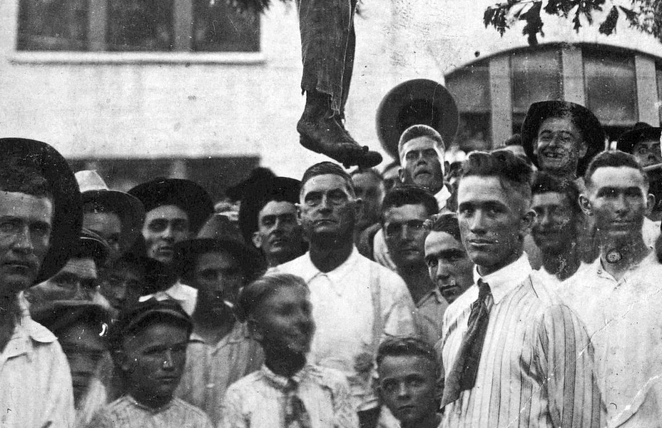A postcard dated August 3, 1920, depicts the aftermath of a lynching in Center, Texas, near the Louisiana border. According to the text on the other side, the victim was a 16-year-old boy.
The work of mobs was a rabid and violent rendition of prejudices that extended even into the upper reaches of American government. The New Deal is today remembered as a model for what progressive government should do—cast a broad social safety net that protects the poor and the afflicted while building the middle class. When progressives wish to express their disappointment with Barack Obama, they point to the accomplishments of Franklin Roosevelt. But these progressives rarely note that Roosevelt’s New Deal, much like the democracy that produced it, rested on the foundation of Jim Crow.
“The Jim Crow South,” writes Ira Katznelson, a history and political-science professor at Columbia, “was the one collaborator America’s democracy could not do without.” The marks of that collaboration are all over the New Deal. The omnibus programs passed under the Social Security Act in 1935 were crafted in such a way as to protect the southern way of life. Old-age insurance (Social Security proper) and unemployment insurance excluded farmworkers and domestics—jobs heavily occupied by blacks. When President Roosevelt signed Social Security into law in 1935, 65 percent of African Americans nationally and between 70 and 80 percent in the South were ineligible. The NAACP protested, calling the new American safety net “a sieve with holes just big enough for the majority of Negroes to fall through.”
The oft-celebrated G.I. Bill similarly failed black Americans, by mirroring the broader country’s insistence on a racist housing policy. Though ostensibly color-blind, Title III of the bill, which aimed to give veterans access to low-interest home loans, left black veterans to tangle with white officials at their local Veterans Administration as well as with the same banks that had, for years, refused to grant mortgages to blacks. The historian Kathleen J. Frydl observes in her 2009 book, The GI Bill, that so many blacks were disqualified from receiving Title III benefits “that it is more accurate simply to say that blacks could not use this particular title.”
In Cold War America, homeownership was seen as a means of instilling patriotism, and as a civilizing and anti-radical force. “No man who owns his own house and lot can be a Communist,” claimed William Levitt, who pioneered the modern suburb with the development of the various Levittowns, his famous planned communities. “He has too much to do.”
But the Levittowns were, with Levitt’s willing acquiescence, segregated throughout their early years. Daisy and Bill Myers, the first black family to move into Levittown, Pennsylvania, were greeted with protests and a burning cross. A neighbor who opposed the family said that Bill Myers was “probably a nice guy, but every time I look at him I see $2,000 drop off the value of my house.”
The neighbor had good reason to be afraid. Bill and Daisy Myers were from the other side of John C. Calhoun’s dual society. If they moved next door, housing policy almost guaranteed that their neighbors’ property values would decline.
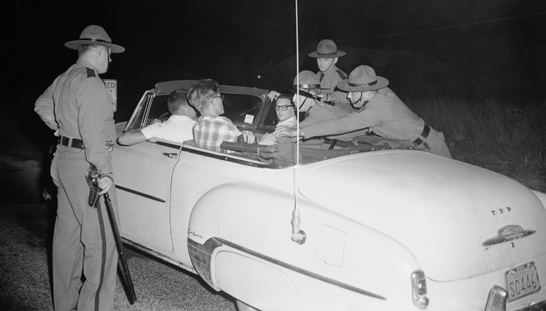In August 1957, state police pull teenagers out of a car during a demonstration against Bill and Daisy Myers, the first African Americans to move into Levittown, Pennsyvlania. (AP Photo/Bill Ingraham)
Whereas shortly before the New Deal, a typical mortgage required a large down payment and full repayment within about 10 years, the creation of the Home Owners’ Loan Corporation in 1933 and then the Federal Housing Administration the following year allowed banks to offer loans requiring no more than 10 percent down, amortized over 20 to 30 years. “Without federal intervention in the housing market, massive suburbanization would have been impossible,” writes Thomas J. Sugrue, a historian at the University of Pennsylvania. “In 1930, only 30 percent of Americans owned their own homes; by 1960, more than 60 percent were home owners. Home ownership became an emblem of American citizenship.”
That emblem was not to be awarded to blacks. The American real-estate industry believed segregation to be a moral principle. As late as 1950, the National Association of Real Estate Boards’ code of ethics warned that “a Realtor should never be instrumental in introducing into a neighborhood … any race or nationality, or any individuals whose presence will clearly be detrimental to property values.” A 1943 brochure specified that such potential undesirables might include madams, bootleggers, gangsters—and “a colored man of means who was giving his children a college education and thought they were entitled to live among whites.”
The federal government concurred. It was the Home Owners’ Loan Corporation, not a private trade association, that pioneered the practice of redlining, selectively granting loans and insisting that any property it insured be covered by a restrictive covenant—a clause in the deed forbidding the sale of the property to anyone other than whites. Millions of dollars flowed from tax coffers into segregated white neighborhoods.
One man said his black neighbor was “probably a nice guy, but every time I look at him I see $2,000 drop off the value of my house.”
“For perhaps the first time, the federal government embraced the discriminatory attitudes of the marketplace,” the historian Kenneth T. Jackson wrote in his 1985 book, Crabgrass Frontier, a history of suburbanization. “Previously, prejudices were personalized and individualized; FHA exhorted segregation and enshrined it as public policy. Whole areas of cities were declared ineligible for loan guarantees.” Redlining was not officially outlawed until 1968, by the Fair Housing Act. By then the damage was done—and reports of redlining by banks have continued.
The federal government is premised on equal fealty from all its citizens, who in return are to receive equal treatment. But as late as the mid-20th century, this bargain was not granted to black people, who repeatedly paid a higher price for citizenship and received less in return. Plunder had been the essential feature of slavery, of the society described by Calhoun. But practically a full century after the end of the Civil War and the abolition of slavery, the plunder—quiet, systemic, submerged—continued even amidst the aims and achievements of New Deal liberals.

VI. Making The Second Ghetto
Today Chicago is one of the most segregated cities in the country, a fact that reflects assiduous planning. In the effort to uphold white supremacy at every level down to the neighborhood, Chicago—a city founded by the black fur trader Jean Baptiste Point du Sable—has long been a pioneer. The efforts began in earnest in 1917, when the Chicago Real Estate Board, horrified by the influx of southern blacks, lobbied to zone the entire city by race. But after the Supreme Court ruled against explicit racial zoning that year, the city was forced to pursue its agenda by more-discreet means.
Like the Home Owners’ Loan Corporation, the Federal Housing Administration initially insisted on restrictive covenants, which helped bar blacks and other ethnic undesirables from receiving federally backed home loans. By the 1940s, Chicago led the nation in the use of these restrictive covenants, and about half of all residential neighborhoods in the city were effectively off-limits to blacks.
It is common today to become misty-eyed about the old black ghetto, where doctors and lawyers lived next door to meatpackers and steelworkers, who themselves lived next door to prostitutes and the unemployed. This segregationist nostalgia ignores the actual conditions endured by the people living there—vermin and arson, for instance—and ignores the fact that the old ghetto was premised on denying black people privileges enjoyed by white Americans.
In 1948, when the Supreme Court ruled that restrictive covenants, while permissible, were not enforceable by judicial action, Chicago had other weapons at the ready. The Illinois state legislature had already given Chicago’s city council the right to approve—and thus to veto—any public housing in the city’s wards. This came in handy in 1949, when a new federal housing act sent millions of tax dollars into Chicago and other cities around the country. Beginning in 1950, site selection for public housing proceeded entirely on the grounds of segregation. By the 1960s, the city had created with its vast housing projects what the historian Arnold R. Hirsch calls a “second ghetto,” one larger than the old Black Belt but just as impermeable. More than 98 percent of all the family public-housing units built in Chicago between 1950 and the mid-1960s were built in all-black neighborhoods.
Governmental embrace of segregation was driven by the virulent racism of Chicago’s white citizens. White neighborhoods vulnerable to black encroachment formed block associations for the sole purpose of enforcing segregation. They lobbied fellow whites not to sell. They lobbied those blacks who did manage to buy to sell back. In 1949, a group of Englewood Catholics formed block associations intended to “keep up the neighborhood.” Translation: keep black people out. And when civic engagement was not enough, when government failed, when private banks could no longer hold the line, Chicago turned to an old tool in the American repertoire—racial violence. “The pattern of terrorism is easily discernible,” concluded a Chicago civic group in the 1940s. “It is at the seams of the black ghetto in all directions.” On July 1 and 2 of 1946, a mob of thousands assembled in Chicago’s Park Manor neighborhood, hoping to eject a black doctor who’d recently moved in. The mob pelted the house with rocks and set the garage on fire. The doctor moved away.
In 1947, after a few black veterans moved into the Fernwood section of Chicago, three nights of rioting broke out; gangs of whites yanked blacks off streetcars and beat them. Two years later, when a union meeting attended by blacks in Englewood triggered rumors that a home was being “sold to niggers,” blacks (and whites thought to be sympathetic to them) were beaten in the streets. In 1951, thousands of whites in Cicero, 20 minutes or so west of downtown Chicago, attacked an apartment building that housed a single black family, throwing bricks and firebombs through the windows and setting the apartment on fire. A Cook County grand jury declined to charge the rioters—and instead indicted the family’s NAACP attorney, the apartment’s white owner, and the owner’s attorney and rental agent, charging them with conspiring to lower property values. Two years after that, whites picketed and planted explosives in South Deering, about 30 minutes from downtown Chicago, to force blacks out.
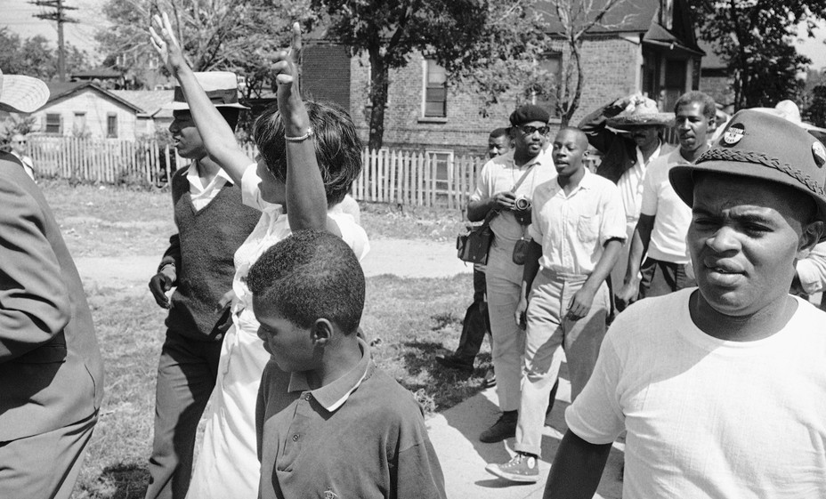The September 1966 Cicero protest against housing discrimination was one of the first nonviolent civil-rights campaigns launched near a major city. (Associated Press)
When terrorism ultimately failed, white homeowners simply fled the neighborhood. The traditional terminology, white flight, implies a kind of natural expression of preference. In fact, white flight was a triumph of social engineering, orchestrated by the shared racist presumptions of America’s public and private sectors. For should any nonracist white families decide that integration might not be so bad as a matter of principle or practicality, they still had to contend with the hard facts of American housing policy: When the mid-20th-century white homeowner claimed that the presence of a Bill and Daisy Myers decreased his property value, he was not merely engaging in racist dogma—he was accurately observing the impact of federal policy on market prices. Redlining destroyed the possibility of investment wherever black people lived.

VII. “A Lot Of People Fell By The Way”
Speculators in North Lawndale, and at the edge of the black ghettos, knew there was money to be made off white panic. They resorted to “block-busting”—spooking whites into selling cheap before the neighborhood became black. They would hire a black woman to walk up and down the street with a stroller. Or they’d hire someone to call a number in the neighborhood looking for “Johnny Mae.” Then they’d cajole whites into selling at low prices, informing them that the more blacks who moved in, the more the value of their homes would decline, so better to sell now. With these white-fled homes in hand, speculators then turned to the masses of black people who had streamed northward as part of the Great Migration, or who were desperate to escape the ghettos: the speculators would take the houses they’d just bought cheap through block-busting and sell them to blacks on contract.
To keep up with his payments and keep his heat on, Clyde Ross took a second job at the post office and then a third job delivering pizza. His wife took a job working at Marshall Field. He had to take some of his children out of private school. He was not able to be at home to supervise his children or help them with their homework. Money and time that Ross wanted to give his children went instead to enrich white speculators.
“The problem was the money,” Ross told me. “Without the money, you can’t move. You can’t educate your kids. You can’t give them the right kind of food. Can’t make the house look good. They think this neighborhood is where they supposed to be. It changes their outlook. My kids were going to the best schools in this neighborhood, and I couldn’t keep them in there.”
Mattie Lewis came to Chicago from her native Alabama in the mid-’40s, when she was 21, persuaded by a friend who told her she could get a job as a hairdresser. Instead she was hired by Western Electric, where she worked for 41 years. I met Lewis in the home of her neighbor Ethel Weatherspoon. Both had owned homes in North Lawndale for more than 50 years. Both had bought their houses on contract. Both had been active with Clyde Ross in the Contract Buyers League’s effort to garner restitution from contract sellers who’d operated in North Lawndale, banks who’d backed the scheme, and even the Federal Housing Administration. We were joined by Jack Macnamara, who’d been an organizing force in the Contract Buyers League when it was founded, in 1968. Our gathering had the feel of a reunion, because the writer James Alan McPherson had profiled the Contract Buyers League for The Atlantic back in 1972.
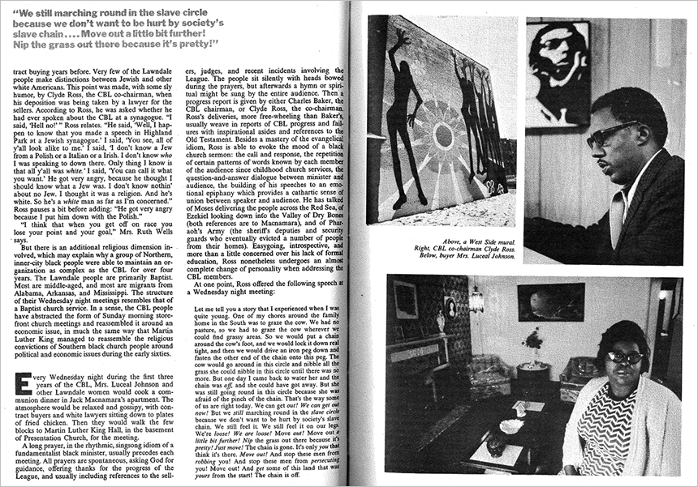Click the image above to download a PDF version of The Atlantic’s April 1972 profile of the Contract Buyers League.
Weatherspoon bought her home in 1957. “Most of the whites started moving out,” she told me. “‘The blacks are coming. The blacks are coming.’ They actually said that. They had signs up: Don’t sell to blacks.”
Before moving to North Lawndale, Lewis and her husband tried moving to Cicero after seeing a house advertised for sale there. “Sorry, I just sold it today,” the Realtor told Lewis’s husband. “I told him, ‘You know they don’t want you in Cicero,’ ” Lewis recalls. “ ‘They ain’t going to let nobody black in Cicero.’ ”
In 1958, the couple bought a home in North Lawndale on contract. They were not blind to the unfairness. But Lewis, born in the teeth of Jim Crow, considered American piracy—black people keep on making it, white people keep on taking it—a fact of nature. “All I wanted was a house. And that was the only way I could get it. They weren’t giving black people loans at that time,” she said. “We thought, ‘This is the way it is. We going to do it till we die, and they ain’t never going to accept us. That’s just the way it is.’
“The only way you were going to buy a home was to do it the way they wanted,” she continued. “And I was determined to get me a house. If everybody else can have one, I want one too. I had worked for white people in the South. And I saw how these white people were living in the North and I thought, ‘One day I’m going to live just like them.’ I wanted cabinets and all these things these other people have.”
White flight was not an accident—it was a triumph of racist social engineering.
Whenever she visited white co-workers at their homes, she saw the difference. “I could see we were just getting ripped off,” she said. “I would see things and I would say, ‘I’d like to do this at my house.’ And they would say, ‘Do it,’ but I would think, ‘I can’t, because it costs us so much more.’ ”
I asked Lewis and Weatherspoon how they kept up on payments.
“You paid it and kept working,” Lewis said of the contract. “When that payment came up, you knew you had to pay it.”
“You cut down on the light bill. Cut down on your food bill,” Weatherspoon interjected.
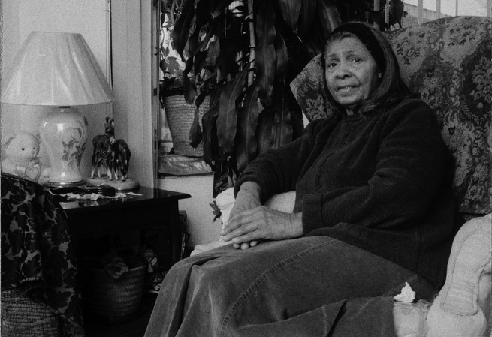Ethel Weatherspoon at her home in North Lawndale. After she bought it in 1957, she says, “most of the whites started moving out.” (Carlos Javier Ortiz)
“You cut down on things for your child, that was the main thing,” said Lewis. “My oldest wanted to be an artist and my other wanted to be a dancer and my other wanted to take music.”
Lewis and Weatherspoon, like Ross, were able to keep their homes. The suit did not win them any remuneration. But it forced contract sellers to the table, where they allowed some members of the Contract Buyers League to move into regular mortgages or simply take over their houses outright. By then they’d been bilked for thousands. In talking with Lewis and Weatherspoon, I was seeing only part of the picture—the tiny minority who’d managed to hold on to their homes. But for all our exceptional ones, for every Barack and Michelle Obama, for every Ethel Weatherspoon or Clyde Ross, for every black survivor, there are so many thousands gone.
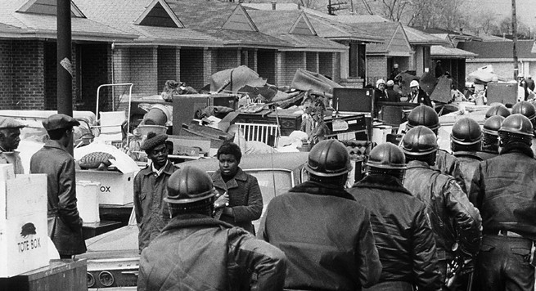Deputy sheriffs patrol a Chicago street in 1970 after a dozen Contract Buyers League families were evicted. (Courtesy of Sun-Times Media)
“A lot of people fell by the way,” Lewis told me. “One woman asked me if I would keep all her china. She said, ‘They ain’t going to set you out.’ ”

VIII. “Negro Poverty is not White Poverty”
On a recent spring afternoon in North Lawndale, I visited Billy Lamar Brooks Sr. Brooks has been an activist since his youth in the Black Panther Party, when he aided the Contract Buyers League. I met him in his office at the Better Boys Foundation, a staple of North Lawndale whose mission is to direct local kids off the streets and into jobs and college. Brooks’s work is personal. On June 14, 1991, his 19-year-old son, Billy Jr., was shot and killed. “These guys tried to stick him up,” Brooks told me. “I suspect he could have been involved in some things … He’s always on my mind. Every day.”
Brooks was not raised in the streets, though in such a neighborhood it is impossible to avoid the influence. “I was in church three or four times a week. That’s where the girls were,” he said, laughing. “The stark reality is still there. There’s no shield from life. You got to go to school. I lived here. I went to Marshall High School. Over here were the Egyptian Cobras. Over there were the Vice Lords.”
Brooks has since moved away from Chicago’s West Side. But he is still working in North Lawndale. If “you got a nice house, you live in a nice neighborhood, then you are less prone to violence, because your space is not deprived,” Brooks said. “You got a security point. You don’t need no protection.” But if “you grow up in a place like this, housing sucks. When they tore down the projects here, they left the high-rises and came to the neighborhood with that gang mentality. You don’t have nothing, so you going to take something, even if it’s not real. You don’t have no street, but in your mind it’s yours.”

Video: The Guardian of North Lawndale
Visit North Lawndale today with Billy Brooks
We walked over to a window behind his desk. A group of young black men were hanging out in front of a giant mural memorializing two black men: In Lovin Memory Quentin aka “Q,” July 18, 1974 ❤ March 2, 2012. The name and face of the other man had been spray-painted over by a rival group. The men drank beer. Occasionally a car would cruise past, slow to a crawl, then stop. One of the men would approach the car and make an exchange, then the car would drive off. Brooks had known all of these young men as boys.
“That’s their corner,” he said.
We watched another car roll through, pause briefly, then drive off. “No respect, no shame,” Brooks said. “That’s what they do. From that alley to that corner. They don’t go no farther than that. See the big brother there? He almost died a couple of years ago. The one drinking the beer back there … I know all of them. And the reason they feel safe here is cause of this building, and because they too chickenshit to go anywhere. But that’s their mentality. That’s their block.”
Brooks showed me a picture of a Little League team he had coached. He went down the row of kids, pointing out which ones were in jail, which ones were dead, and which ones were doing all right. And then he pointed out his son—“That’s my boy, Billy,” Brooks said. Then he wondered aloud if keeping his son with him while working in North Lawndale had hastened his death. “It’s a definite connection, because he was part of what I did here. And I think maybe I shouldn’t have exposed him. But then, I had to,” he said, “because I wanted him with me.”
From the White House on down, the myth holds that fatherhood is the great antidote to all that ails black people. But Billy Brooks Jr. had a father. Trayvon Martin had a father. Jordan Davis had a father. Adhering to middle-class norms has never shielded black people from plunder. Adhering to middle-class norms is what made Ethel Weatherspoon a lucrative target for rapacious speculators. Contract sellers did not target the very poor. They targeted black people who had worked hard enough to save a down payment and dreamed of the emblem of American citizenship—homeownership. It was not a tangle of pathology that put a target on Clyde Ross’s back. It was not a culture of poverty that singled out Mattie Lewis for “the thrill of the chase and the kill.” Some black people always will be twice as good. But they generally find white predation to be thrice as fast.
Is affirmative action meant to increase “diversity”? If so, it only tangentially relates to the specific problems of black people.
Liberals today mostly view racism not as an active, distinct evil but as a relative of white poverty and inequality. They ignore the long tradition of this country actively punishing black success—and the elevation of that punishment, in the mid-20th century, to federal policy. President Lyndon Johnson may have noted in his historic civil-rights speech at Howard University in 1965 that “Negro poverty is not white poverty.” But his advisers and their successors were, and still are, loath to craft any policy that recognizes the difference.
After his speech, Johnson convened a group of civil-rights leaders, including the esteemed A. Philip Randolph and Bayard Rustin, to address the “ancient brutality.” In a strategy paper, they agreed with the president that “Negro poverty is a special, and particularly destructive, form of American poverty.” But when it came to specifically addressing the “particularly destructive,” Rustin’s group demurred, preferring to advance programs that addressed “all the poor, black and white.”
reporter’s notebook
White Racism vs. White Resentment
“The idea that Affirmative Action justifies white resentment may be the greatest argument made for reparations—like ever.”
Read more
The urge to use the moral force of the black struggle to address broader inequalities originates in both compassion and pragmatism. But it makes for ambiguous policy. Affirmative action’s precise aims, for instance, have always proved elusive. Is it meant to make amends for the crimes heaped upon black people? Not according to the Supreme Court. In its 1978 ruling in Regents of the University of California v. Bakke, the Court rejected “societal discrimination” as “an amorphous concept of injury that may be ageless in its reach into the past.” Is affirmative action meant to increase “diversity”? If so, it only tangentially relates to the specific problems of black people—the problem of what America has taken from them over several centuries.
This confusion about affirmative action’s aims, along with our inability to face up to the particular history of white-imposed black disadvantage, dates back to the policy’s origins. “There is no fixed and firm definition of affirmative action,” an appointee in Johnson’s Department of Labor declared. “Affirmative action is anything that you have to do to get results. But this does not necessarily include preferential treatment.”
Yet America was built on the preferential treatment of white people—395 years of it. Vaguely endorsing a cuddly, feel-good diversity does very little to redress this.
Today, progressives are loath to invoke white supremacy as an explanation for anything. On a practical level, the hesitation comes from the dim view the Supreme Court has taken of the reforms of the 1960s. The Voting Rights Act has been gutted. The Fair Housing Act might well be next. Affirmative action is on its last legs. In substituting a broad class struggle for an anti-racist struggle, progressives hope to assemble a coalition by changing the subject.
The politics of racial evasion are seductive. But the record is mixed. Aid to Families With Dependent Children was originally written largely to exclude blacks—yet by the 1990s it was perceived as a giveaway to blacks. The Affordable Care Act makes no mention of race, but this did not keep Rush Limbaugh from denouncing it as reparations. Moreover, the act’s expansion of Medicaid was effectively made optional, meaning that many poor blacks in the former Confederate states do not benefit from it. The Affordable Care Act, like Social Security, will eventually expand its reach to those left out; in the meantime, black people will be injured.
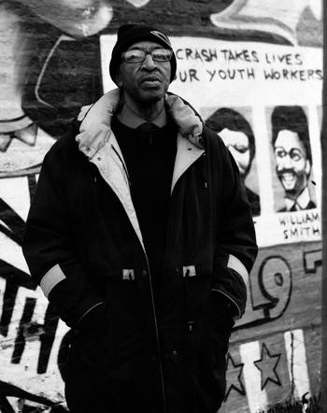Billy Brooks, who assisted the Contract Buyers League, still works in the neighborhood, helping kids escape poverty and violence. (Carlos Javier Ortiz)
“All that it would take to sink a new WPA program would be some skillfully packaged footage of black men leaning on shovels smoking cigarettes,” the sociologist Douglas S. Massey writes. “Papering over the issue of race makes for bad social theory, bad research, and bad public policy.” To ignore the fact that one of the oldest republics in the world was erected on a foundation of white supremacy, to pretend that the problems of a dual society are the same as the problems of unregulated capitalism, is to cover the sin of national plunder with the sin of national lying. The lie ignores the fact that reducing American poverty and ending white supremacy are not the same. The lie ignores the fact that closing the “achievement gap” will do nothing to close the “injury gap,” in which black college graduates still suffer higher unemployment rates than white college graduates, and black job applicants without criminal records enjoy roughly the same chance of getting hired as white applicants with criminal records.
Chicago, like the country at large, embraced policies that placed black America’s most energetic, ambitious, and thrifty countrymen beyond the pale of society and marked them as rightful targets for legal theft. The effects reverberate beyond the families who were robbed to the community that beholds the spectacle. Don’t just picture Clyde Ross working three jobs so he could hold on to his home. Think of his North Lawndale neighbors—their children, their nephews and nieces—and consider how watching this affects them. Imagine yourself as a young black child watching your elders play by all the rules only to have their possessions tossed out in the street and to have their most sacred possession—their home—taken from them.
The message the young black boy receives from his country, Billy Brooks says, is “ ‘You ain’t shit. You not no good. The only thing you are worth is working for us. You will never own anything. You not going to get an education. We are sending your ass to the penitentiary.’ They’re telling you no matter how hard you struggle, no matter what you put down, you ain’t shit. ‘We’re going to take what you got. You will never own anything, nigger.’ ”

IX. Toward A New Country
When Clyde Ross was a child, his older brother Winter had a seizure. He was picked up by the authorities and delivered to Parchman Farm, a 20,000-acre state prison in the Mississippi Delta region.
“He was a gentle person,” Clyde Ross says of his brother. “You know, he was good to everybody. And he started having spells, and he couldn’t control himself. And they had him picked up, because they thought he was dangerous.”
Built at the turn of the century, Parchman was supposed to be a progressive and reformist response to the problem of “Negro crime.” In fact it was the gulag of Mississippi, an object of terror to African Americans in the Delta. In the early years of the 20th century, Mississippi Governor James K. Vardaman used to amuse himself by releasing black convicts into the surrounding wilderness and hunting them down with bloodhounds. “Throughout the American South,” writes David M. Oshinsky in his book Worse Than Slavery, “Parchman Farm is synonymous with punishment and brutality, as well it should be … Parchman is the quintessential penal farm, the closest thing to slavery that survived the Civil War.”
When the Ross family went to retrieve Winter, the authorities told them that Winter had died. When the Ross family asked for his body, the authorities at Parchman said they had buried him. The family never saw Winter’s body.
And this was just one of their losses.
Scholars have long discussed methods by which America might make reparations to those on whose labor and exclusion the country was built. In the 1970s, the Yale Law professor Boris Bittker argued in The Case for Black Reparations that a rough price tag for reparations could be determined by multiplying the number of African Americans in the population by the difference in white and black per capita income. That number—$34 billion in 1973, when Bittker wrote his book—could be added to a reparations program each year for a decade or two. Today Charles Ogletree, the Harvard Law School professor, argues for something broader: a program of job training and public works that takes racial justice as its mission but includes the poor of all races.
To celebrate freedom and democracy while forgetting America’s origins in a slavery economy is patriotism à la carte.
Perhaps no statistic better illustrates the enduring legacy of our country’s shameful history of treating black people as sub-citizens, sub-Americans, and sub-humans than the wealth gap. Reparations would seek to close this chasm. But as surely as the creation of the wealth gap required the cooperation of every aspect of the society, bridging it will require the same.
When we think of white supremacy, we picture Colored Only signs, but we should picture pirate flags.
Perhaps after a serious discussion and debate—the kind that HR 40 proposes—we may find that the country can never fully repay African Americans. But we stand to discover much about ourselves in such a discussion—and that is perhaps what scares us. The idea of reparations is frightening not simply because we might lack the ability to pay. The idea of reparations threatens something much deeper—America’s heritage, history, and standing in the world.
The early American economy was built on slave labor. The Capitol and the White House were built by slaves. President James K. Polk traded slaves from the Oval Office. The laments about “black pathology,” the criticism of black family structures by pundits and intellectuals, ring hollow in a country whose existence was predicated on the torture of black fathers, on the rape of black mothers, on the sale of black children. An honest assessment of America’s relationship to the black family reveals the country to be not its nurturer but its destroyer.
And this destruction did not end with slavery. Discriminatory laws joined the equal burden of citizenship to unequal distribution of its bounty. These laws reached their apex in the mid-20th century, when the federal government—through housing policies—engineered the wealth gap, which remains with us to this day. When we think of white supremacy, we picture Colored Only signs, but we should picture pirate flags.
On some level, we have always grasped this.
“Negro poverty is not white poverty,” President Johnson said in his historic civil-rights speech.
Many of its causes and many of its cures are the same. But there are differences—deep, corrosive, obstinate differences—radiating painful roots into the community and into the family, and the nature of the individual. These differences are not racial differences. They are solely and simply the consequence of ancient brutality, past injustice, and present prejudice.
We invoke the words of Jefferson and Lincoln because they say something about our legacy and our traditions. We do this because we recognize our links to the past—at least when they flatter us. But black history does not flatter American democracy; it chastens it. The popular mocking of reparations as a harebrained scheme authored by wild-eyed lefties and intellectually unserious black nationalists is fear masquerading as laughter. Black nationalists have always perceived something unmentionable about America that integrationists dare not acknowledge—that white supremacy is not merely the work of hotheaded demagogues, or a matter of false consciousness, but a force so fundamental to America that it is difficult to imagine the country without it.
And so we must imagine a new country. Reparations—by which I mean the full acceptance of our collective biography and its consequences—is the price we must pay to see ourselves squarely. The recovering alcoholic may well have to live with his illness for the rest of his life. But at least he is not living a drunken lie. Reparations beckons us to reject the intoxication of hubris and see America as it is—the work of fallible humans.
Won’t reparations divide us? Not any more than we are already divided. The wealth gap merely puts a number on something we feel but cannot say—that American prosperity was ill-gotten and selective in its distribution. What is needed is an airing of family secrets, a settling with old ghosts. What is needed is a healing of the American psyche and the banishment of white guilt.
What I’m talking about is more than recompense for past injustices—more than a handout, a payoff, hush money, or a reluctant bribe. What I’m talking about is a national reckoning that would lead to spiritual renewal. Reparations would mean the end of scarfing hot dogs on the Fourth of July while denying the facts of our heritage. Reparations would mean the end of yelling “patriotism” while waving a Confederate flag. Reparations would mean a revolution of the American consciousness, a reconciling of our self-image as the great democratizer with the facts of our history.

X. “There Will Be No ‘Reparations’ From Germany”
We are not the first to be summoned to such a challenge.
In 1952, when West Germany began the process of making amends for the Holocaust, it did so under conditions that should be instructive to us. Resistance was violent. Very few Germans believed that Jews were entitled to anything. Only 5 percent of West Germans surveyed reported feeling guilty about the Holocaust, and only 29 percent believed that Jews were owed restitution from the German people.
reporter’s notebook
The Auschwitz All Around Us
“It’s very hard to accept white supremacy as a structure erected by actual people, as a choice, as an interest, as opposed to a momentary bout of insanity.”
Read more
“The rest,” the historian Tony Judt wrote in his 2005 book, Postwar, “were divided between those (some two-fifths of respondents) who thought that only people ‘who really committed something’ were responsible and should pay, and those (21 percent) who thought ‘that the Jews themselves were partly responsible for what happened to them during the Third Reich.’ ”
Germany’s unwillingness to squarely face its history went beyond polls. Movies that suggested a societal responsibility for the Holocaust beyond Hitler were banned. “The German soldier fought bravely and honorably for his homeland,” claimed President Eisenhower, endorsing the Teutonic national myth. Judt wrote, “Throughout the fifties West German officialdom encouraged a comfortable view of the German past in which the Wehrmacht was heroic, while Nazis were in a minority and properly punished.”
Konrad Adenauer, the postwar German chancellor, was in favor of reparations, but his own party was divided, and he was able to get an agreement passed only with the votes of the Social Democratic opposition.
“If I could take German property without sitting down with them for even a minute but go in with jeeps and machine guns,” said David Ben-Gurion, “I would do that.”
Among the Jews of Israel, reparations provoked violent and venomous reactions ranging from denunciation to assassination plots. On January 7, 1952, as the Knesset—the Israeli parliament—convened to discuss the prospect of a reparations agreement with West Germany, Menachem Begin, the future prime minister of Israel, stood in front of a large crowd, inveighing against the country that had plundered the lives, labor, and property of his people. Begin claimed that all Germans were Nazis and guilty of murder. His condemnations then spread to his own young state. He urged the crowd to stop paying taxes and claimed that the nascent Israeli nation characterized the fight over whether or not to accept reparations as a “war to the death.” When alerted that the police watching the gathering were carrying tear gas, allegedly of German manufacture, Begin yelled, “The same gases that asphyxiated our parents!”
Begin then led the crowd in an oath to never forget the victims of the Shoah, lest “my right hand lose its cunning” and “my tongue cleave to the roof of my mouth.” He took the crowd through the streets toward the Knesset. From the rooftops, police repelled the crowd with tear gas and smoke bombs. But the wind shifted, and the gas blew back toward the Knesset, billowing through windows shattered by rocks. In the chaos, Begin and Prime Minister David Ben-Gurion exchanged insults. Two hundred civilians and 140 police officers were wounded. Nearly 400 people were arrested. Knesset business was halted.
Begin then addressed the chamber with a fiery speech condemning the actions the legislature was about to take. “Today you arrested hundreds,” he said. “Tomorrow you may arrest thousands. No matter, they will go, they will sit in prison. We will sit there with them. If necessary, we will be killed with them. But there will be no ‘reparations’ from Germany.”
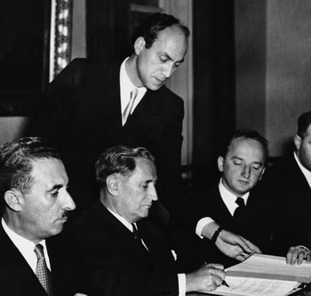Nahum Goldman, the president of the Jewish Claims Commission (center), signs 1952 reparations agreements between Germany and Israel. The two delegations entered the room by different doors, and the ceremony was carried out in silence. (Associated Press)
Survivors of the Holocaust feared laundering the reputation of Germany with money, and mortgaging the memory of their dead. Beyond that, there was a taste for revenge. “My soul would be at rest if I knew there would be 6 million German dead to match the 6 million Jews,” said Meir Dworzecki, who’d survived the concentration camps of Estonia.
Ben-Gurion countered this sentiment, not by repudiating vengeance but with cold calculation: “If I could take German property without sitting down with them for even a minute but go in with jeeps and machine guns to the warehouses and take it, I would do that—if, for instance, we had the ability to send a hundred divisions and tell them, ‘Take it.’ But we can’t do that.”
The reparations conversation set off a wave of bomb attempts by Israeli militants. One was aimed at the foreign ministry in Tel Aviv. Another was aimed at Chancellor Adenauer himself. And one was aimed at the port of Haifa, where the goods bought with reparations money were arriving. West Germany ultimately agreed to pay Israel 3.45 billion deutsche marks, or more than $7 billion in today’s dollars. Individual reparations claims followed—for psychological trauma, for offense to Jewish honor, for halting law careers, for life insurance, for time spent in concentration camps. Seventeen percent of funds went toward purchasing ships. “By the end of 1961, these reparations vessels constituted two-thirds of the Israeli merchant fleet,” writes the Israeli historian Tom Segev in his book The Seventh Million. “From 1953 to 1963, the reparations money funded about a third of the total investment in Israel’s electrical system, which tripled its capacity, and nearly half the total investment in the railways.”
Israel’s GNP tripled during the 12 years of the agreement. The Bank of Israel attributed 15 percent of this growth, along with 45,000 jobs, to investments made with reparations money. But Segev argues that the impact went far beyond that. Reparations “had indisputable psychological and political importance,” he writes.
Reparations could not make up for the murder perpetrated by the Nazis. But they did launch Germany’s reckoning with itself, and perhaps provided a road map for how a great civilization might make itself worthy of the name.
Assessing the reparations agreement, David Ben-Gurion said:
For the first time in the history of relations between people, a precedent has been created by which a great State, as a result of moral pressure alone, takes it upon itself to pay compensation to the victims of the government that preceded it. For the first time in the history of a people that has been persecuted, oppressed, plundered and despoiled for hundreds of years in the countries of Europe, a persecutor and despoiler has been obliged to return part of his spoils and has even undertaken to make collective reparation as partial compensation for material losses.
Something more than moral pressure calls America to reparations. We cannot escape our history. All of our solutions to the great problems of health care, education, housing, and economic inequality are troubled by what must go unspoken. “The reason black people are so far behind now is not because of now,” Clyde Ross told me. “It’s because of then.” In the early 2000s, Charles Ogletree went to Tulsa, Oklahoma, to meet with the survivors of the 1921 race riot that had devastated “Black Wall Street.” The past was not the past to them. “It was amazing seeing these black women and men who were crippled, blind, in wheelchairs,” Ogletree told me. “I had no idea who they were and why they wanted to see me. They said, ‘We want you to represent us in this lawsuit.’ ”
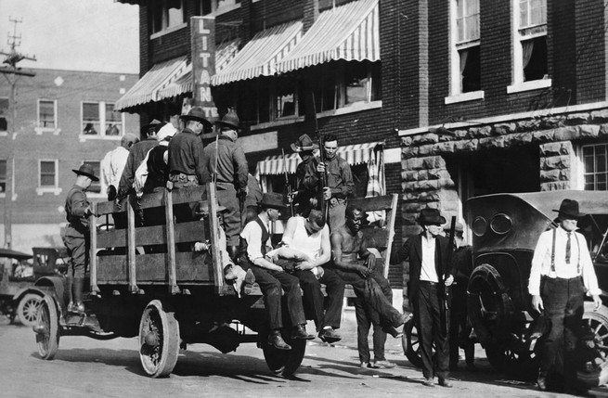In the spring of 1921, a white mob leveled “Black Wall Street” in Tulsa, Oklahoma. Here, wounded prisoners ride in an Army truck during the martial law imposed by the Oklahoma governor in response to the race riot. (Hulton-Deutsch Collection/Corbis)
A commission authorized by the Oklahoma legislature produced a report affirming that the riot, the knowledge of which had been suppressed for years, had happened. But the lawsuit ultimately failed, in 2004. Similar suits pushed against corporations such as Aetna (which insured slaves) and Lehman Brothers (whose co-founding partner owned them) also have thus far failed. These results are dispiriting, but the crime with which reparations activists charge the country implicates more than just a few towns or corporations. The crime indicts the American people themselves, at every level, and in nearly every configuration. A crime that implicates the entire American people deserves its hearing in the legislative body that represents them.
John Conyers’s HR 40 is the vehicle for that hearing. No one can know what would come out of such a debate. Perhaps no number can fully capture the multi-century plunder of black people in America. Perhaps the number is so large that it can’t be imagined, let alone calculated and dispensed. But I believe that wrestling publicly with these questions matters as much as—if not more than—the specific answers that might be produced. An America that asks what it owes its most vulnerable citizens is improved and humane. An America that looks away is ignoring not just the sins of the past but the sins of the present and the certain sins of the future. More important than any single check cut to any African American, the payment of reparations would represent America’s maturation out of the childhood myth of its innocence into a wisdom worthy of its founders.
In 2010, Jacob S. Rugh, then a doctoral candidate at Princeton, and the sociologist Douglas S. Massey published a study of the recent foreclosure crisis. Among its drivers, they found an old foe: segregation. Black home buyers—even after controlling for factors like creditworthiness—were still more likely than white home buyers to be steered toward subprime loans. Decades of racist housing policies by the American government, along with decades of racist housing practices by American businesses, had conspired to concentrate African Americans in the same neighborhoods. As in North Lawndale half a century earlier, these neighborhoods were filled with people who had been cut off from mainstream financial institutions. When subprime lenders went looking for prey, they found black people waiting like ducks in a pen.
“Wells Fargo mortgage had an emerging-markets unit that specifically targeted black churches.”
“High levels of segregation create a natural market for subprime lending,” Rugh and Massey write, “and cause riskier mortgages, and thus foreclosures, to accumulate disproportionately in racially segregated cities’ minority neighborhoods.”
Plunder in the past made plunder in the present efficient. The banks of America understood this. In 2005, Wells Fargo promoted a series of Wealth Building Strategies seminars. Dubbing itself “the nation’s leading originator of home loans to ethnic minority customers,” the bank enrolled black public figures in an ostensible effort to educate blacks on building “generational wealth.” But the “wealth building” seminars were a front for wealth theft. In 2010, the Justice Department filed a discrimination suit against Wells Fargo alleging that the bank had shunted blacks into predatory loans regardless of their creditworthiness. This was not magic or coincidence or misfortune. It was racism reifying itself. According to The New York Times, affidavits found loan officers referring to their black customers as “mud people” and to their subprime products as “ghetto loans.”
“We just went right after them,” Beth Jacobson, a former Wells Fargo loan officer, told The Times. “Wells Fargo mortgage had an emerging-markets unit that specifically targeted black churches because it figured church leaders had a lot of influence and could convince congregants to take out subprime loans.”
In 2011, Bank of America agreed to pay $355 million to settle charges of discrimination against its Countrywide unit. The following year, Wells Fargo settled its discrimination suit for more than $175 million. But the damage had been done. In 2009, half the properties in Baltimore whose owners had been granted loans by Wells Fargo between 2005 and 2008 were vacant; 71 percent of these properties were in predominantly black neighborhoods.

Enjoy unlimited access to The Atlantic.

